Community Health Worker Orientation Toolkit

We help people live healthier lives.

Edward M. Kennedy Community Health Center is a Federally Qualified Health Center located in Worcester, Framingham, Milford, and Clinton, Massachusetts.

This toolkit was created by Edward M. Kennedy Community Health Center. This project was funded by a Health Care Workforce Transformation Fund grant through the Commonwealth of Massachusetts, Executive Office of
Labor and Workforce Development. The grant program was administered by Commonwealth Corporation.

February 2017

REV 2_7_2017

COMMUNITY HEALTH WORKER ORIENTATION TOOLKIT
DEVELOPED BY: Sue Schlotterbeck
EDWARD M. KENNEDY COMMUNITY HEALTH CENTER (Kennedy CHC) Worcester, MA
This project was funded by a Health Care Workforce Transformation Fund grant through the Commonwealth of Massachusetts, Executive Office of Labor and Workforce Development. The grant program was administered by Commonwealth Corporation. The Center for Health Impact was the lead on this grant and Edward M. Kennedy Community Health Center was the employment partner.

In collaboration with:

Kennedy CHC Community Health Workers:
Claudia Tamsky Daniela Molina Diogenito Jorge Ericka Olivera Flavia Santos
Francisca Negron Cruz Ivelisse Sully
Kelly Celestino Lizette Perez Luz Torres
Marcia Nascimento Maria “Mel” Ramos Maria Cruz
Maria Jorge
Maribel Gonzalez Melissa Taranto Oscar De La Rosa Rafaela Dos Santos Ramona Gil
Robert Arce Sousn Imam Yasinca Monzon
Kennedy CHC Supervisors/Leadership and Administration Staff :
Bernadine Mavhungu Brenda Figueroa
Jose Ramirez Leah Gallivan Leo Negron Cruz
Nora Alarcon Paula Kaminow Ramon Medina Robynn Eisley Tania Henkle Others:
Blair Komar (Community Legal Aid, Inc)
Jena Bauman Adams (Center for Health Impact)
Katie Condon Grace (MetroWest Legal Services)
Meghan Reynolds (Medical Student, UMass Medical School)
Melina Munoz (Community Legal Aid, Inc)
Valerie Zolezzi-Wyndham (Community Legal Aid, Inc)

1

A special thank you to:
- The Kennedy CHC Community Health Workers for sharing their resources and knowledge, piloting sections of the Toolkit and working with our communities to address the social determinants of health to create health equity.
- The Kennedy CHC leadership team and support staff for participating in the development and piloting of the Toolkit.
- Our Medical Legal Partnerships (Community Legal Aid and MetroWest Legal Services) for their ongoing support in providing resources and training to our CHWs and providing legal services to the patients we serve.

Purpose: Completing CHW core training is very important for the CHW workforce. In addition, there is a need for organizations to have a standardized way to orient CHWs to the organizational systems, resources and specific health-related needs of the communities they serve. This CHW Orientation Toolkit (Toolkit) was developed to meet this need.

Content: The Toolkit includes policies and procedures; assessments, documentation and data collection standards; job descriptions; standards for communicating with patients, coworkers and partner agencies; resources; and basic education guidelines. This Toolkit includes samples and resources developed by Kennedy CHC, partner agencies, and links to additional information available through other reputable sources.
Attachments for specific sections are included at the end of the Toolkit.

Please Note: These samples and resources are intended to be used by other agencies as templates for developing their own toolkits. The sample documents may have compliance and organizational implications for your agency which should be investigated before adapting them to meet your needs.

Additional Resources: Since many resources are location specific, we have not listed all the resources that we use in this Toolkit. However, there are many useful websites to learn more about the topics listed below; some of our favorites include: https://www.cdc.gov/; https://massclearinghouse.ehs.state.ma.us/; https://medlineplus.gov/languages/all_healthtopics.html; http://www.masslegalhelp.org/

Format: This Toolkit is organized into five sections. The suggested time frame for introducing each topic is listed in order in each section, starting with orientation topics to complete during the first week. Most of the sections are to be completed by the CHW along with his or her supervisor or designee, usually during 1-2 hour meetings which may be combined with supervision time during the first six months of hire.

Contact: Sue Schlotterbeck sue.schlotterbeck@kennedychc.org

Community Health Worker Orientation Toolkit – to be completed within 6 months of hire CHW Name: Date of Hire:

SECTION 1: ORGANIZATIONAL INFORMATION AND WELCOME
WEEK 1-2= RED; WEEK 2-4=BLUE; 1 MONTH=GREEN; MONTH 3=PURPLE; MONTH 6=ORANGE
Information | Time- line | CHW  reviewed documents | Demonstrated by teach back | Demonstrated by observation | Demonstrated in writing | Demonstrated by role play or  case scenario | Suggested trainer | Trainer sign-off | Date
Generic Site Specific Checklist (keys, supplies, parking….) | Week 1 |  |  |  |  |  | Supervisor or Designee
Agency Website; CHW Folders; Staff Portal, including Health Ed Materials in Multiple Languages  https://medlineplus.gov/l anguages/all_healthtopic s.html; https://masscleari nghouse.ehs.state.ma.us  / | Week 1 |  |  |  |  |  | Supervisor or Designee
Introduce and/or meet with agency staff | Week 1-2 |  |  |  |  |  | Supervisor or Designee
Job Specific Grants or Projects (such as HIV, PWTF, Refugee) | Within 1  month |  |  |  |  |  | Supervisor or Grants Manager
Meet Community Partners  Ongoing Meeting Requirements | Within 1  month |  |  |  |  |  | Supervisor or Designee

SECTION 2: Job Description, Vision, Competencies, Ethics, Social Determinants of Health, Boundaries/Self-Care, Patient Centered Medical Home (PCMH)
WEEK 1-2= RED; WEEK 2-4=BLUE; 1 MONTH=GREEN; MONTH 3=PURPLE; MONTH 6=ORANGE
Information | Time- line | CHW  reviewed documents | Demonstrated by teach back | Demonstrated by observation | Demonstrated in writing | Demonstrated by role play or  case scenario | Suggested trainer | Trainer sign-off | Date
CHW Job Description &  Vision (Attachment 1, 2) | Week  1-2 |  |  |  |  |  | Supervisor  or Designee
Massachusetts CHW Core  Competencies http://ww w.mass.gov/eohhs/gov/de partments/dph/programs/ hcq/dhpl/community- health-workers/ma-board- of-certification-of- community-health- workers.html  American Association of CHWs Core Values & Code of  Ethics http://www.chwcrs  .org/files/4913/9636/5587  /CHW_Code_of_Ethics.pdf | Week 1-2 |  |  |  |  |  | Supervisor or Designee
Boundaries and Self Care (Attachment  3A,B,C) | Week 1-2 |  |  |  |  |  | Supervisor or Behavioral Health Staff
Patient Centered Medical  Home https://pcmh.ahrq. gov/page/defining-pcmh | Week 1-2 |  |  |  |  |  | Supervisor or Nursing Supervisor
Social Determinants of Health http://www.cdc.g ov/socialdeterminants/ | Week 1-2 |  |  |  |  |  | Supervisor or Designee

Section 3: ELECTRONIC RECORD DOCUMENTATION, ASSESSMENT, COMMUNICATION WITH STAFF
WEEK 1-2= RED; WEEK 2-4=BLUE; 1 MONTH=GREEN; MONTH 3=PURPLE; MONTH 6=ORANGE
Information | Time- line | CHW  reviewed documents | Demonstrated by teach back | Demonstrated by observation | Demonstrated in writing | Demonstrated by role play or  case scenario | Suggested trainer | Trainer sign-off | Date
Overview of Electronic Patient Management (EPM) System and Electronic Health  Record (EHR) | Week 2-4 |  |  |  |  |  | IT staff
Scheduling and Checking in patients for CHW | Week 2-4 |  |  |  |  |  | Site Front Desk Supervisor
CHW Template and Workflow (Attachment 4A,B) | Week 2-4 |  |  |  |  |  | Supervisor or Designee
Psychosocial Assessment Tool and Procedures (Attachment 5A,B,C) | Week 2-4 |  |  |  |  |  | Supervisor or Designee
CHW-Clinical Staff Communication Procedures (Attachment 6) | Week 2-4 |  |  |  |  |  | Supervisor or Designee

SECTION 4: COMMUNICATION WITH PATIENTS
WEEK 1-2= RED; WEEK 2-4=BLUE; 1 MONTH=GREEN; MONTH 3=PURPLE; MONTH 6=ORANGE
Information | Time- line | CHW  reviewed documents | Demonstrated by teach back | Demonstrated by observation | Demonstrated in writing | Demonstrated by role play or  case scenario | Suggested trainer | Trainer sign-off | Date
 |  |  |  |  |  |  | Director or
Interpreter Services | Week |  |  |  |  |  | Supervisor of
(Attachment 7) | 2-4 |  |  |  |  |  | Interpreter
 |  |  |  |  |  |  | Services
Body Language | Within 1  month |  |  |  |  |  | Supervisor or Designee
Encouraging Patients to Ask Questions (Attachment 8) | Within 1  month |  |  |  |  |  | Supervisor or Designee
Motivational Interviewing (Attachment 9A,B,C,D) | Within 1  month |  |  |  |  |  | Supervisor or Designee
Teach Back Procedures (Attachment 10) | Within 1  month |  |  |  |  |  | Supervisor or Designee

Section 5: Resources, Procedures, Basic Education Guidelines (1)
WEEK 1-2= RED; WEEK 2-4=BLUE; 1 MONTH=GREEN; MONTH 3=PURPLE; MONTH 6=ORANGE
Information | Time- line | CHW  reviewed documents | Demonstrated by teach back | Demonstrated by observation | Demonstrated in writing | Demonstrated by role play or case scenario | Suggested trainer | Trainer sign-off | Date
211 Resource Hotline  http://mass211.org/ | Week 1 |  |  |  |  |  | Supervisor or Designee
Confidentiality Policy (Attachment 11) | Week 1 |  |  |  |  |  | Supervisor or Designee
Informed Consent Policy (focus on consent to treat minors) | Week 1 |  |  |  |  |  | Supervisor or Designee
Reporting Suspected Abuse or Neglect Policy (Attachment 12) | Week 1-2 |  |  |  |  |  | Supervisor or Behavioral Health Staff
Safety for CHWs (Attachment 13A,B) | Week 1-2 |  |  |  |  |  | QI Director or Supervisor
Benefits (Attachment 14) | Within 1  month |  |  |  |  |  | Supervisor or Designee
Home Visits and Other Contacts Outside Kennedy CHC Policy (Attachment 15) | Within 1  month |  |  |  |  |  | Supervisor or Designee
Letters on Patients Behalf Procedures (Attachment 16) | Within 1  month |  |  |  |  |  | Supervisor or Designee

Section 5: Resources, Procedures, Basic Education Guidelines (2)
WEEK 1-2= RED; WEEK 2-4=BLUE; 1 MONTH=GREEN; MONTH 3=PURPLE; MONTH 6=ORANGE
Information | Time- line | CHW  reviewed documents | Demonstrated by teach back | Demonstrated by observation | Demonstrated in writing | Demonstrated by role play or  case scenario | Suggested trainer | Trainer sign-off | Date
Outreach for Special Projects and Urgent Needs (attachment  17A,B) | Within 1  month |  |  |  |  |  | Supervisor or Designee
Patient Rights and Responsibilities Policy (Attachment 18) | Within 1  month |  |  |  |  |  | Supervisor or Designee
Domestic Violence (Attachment 19) http://www.ncdsv.org/pub lications_wheel.html | Within 3  months |  |  |  |  |  | Supervisor or Designee
Food Security (SNAP, WIC, School Breakfast/Lunch, Summer Meals, Food Pantries, Community Meals, Meals on Wheels, Senior Meal Programs), Project Bread-1-800-645-8333  http://www.projectbread. org | Within 3  months |  |  |  |  |  | Supervisor or Designee
Health Insurance https://www.mahealthcon nector.org/ | Within 3  months |  |  |  |  |  | Managed Care Supervisor or Designee

Section 5: Resources, Procedures, Basic Education Guidelines (3)
WEEK 1-2= RED; WEEK 2-4=BLUE; 1 MONTH=GREEN; MONTH 3=PURPLE; MONTH 6=ORANGE
Information | Time- line | CHW  reviewed  documents | Demonstrated by teach back | Demonstrated by observation | Demonstrated in writing | Demonstrated by role play or  case scenario | Suggested trainer | Trainer sign-off | Date
Housing: public housing, vouchers, shelters, transitional programs, lead, landlord issues, roaches/mice… http://w ww.mass.gov/hed/housing  /ph-manage/public- housing-applications-and- documentation.html  http://www.mass.gov/hed  /economic/eohed/dhcd/re ntal-applications-and- documentation.html | Within 3  months |  |  |  |  |  | Supervisor or Designee
http://www.masslegalhelp
.org/housing
http://www.masslegalhelp
.org/homelessness/basic- shelter-rights
Legal Services http://www.masslegalservi ces.org/findlegalaid | Within 3  months |  |  |  |  |  | Supervisor or Designee
SSI/SSDI/Elderly and Disabled Services (Attachment 20) | Within 3  months |  |  |  |  |  | Supervisor or Designee

Section 5: Resources, Procedures, Basic Education Guidelines (4)
WEEK 1-2= RED; WEEK 2-4=BLUE; 1 MONTH=GREEN; MONTH 3=PURPLE; MONTH 6=ORANGE
Information | Time- line | CHW  reviewed documents | Demonstrated by teach back | Demonstrated by observation | Demonstrated in writing | Demonstrated by role play or case scenario | Suggested trainer | Trainer sign-off | Date
Transportation and PT1- public transport, transport for seniors/disabled, handicap placard, PT1 website https://masshealt h.ehs.state.ma.us/default. aspx | Within 3  months |  |  |  |  |  | Supervisor or Designee
(Attachment 21A,B,C,D)
Utilities Assistance (Attachment 22)  http://www.masslegalservi ces.org/node/12432 | Within 3  months |  |  |  |  |  | Supervisor or Designee
Asthma (Attachment 23) | Within 6  months |  |  |  |  |  | Supervisor or Designee
Behavioral Health | Within 6  months |  |  |  |  |  | Supervisor
(Attachment |  |  |  |  |  |  | and
24) https://www.masspart |  |  |  |  |  |  | Behavioral
nership.com/ |  |  |  |  |  |  | Health Staff
Cancer Prevention and Screening http://www.ca ncer.org | Within 6  months |  |  |  |  |  | Supervisor or Designee

Section 5: Resources, Procedures, Basic Education Guidelines (5)
WEEK 1-2= RED; WEEK 2-4=BLUE; 1 MONTH=GREEN; MONTH 3=PURPLE; MONTH 6=ORANGE
Information | Time- line | CHW  reviewed documents | Demonstrated by teach back | Demonstrated by observation | Demonstrated in writing | Demonstrated by role play or  case scenario | Suggested trainer | Trainer sign-off | Date
Children and Youth- Childcare, Child Support, Parenting http://www.m ass.gov/edu/birth-grade- 12/early-education-and- care/find-early-education- and-care-programs/ | Within 6  months |  |  |  |  |  | Supervisor or Designee
Diabetes (Attachment 25) | Within 6  months |  |  |  |  |  | Supervisor or Designee
Education Programs – ESL – HiSET (GED) –  Head Start-Citizenship | Within 6  months |  |  |  |  |  | Supervisor or Designee
Employment http://www  .workforcecentralma.org/ | Within 6  months |  |  |  |  |  | Supervisor or Designee
Exercise/Fitness Programs – YMCA, YWCA, Audubon, AMC | Within 6  months |  |  |  |  |  | Supervisor or Designee
Fall Prevention (Attachment 26) | Within 6  months |  |  |  |  |  | Supervisor or Designee
Family Planning | Within 6  months |  |  |  |  |  | Supervisor or Designee

Section 5: Resources, Procedures, Basic Education Guidelines (6)
WEEK 1-2= RED; WEEK 2-4=BLUE; 1 MONTH=GREEN; MONTH 3=PURPLE; MONTH 6=ORANGE
Information | Time- line | CHW  reviewed documents | Demonstrated by teach back | Demonstrated by observation | Demonstrated in writing | Demonstrated by role play or case scenario | Suggested trainer | Trainer sign-off | Date
Furniture Household  Goods http://householdg oods.org/ | Within 6  months |  |  |  |  |  | Supervisor or Designee
Health Systems Education (Attachment 27) | Within 6  months |  |  |  |  |  | Supervisor or Designee
HIV, STDs, Hepatitis C (Attachment 28) | Within 6  months |  |  |  |  |  | CHW  Supervisor Comm. Program
Hypertension (Attachment 29) | Within 6  months |  |  |  |  |  | Supervisor or Designee
Pregnancy/Postpartum/ Newborn  (Attachment 30 A,B) | Within 6  months |  |  |  |  |  | Supervisor or Designee
Refugees-I Speak Cards- RHS-15 | Within 6  months |  |  |  |  |  | Director Health Equity

Section 5: Resources, Procedures, Basic Education Guidelines (7)
WEEK 1-2= RED; WEEK 2-4=BLUE; 1 MONTH=GREEN; MONTH 3=PURPLE; MONTH 6=ORANGE
Information | Time- line | CHW  reviewed documents | Demonstrated by teach back | Demonstrated by observation | Demonstrated in writing | Demonstrated by role play or  case scenario | Suggested trainer | Trainer sign-off | Date
Substance Use – Addiction – Recovery MA Substance Abuse Helpline at 800-327- 5050 or go to www.helpline-  online.org. http://learn2co pe.org/ http://www.moar  -  recovery.org/ https://na.or g/  http://www.aa.org/ (Attachment 31) | Within 6  months |  |  |  |  |  | Supervisor or Designee
Tax Help- FREE http://masscashback.ehs.s tate.ma.us/ | Within 6  months |  |  |  |  |  | Supervisor or Designee
Tobacco (Attachment 32) | Within 6  months |  |  |  |  |  | Supervisor or Designee
OTHER Local Resources: Cell phone, clothing, newborn items, EBT discounts at museums, etc. | Within 6  months |  |  |  |  |  | Supervisor or Designee

Comments:

List of Attachments for Community Health Worker (CHW) Toolkit

- CHW Vision
- CHW Job Description
- (A, B, C) Boundaries and Self Care
- (A, B) CHW Electronic Health Record Template and Workflow
- (A, B, C) CHW Psychosocial Assessment Template and Procedures
- CHW-Clinical Staff Communication Procedures
- Interpreter Services Guidelines for CHWs
- Encouraging Patients to Ask Questions
- (A, B, C, D) Motivational Interviewing
- Teach Back Procedures
- Patient Confidentiality Policy
- Reporting Suspected Abuse or Neglect Policy
- (A, B) CHW Safety Training
- Public Benefits Information
- Home Visits and Other Contacts Outside the Health Center Policy
- Assisting with Letters on Patient’s Behalf Procedure
- (A, B) Special and Urgent Need Outreach Flowcharts
- Patient Rights and Responsibilities Policy
- Domestic Violence Screening Flow Chart
- Social Security Disability Benefits
- (A, B, C, D) Transportation Policy and Agreements
- Utility Termination Protection
- Asthma Procedures and Basic Education Guidelines
- Behavioral Health Procedures and Basic Education Guidelines
- Diabetes Procedures and Basic Education Guidelines
- Fall Prevention Procedures and Basic Education Guidelines
- Health Systems Education Guide
- HIV/AIDS, STDs, Hepatitis C Procedures and Basic Education Guidelines
- Hypertension Procedures and Basic Education Guidelines
- (A, B) Prenatal-Postpartum-Newborn Procedures and Basic Education Guidelines
- Alcohol and other Drug Treatment Websites and Organizations
- Tobacco Procedures and Basic Education Guidelines

Attachment 1

CHW Vision

Community Health Worker (CHW) Vision Edward M. Kennedy Community Health Center

Create and implement a CHW model that:
  - Improves patient outcomes
  - Increases access to care
  - Addresses social determinants of health
  - Positions the health center for future reimbursement for CHW services
  - Provides a bridge between the community and the health center How do CHWs help us achieve our vision?
- CHW works as a member of the PCMH team to keep current patients connected to their medical home and adhering to their plan of care.

- CHW reduces barriers to care by addressing psychosocial needs and providing education, resources, support and navigation.

- CHW engages patients to become active members of their health care team and participate in making decisions about their care and reaching their healthcare goals.

- CHW acts as a cultural broker to provide feedback to staff and patients on cultural issues that may affect patient’s health, including ways to address health disparities and meet Quality Improvement project goals. CHW acts as a bridge between the community and the Kennedy Health Center.

- CHW provides access to people who need a medical home. In collaboration with marketing/development team, CHW participates in outreach which is matched to CHW cultural expertise, skills and organizational needs.

rev 3_12_2014

Attachment 2

CHW Job Description

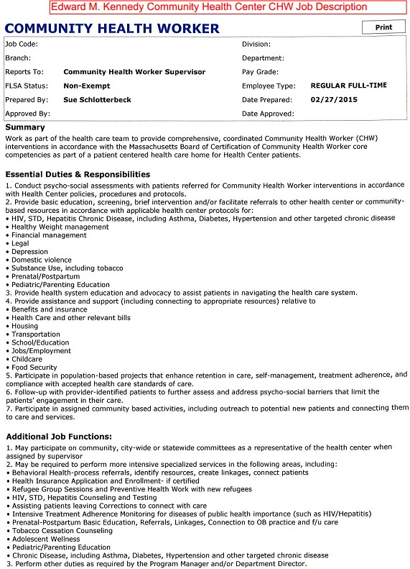
SAMPLE Job Description
Edward M. Kennedy Community Health Center CHW Job Description

. ED W ARD M. KENNEDY
)J'\... Community Health Center

Ct"itical Demands of Che Job:
1. Uti li Zla!s: t,lile l!ow ing e,thnig1,11;!!!;. In Q)Jitdl.lO- n,g CHW lriterventlo s: sel •m;in ;11g;ernen , nn.l;ltlv.at io r\i!II in te,n,i lng,
te.i-ch b!!ck, and other p b'ient en9.1ge-m e-nt ,n.d ,re entian tec:h nigu,es.
- . WOl"k!o 111 t he clinical _{,;1r-e,.i} oi!o p;u t of ttie integra ted health care earn, o1s ;i:!,!,lgne dl.
- . Corid cts home visits II) aa:.or<lance with CHW protoools and as assi gned by supervi:;:or·.

4 . SuppQrt,;; .i work envirnnment tllat i!i r,esp o:n 5i..,e .i1rtd 115L'l;r.ie w t h e m eds of diverse st.tif-f (:{IJiliim 1,mk:ates effe.ctlvely wltti p;i,1.llen .i,nd oo11 a,g ue•s
- Contri'bu te:s. and is n act i'I'@ p a.rt of a po!;itive ,!Ind l'.)rnte:ssioni!!I t-e m, St.Ipporting our Mission.
6 . W□ii ::5: wl hi111o :;m 01,1t1Ja-, etllt o-ffl«! setting -.1ml com mun lty outreach sernng-
fldl cl!m t s a d

7. Do,curnents: In electronic healtti record or othe,- ssignedl r'!CCrdke!!!p in g format aooorolng ro he<1lth i;e11 r protocols_
8 . Furtctforis wit hin, fle:i:l l;Jle w<i.-k si;:hecl1.1l e o!!o a,s:s !}ned b y si te a11d s;1,1peJYiso:r ..in.d .Jis reql!li'red by th:e job .
- PartklpatMo In all scheduled depart ment:8I,. Narn, _{&ridi} Cerrrer wide me e· lngis, as well as all QI projects in 1tie
DIJip!l rt t'IU!l'it Oar HMrrth Ce t , i'.1:S ,'JS:SiQM i:I.
10, P-,11rt k: lp at . In .iny COQtracts frorn whi ch the H alth Cenre r recell!;'es n.mdlrig th.it sYp J;Jort!il C{;lm mi,nility Healdlt Work-er job ruroc ion-s, and fonds M h@ir ir1 Full o r in p11rt tthi!!• .1!;$ig n:eci CHW po s:lti o11.
11 , P-;i,rti cll)ates, In Qll •!:lit:e arid off sit e co-ritlnuIng '3ducat oo prcgrams am! In• seiv ite tr.;ii n in g s to rn.aet CHW
1;el't!Ac:at:io-n, rundlng, or regl!.ll at ory 11eq ui e-m i:mts ancl ro mfli@t the fi'lll'!!@ds of the rommun lty.

Requ!11i11dl q1u,11litlcabl Hi1S & S'Llbs
_ J. lilgh Sdill!Oll Dll!ffiffl _{l)f'} t Qul'la l'e.n.cy
  - Minim11m 2- ei!lrs w.ork er volunteer ex perll! ll 11'1 h. man S@IVl!,,lE!s; o:r hen.'ltl!tel!l, e, wllh di!im0"1WMM lll0Wl ed9C of or·
,i!bl ty to ¥«lillo: \1lllllh ill'Jd}Qr tli rri tl!e rergetedl Ql)l U'fl!llll y
  - 511J · 1 wal rn m'i}11sti, nd 1©lh >i!r l!inQU'l'l'i18 l d ntl ed by the, Hea Ith 1LJ8 n Nr's as be ng .a h11r1gu e r--need.
  - 'i'llh lll nnilWi-;l Ion;: i!\PIJ t;I b,ij' lhe $Y[Pe rv r n .;ii;l'li , a (l-l J _ e :iq :iec ted to hta'IE! a v?ilid: U. S. owr
Vehlcl'o t lcoos'1,;:md r,i;:lrabl · aMJ>;lrtilltiOin to ua1,1ell to/fmm O(JYfiQ'hi act'l.,.ible:s, as. th ey may be a<5slgned ·from·time tfrt.e, If t e QHW wiII arso be ass&gne :to h"an511ort p ilitiients:,r :the CHW must jil"Mfd'.e p ro cf f :st:ilie-mtifiiUI 1perw mil1 Motor Vellld e lns.Ul'aflce,
S. ll millmit!"a' di llli'ln.ii;al.. ;i,;liJ riraru; w.i flfi!a"ir.iQft W rd, E;;;Qal ( Q · ;;- , "l'ilr ,id ) , -'lfld lAt:u Gil l ei-.
E:«:ellent 'Jlall end w i't'ten 5Mll51,

Pfflfanted ·QWllllfl:cat!lians::
I , II: 13't'i!lcit u fld4i r. fiid, u Ull!; ,de
2, lfac led,g o:l' <l:P l ble 5''taite₁ •federal1 andfor loea,t reguta □11s a . e:imriiunll:y l"l:!ro 11roes.
Patient Aue Gro up served Neeof! .b ·. ( IJ11(1er i. Of'tll) P,edl&t.l'lr.: ( .I. 'lo lii th i.o L2 'i'e:irS)·
Mo!es nee· (! .2• 11 Yea rs,)
,Ad 1.1it ( UH ,411r,e )
G(I· trli!: (•6 5 Veo!i:IS)

PHYSl!C'AL REQIJIREMEiNTS OHIECKUS
A tM % ef DM comments
- s rn,g _{G} _{F} b n 2
Walking Lrn t an 2$%
S- ndlir11 l'e<.
fl Qlii Ye
Ab VII Shoo'ldi!r No
- llepi!lil l ! Hand l'IOV! lltellt Y,i!':!l fy plng Gr!! pln Yel
l'l e Ma l!'Uiatlon v:

Sitting Grtllt r tli,l!!rn s:
- Rer,-e Ive filot t<lbvernemt No

Af iiil y F Li! l'li!)' • Lb s. torn1 n!.'!i
2, I 1111 O«,,.slari.tVl:11ft• lll J!llt Le 1ju r1 5 lb:i;
O!Jl'il'{ g, \, kl)' Legs tlialfl1 25 111:i .
IPtlslil Om1sl1Jn111/!lilfrn:querit l.GM tmm 2S lbs jl1' J1llrn CictA$ioo{li/lll'li rewq n {1) 1th i) 2S b-,, Actlwity 't @i. / No C!Jmm(ln l!i
,3_ ·Climb' I t _{Q}
Bala;1Ki111g o
'-· Sl,OQlltn!l tk1
a, siiea Ing Ye
Heam Yes
9. See D Yes
l)eptll Percep o.n !'lo
Color Iii IQII No
Eft IM mMt.lJ ·C011d, M CiHl\ Ms.
1. Inside/Outside Il'ISide/Outslde \'leej<)ly com111urutr olitrea(;II ei pected
- Cold/ He. ! llO!'lllBI
- W l;fDrv NQrm I
- Qi MDri!tJQIIS ll llmlill
- Hm N:ls rg011omic,s

Kiloo-li, l"lo
6 , Fumes/lM I/Odm Cfm I
OSHA Plly kal WD!t Coooritlcns (Se ea Ollll)

Croocill , g l'lo,
Cr3 ,.,,.lini;i N¢
1. D 'Jt rwtlne/i,> ln l e ellJ:%\lre o\lr e p or / olleBtl I m;iy be 11!qulred.
- tlnef( lfl';olres x,m 1.1re, t0 p,n ts llllt m y c..arli' pot.enU lfy oi r-b0rne 1 g .

Attachments 3A, 3B, 3C

Boundaries and Self Care

BOUNDARIES AND SELF CARE for
Community Health Workers
Adapted by Edward M. Kennedy Community Health Center
from Initiation and Engagement of Alcohol and Other Drug Treatment: Module 2: Strategies for Approaching, Engaging and Motivating Clients

A MassHealth/UMass Medical School Curriculum for Community Health Workers

Why are boundaries very important for Community Health Workers (CHWs)?
- CHWs usually live in the communities they serve and may:
  - have personal relationship with the patient’s or the families who receive care at the health center
  - run into patient’s or their families at community gatherings,
places of worship, at the grocery store….

- CHWs are part of a team and may develop close friendships with their co-workers.
- CHWs need to set boundaries to meet professional standards and maintain confidentiality. Personal life and work life boundaries are not identical!
- CHWs need to set boundaries to stay healthy and avoid stress and burnout.

Maintaining Professional Boundaries
- Be intentional and clear when setting boundaries with patients and coworkers.
- Let patients and their families know the boundaries you have
set.
- Be honest with yourself and seek supervision when needed.

Know and Keep Your Boundaries
- Follow health center policies and maintain confidentiality
- Practice honesty
- Be attentive to your safety and patient safety
- Do not act like a counselor, because if you do, the patient will respond as if you are one!
4

Questions of Self-Disclosure
?
- Ask yourself who is being served by the self-disclosure. It should be the client who is being served.
- Don’t self-disclose as a means of telling the patient what they should do.
- DO NOT DISCLOSE traumatic incidences in your life since you have no knowledge of how the self-disclosure will be received.

Positive Use of Telling Our Stories
- Your interactions with a client are about them and not you.
- Keep your own story brief and with a
purpose.
- Use your story to show empathy, illustrate an example, or describe a choice and its consequences.
- Remember: parts of our story may raise uncomfortable feelings for someone who hasn’t yet dealt with difficulties.
- Your story should only be 2-3 sentences long!

If you have unplanned contact with a patient (outside your work environment)

- To protect confidentially, do not greet the patient unless the patient initiates contact.

- If patient initiates contact, respond in a friendly manner but do not continue conversations related to your role with patient at the health center.

- If patient begins to discuss personal information, reply that you are not allowed to discuss health center work outside of your work hours and encourage the patient to follow up during your work hours.
7

Seek Support when Needed for:
- Understanding institutional and professional policies
- Protecting your emotional health and physical safety
- Being ‘professional’ without creating barriers for patients
- Communicating clearly to patients, coworkers, and supervisors.
- Coping with frustration when things don’t go as expected
- Other circumstances?
8

Tips to reduce stress and take care of yourself.
Share your ideas with others.
9

Practice Self-Care
- Try not to take on more than you can handle
- Advocate for the tools/information/resources/training that
you need to do your best work
- Break for lunch each day and drink enough water
- Keep your own safety in mind; avoid risky situations
- Share your concerns or feelings with your supervisor
- “Leave work at work”
- Practice healthy habits which can reduce or relieve stress such as: meditation, breathing exercises, exercise, music…
10

Boundaries Scenario Activity
- Each group will review one scenario.

- Each group will have 10 minutes to discuss what they would do in the situation, using the questions provided to help them think it through.

- Groups will share what they discussed back in the large group.

Handout – Boundary Scenarios
You are a CHW. You have become aware that another staff member often comes to work under the influence. He/she has fallen behind in his work and has asked you to cover for him more than once.
- What kinds of boundaries are in play?
- What other information may you need?
- Who could be a resource to you?
- What do you do?
You are a CHW. One of your co-workers informs you that she will be out of the office because she needs personal time due to a problem she is having with her son.
- What types of questions are appropriate to ask?
- When other staff asks you why your co-worker is out of the office, how should you respond?
- What kinds of boundaries are in play?
You are a CHW. During a client visit, you see the client hit his/her son for using foul language.
- What kinds of boundaries are in play?
- What other information may you need?
- Who could be a resource to you?
- What do you do?
You are a CHW. After leaving a client's home after an appointment,you witness illegal drug activity occurring outside. You know the individuals have seen you and you are afraid for your safety. You make your exit safely. You don't want to tell your supervisor what you saw, but you don't want to return to that neighborhood either.
- What kinds of boundaries are in play?
- What other information may you need?
- Who could be a resource to you?
- What do you do?
You are a CHW. You have been invited to your good friend's party this weekend, but you know she has invited several other community members that are your patients. You can't decide whether you should attend the party, but you really want to go.
- What kinds of boundaries are in play?
- What other information may you need?
- Who could be a resource to you?
- What do you do?
You are a CHW. You are working with a client who has experienced domestic violence. You yourself are dealing with domestic violence but you haven't shared that information with the client and don't really want people to know about it. One day at the agency that serves people experiencing domestic violence, you bump into your client.
- What kinds of boundaries are in play?
- What other information may you need?
- Who could be a resource to you?
- What do you do?

.

Handout - Stages of Boundary Setting

Boundaries are imaginary lines that we draw to protect mind, body and soul and allow us to be with others in a way that honors us both.
  - When setting boundaries always, always, be calm – with no emotional charge. Don’t even try setting boundaries when you are angry or charged. Calm down first.
  - Keep your language simple, clear, and focused on the behavior and how you feel about it.
  - Remember your goal is not to make the other person feel bad but rather to change the behavior, so you want their full co-operation.
  - This is not about making the other person wrong or scoring points. It is about creating an environment of mutual respect in which your relationship can grow.

Inform.
Let the other person know your standard, or what is bothering you. If there is a problem, clearly and simply let the other person know - don’t make a big guessing game out of it.
Example: Do you know I am not allowed to communicate with you outside of my working hours?

Request.
If the other person doesn’t stop or change the behavior after #1 (most will) simply and clearly ask them to stop or change the behavior, for example:
Will you please stop calling my cell phone every night?

Educate.
Give alternatives, and/or model the new behavior yourself.
Example: You can call me between the hours of 9 – 5. Let’s make a plan about who you can call at other times if you need something.

- Warn. First give this some careful thought because if you give a warning you must be able to carry it through.
If the behavior keeps repeating, it may be necessary to give fair warning that there will be consequences if the behavior continues.
Example: If you keep calling me every night, my boss may assign someone else to work with you.

Attachments 4A, 4B

CHW Electronic Health Record Template and Workflow

Edward M. Kennedy Community Health Center NEXTGEN EHR Template rev 12_13_2016
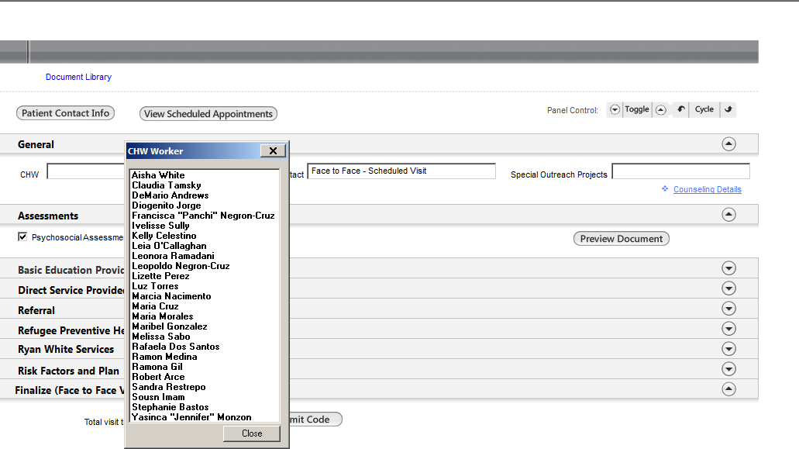

CHW Dropdown Names are listed in this dropdown

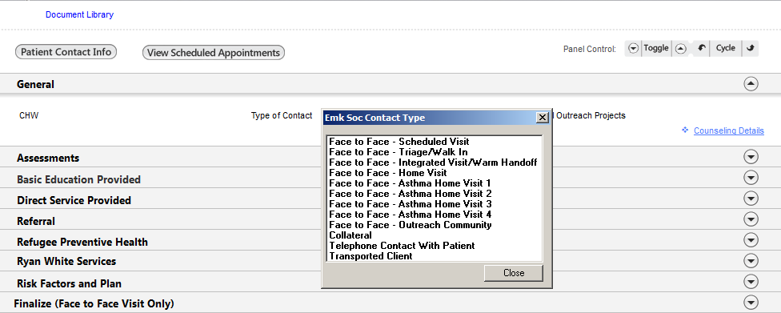
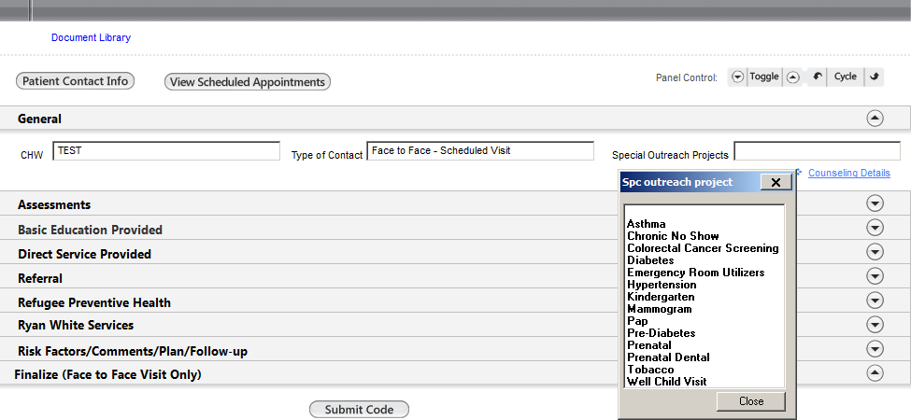

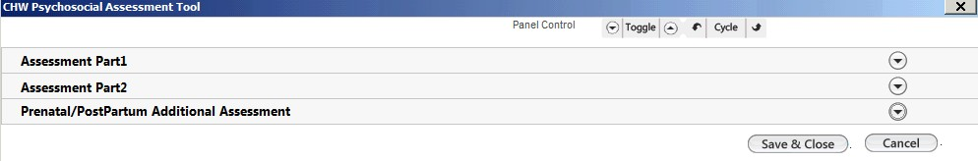

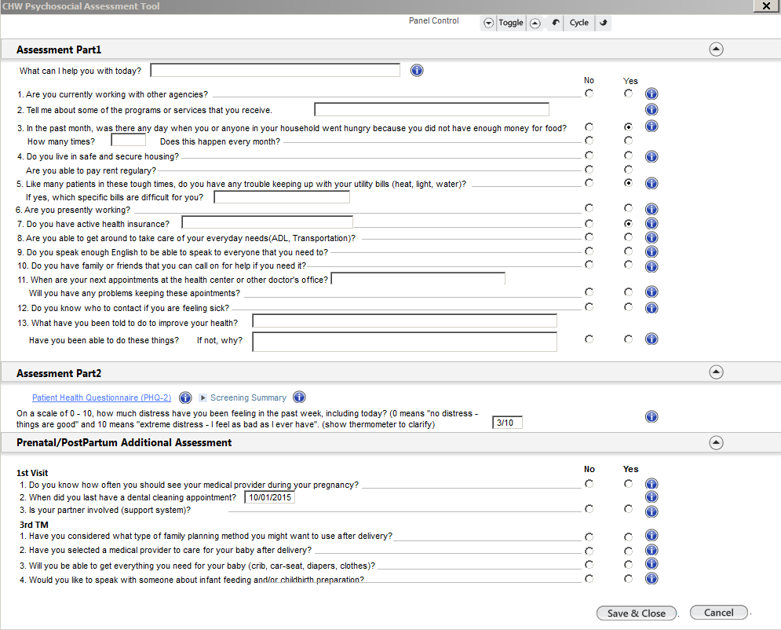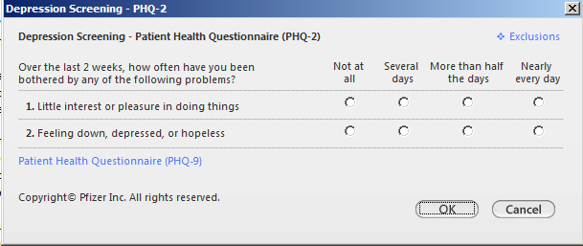

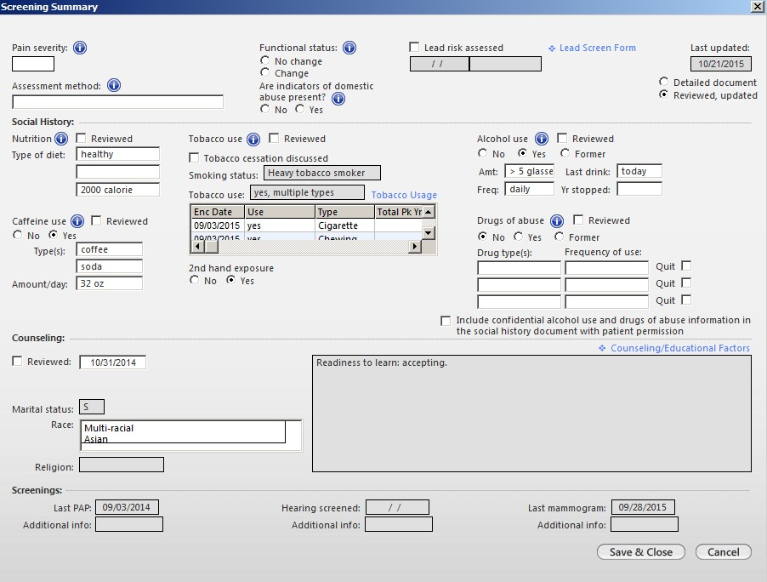

Record DV screen
DO NOT CHECK THIS BOX
Record Alcohol, Drug, and Tobacco Results but do not check box below

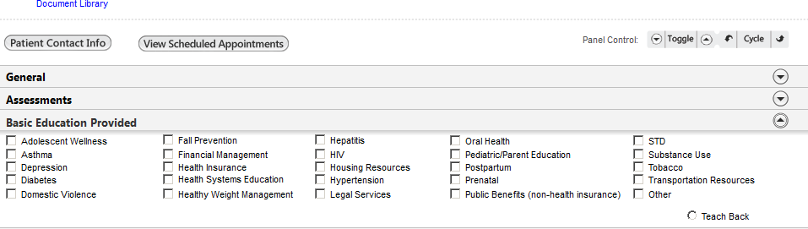
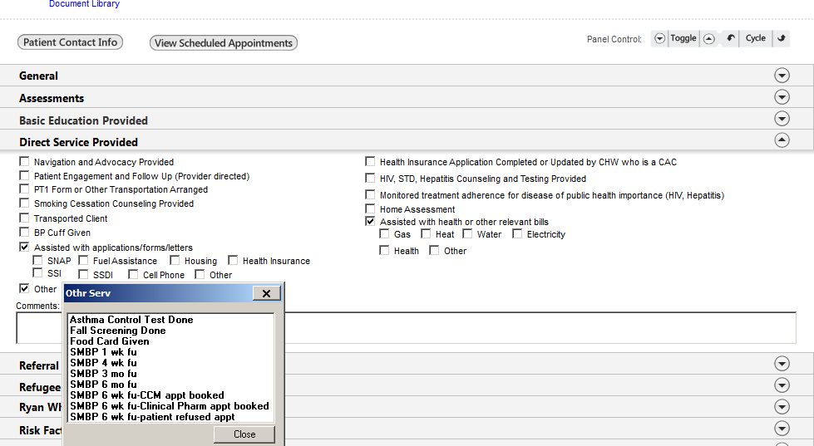

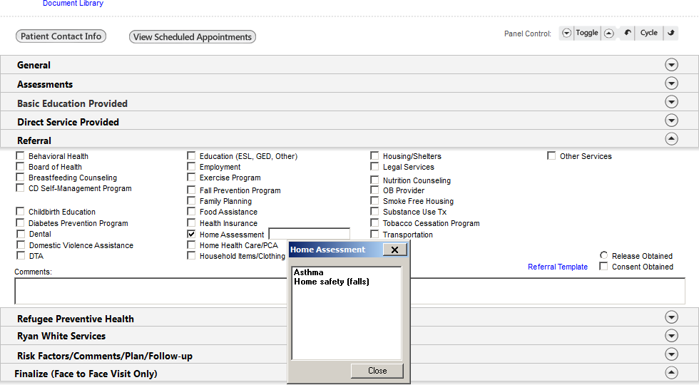
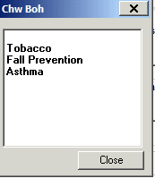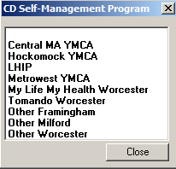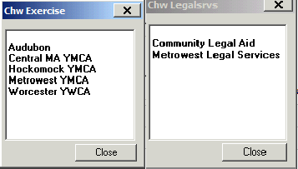

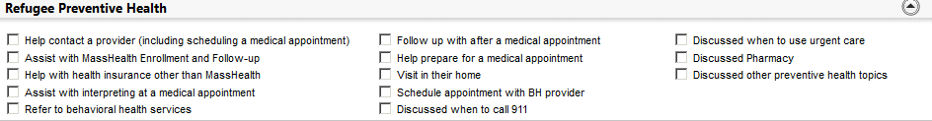

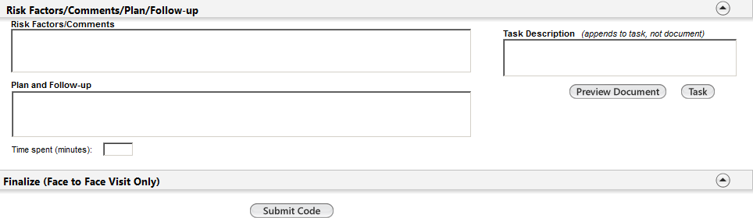

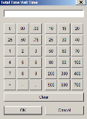

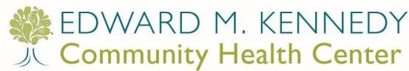

REV. 1/25/2017 ss
Objective: Demonstrate the process for CHW to document in NEXTGEN and CHW workflow. Orient CHWs to all required data entry points on the CHW-EMK template, telephone template, tasking, missed appointment and other templates that can be accessed through the CHW template (such as Psychosocial Assessment, PHQ, and Screening Summary template).
IMPORTANT INFORMATION:
- CHW documents in the EHR for both “Face to Face” and “Non-Face to Face” visits

- “Non-Face to Face” visits (such as Collateral, Telephone Contact with Patient, or Transported Client) should not be added to CHW schedule or checked in. The encounter is created by the user in the EHR.

- “Face to Face” visits must be on CHWs EPM schedule and checked in before documenting in EHR. The encounter is created in the EPM.

CHW may have a “Face to Face” Visit that is:
- Already in CHW schedule and checked in by a secretary
- Already in CHW schedule but has not been checked in by a secretary. In this case, the CHW needs to check in the patient in EPM before entering anything into the EHR.
- Not in the CHW schedule and has not been checked in by a secretary. In this case the CHW needs to go to the EPM, add the patient to his/her schedule and check in the patient in EPM before entering anything into the EHR

Always close notes ASAP or within 48 hours

CHW NEXTGEN TEMPLATE TRAINING AND WORKFLOW CHECKLIST
- Preparing to Document a “Face to Face” Visit
  - Find or Create an appointment in EPM/ Workflow/Check in
  - 4 Point Check / Selecting the Encounter and Template/ Verifying First Consultant Field
- Preparing to Document a “Non-Face to Face” Contact
  - Manual Patient Lookup in EHR/Create new EHR encounter
  - 4 Point Check / Selecting the Encounter and Template
- Documenting in the CHW-EMK Template
  - CHW Name
  - Type of Contact
  - Special Outreach Projects
  - Counseling Details-to document interpreter used
  - View at top of Template- documents library, patient contact info and scheduled appointments
  - Psychosocial Assessment- including Part 1, Part 2 (PHQ and Screening Summary and Stress Assessment) and Extra Assessment for PN/PP and “i” buttons
  - Basic Education Provided- pick from list or choose other if topic is not on list and write in topic
  - Direct Services- including extra check boxes for specific services (assisted with application/forms/letters: assisted with health or other relevant bills) and picklist under “other”.
  - Referrals- checkboxes and 5 items include picklists if relevant; Release Obtained (for all sites), Consent Obtained/Referral Template (for PWTF sites that have been trained on using electronic referral).
  - Refugee Preventive Health- grant specific staff only
  - Ryan White Services- grant specific staff only
  - Risk Factors/Comments, Plan/Follow Up- including task description, preview document and task buttons
  - Preview Document and Save
  - Document Time Spent
  - Submit Code for “face to face” only contacts
- Changing Encounter Description
  - Customize Preferences
  - Adding encounter description/remark
- OB Documentation
  - If abnormal/positives from psychosocial assessment, document summary in risk factors and task to OB provider if onsite.
  - Update encounter description/remark to read CHW OB New or CHW OB Follow up
- Telephone Template
  - Communicating with other staff when you want a reply
  - Documenting unsuccessful calls (no answer, left message, line busy)
- Managing Tasks
  - Sending Tasks when sending FYI information only
  - Receiving Tasks
- Missed Appointment Template
- Documenting Missed Appointments
- Patient checked in but left without being seen
  - Do not open a template, send email to billing
  - If patient did not reschedule, contact patient by phone

Preparing to document “Face to Face” Visits
Make sure the patient has an appointment in EPM and is checked in. Find the appointment in your EHR workflow inbox.
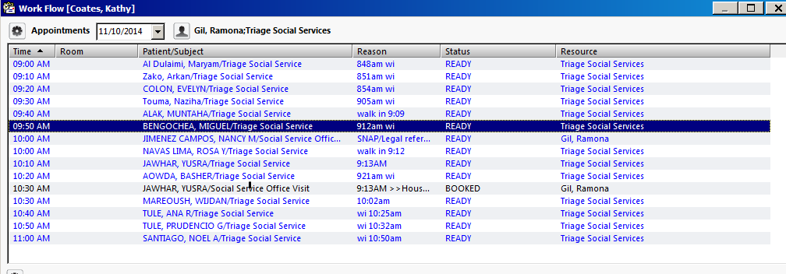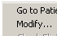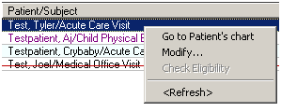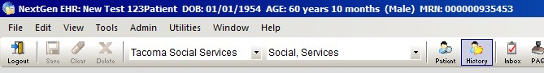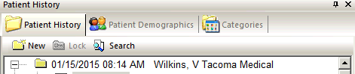
4- Point Check! PATIENT LOCATION PROVIDER ENCOUNTER
4 - Point Check
Name
here

Select the template that you will use

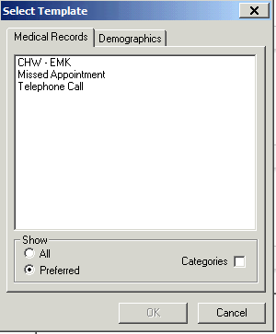

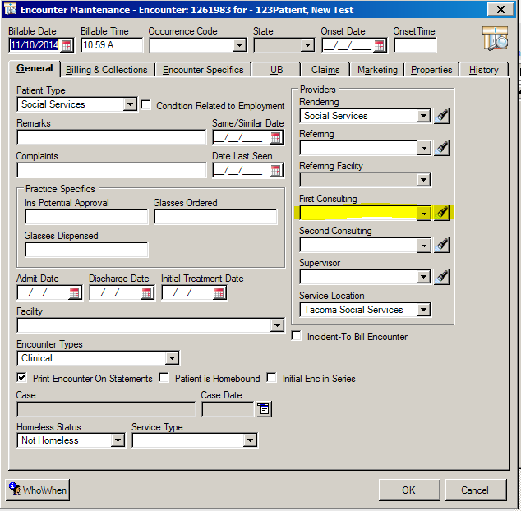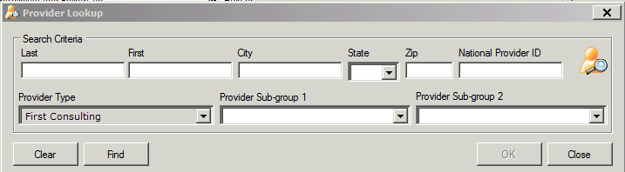All “Face to Face” encounters must have the CHW name entered as First Consultant so that the visit productivity report is accurate. This should have been done when patient was checked in but you can check this by going to “encounter properties”. To see encounter properties, right click on your encounter and select properties. Select your name in First Consultant field by selecting the flashlight (next to first consultant field) and selecting you name if it has not been entered.
Right click on your encounter and select properties
Name
here

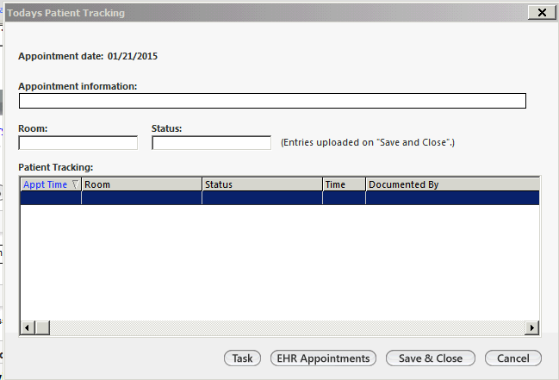

Tracking Button on INFO Bar- this let’s everyone know where you are and status of your visit.
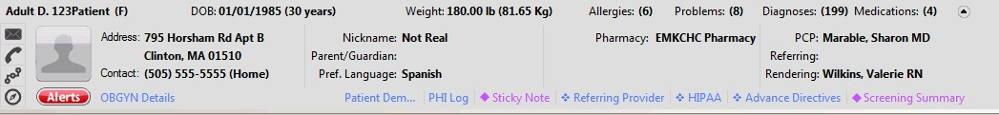

Tracking Button

Dropdown when you click on Status under tracking

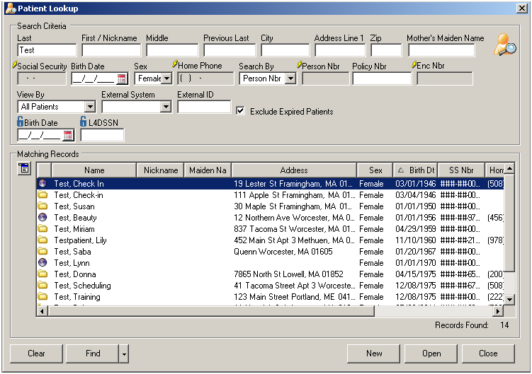
4- Point Check! PATIENT LOCATION PROVIDER ENCOUNTER
4 -
Point
2. Preparing to document a “Non-Face to Face” Contact (such as Collateral,

Create Encounter for Non-Face to Face in EHR not EPM. Manual Patient Lookup in EHR:
Telephone Contact with Patient, or Transported Client):
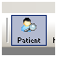
Search for patient and open patient to create encounter in EHR for non-face to face contacts only.

4 Point Check

Create New Encounter in EHR or non-face to face contacts

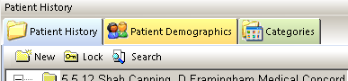

As part of your 4 point check, be sure the encounter is correct
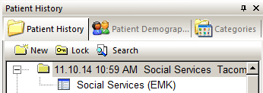
Select Template

CHW-EMK Template for “Face to Face” and “Non-Face to Face” Visits

CHW: CHW will select their name from dropdown list

List of CHW Names are included as dropdown here

    - Type of Contact: Select the appropriate contact type from the drop down menu
      - Face to Face – Home Visit – CHW goes to patient home and meet/interact with them.
      - Face to Face- Asthma Home Visit 1- 1st HV as part of PWTF program
      - Face to Face- Asthma Home Visit 2- 2nd HV as part of PWTF program
      - Face to Face- Asthma Home Visit 3- 3rd HV as part of PWTF program
      - Face to Face- Asthma Home Visit 4- 4th HV as part of PWTF program
      - Face to Face – Integrated Visit/Warm Handoff – Provider introduces patient and/or connects patient to the CHW while patient is in the building.
      - Face to Face – Outreach Community – Visit with patient in a community setting (such as jail).
      - Face to Face – Scheduled Visit – Scheduled appointment for patient to be seen.
      - Face to Face – Triage/Walk In – Patient walks in without a scheduled appointment.
      - THERE ARE 3 types of NON-FACE TO FACE contacts under “Type of Contact” dropdown The
encounter is created in the EHR (not EPM) because this is not a “face to face” visit, do not Submit
Code, just preview and save encounter when you complete documentation. The 3 types of non-face to
face encounters include:
        - Telephone Contact with Patient - CHW speaks with the patient over the phone. DO NOT DOCUMENT in the CHW Template if you left a message or were unable to speak with the patient. If you want to document when you left a message or you were unable to reach the patient, use the telephone template not the CHW template.
        - Transported Client – CHW provides transportation to a patient. If you transported a client but also felt that you did a face to face visit while in the car, choose face to face visit above and

document what you discussed and include documentation of “transported client” under direct services.
        - Collateral – Any action done on behalf of patient by the CHW without their presence (such as coordinating services with another agency)

Special Outreach Projects- document if you make contact with a patient from a list which is part of a population based special outreach project such as a list of patients who are chronic no shows or who are not up to date with their well child visits.

    - Counseling Details- document if you worked with an interpreter during the visit. Only document interpreter information in this template, not other fields. Under interpreter name- put name of onsite interpreter or phone interpreter ID code.

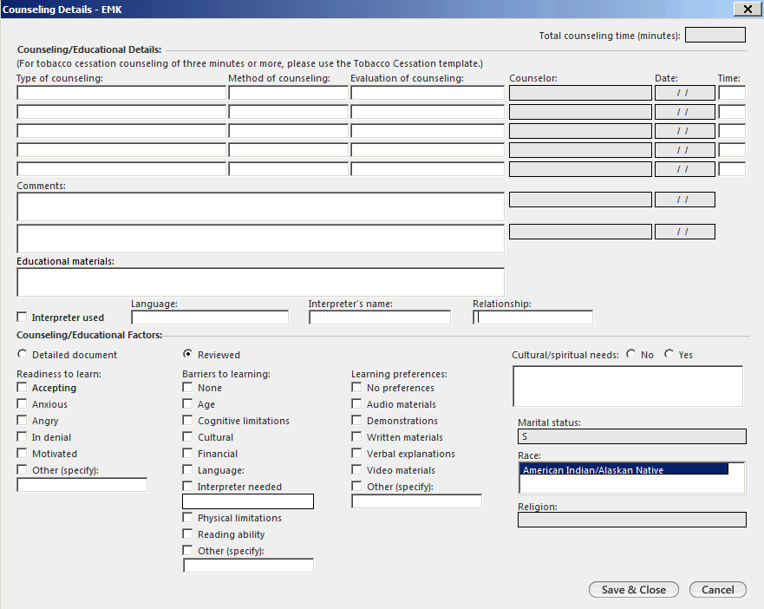

    - FYI- In top of the CHW template you can see:
      - Document Library button - standard utility letters and other documents can be found here
      - Patient Contact information button
      - View Scheduled Appointments button

    - Assessments: Psychosocial Assessment- including PHQ and screening summary for DV, tobacco, alcohol, and drugs. Always try to complete the full psychosocial assessment (per psychosocial assessment protocol) and address issues briefly as you ask the questions and then go back to provide the complete information. If assessment cannot be completed in one visit, request to schedule f/u visit with patient. Complete the PHQ and screening summary if patient was not seen in medical on the same day as your visit. Preview and save document.

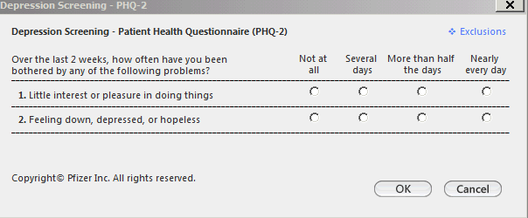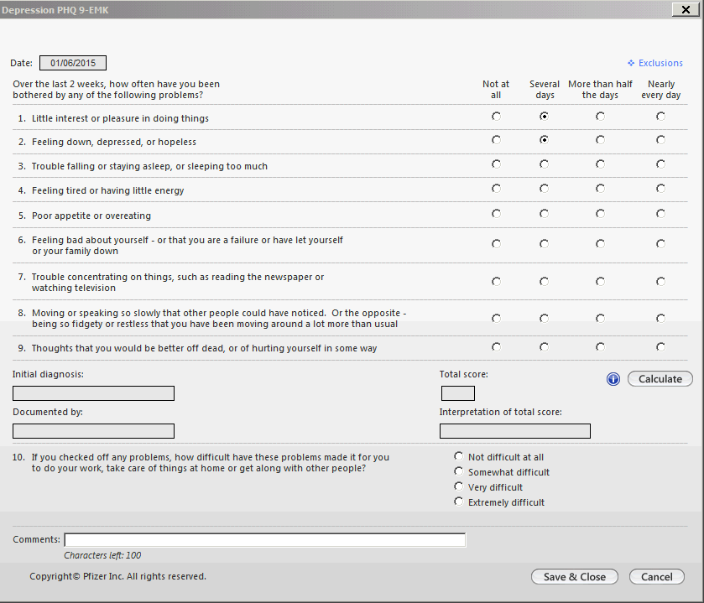PHQ-2 and PHQ-9 questions can be accessed through the psychosocial screening tool.

“Screening Summary” can be accessed through the psychosocial screening tool in the CHW template- document results of questions about domestic violence, tobacco, alcohol and drugs in the screening summary
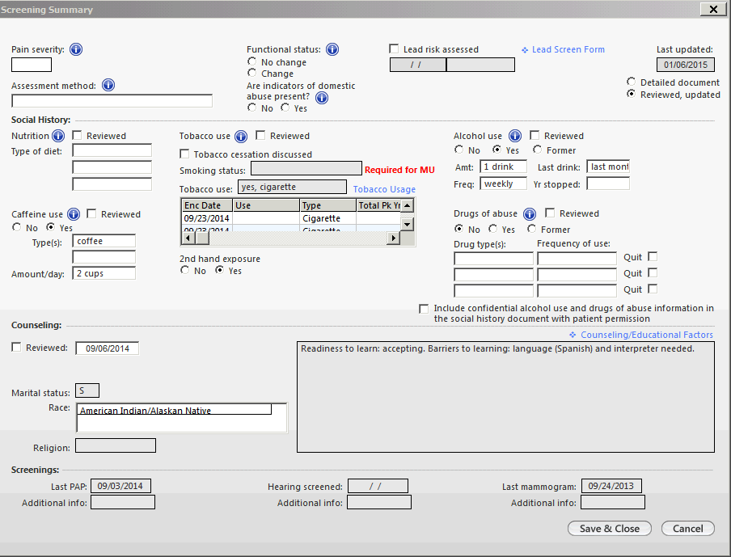
DO NOT CHECK THIS BOX

    - 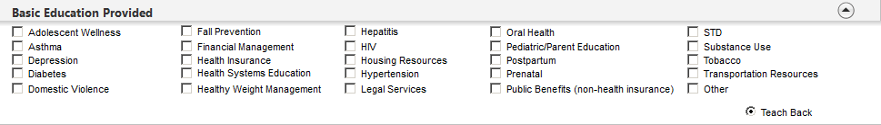Basic Education Provided- select topic and select “teach back” if you used “teach back” when providing education. If you provide education on another topic, check “other” and type.

    - Direct Services Provided- select all direct services you provided. Use check boxes for “assisted with applications/forms/letters” and “assisted with health or other relevant bills”. Use
dropdown list under “other” to document “other services such as asthma control test done, fall screening done, food card given, SMBP… Make comments in the direct services “comments box “ if needed (BP cuff serial # or dates of appointments made for other providers…).

    - Referrals- select all referrals. Make referral comments in box if needed. Use picklist if you refer to CD self-management program, exercise, board of health, legal services or home assessment. Always obtain a release prior to sharing any patient information with referral agencies and then, click “release obtained”. Consent Obtained/Referral Template is only used by PWTF CHWs that have been trained on using the electronic referral system.
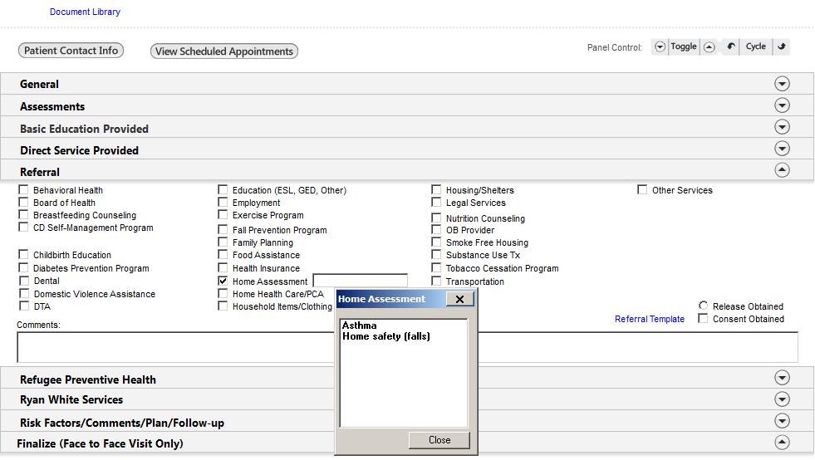

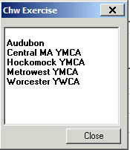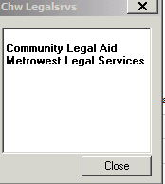

Refugee Preventive Health- grant specific staff only
    - Ryan White Services- grant specific staff only
    - Risk Factors/Comments and Plan/Follow Up: includes task description and task button, and preview document which creates the document. Include risk factors related to social determinates of health such as homeless, food insecurity, domestic violence.

- Task Description- Use to write a note you want to task to another staff member as FYI, do not use tasking if you want to get a response. This information will not populate onto the document, it will display in the template and in the task box if a task is sent. NEVER decline a TASK (see training on tasking and telephone template). If you open a task you may reassign or close the window but do not DECLINE a task or it will disappear from the list and no one else can pick it up.

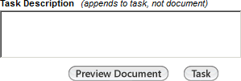

- Add time spent in minutes. Type minutes spent or select number of minutes (this is not a calculator). Include time for face to face and non-face to face encounters.
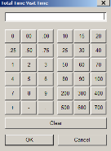

- After you finish your documentation, select: Preview Document and Save to create the document. You can then send a task and attach your document if needed.
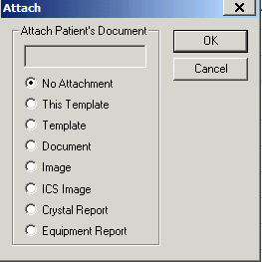

Finalize:
      - Submit Code: Select only for Face to Face visit. Submit non-billable charge code (SOCSV) for the encounter. DO NOT Submit Code for Non-Face to Face Visits such as Collateral, Telephone Contact with Patient, or Transported Client.

Select tracking button on info bar so you and others know where you are in the process with this patient.

After you document in NEXTGEN, change the encounter description by right
clicking on the folder and clicking “encounter description/remark”:
- If you did not set up your encounter description preferences during your initial training:
  - Right click on the encounter description to customize display (you only need to do this once)
  - Customize display in the following order: date, time, remarks, location, provider
- After completing your template and creating a document, right click on folder and click “encounter description/remark” to update the remark:
  - Under remarks put description (phone, missed appt, CHW OB New, CHW OB Follow Up, Food Card Given, PT1 or other short descript of visit , then your last name, and first initial) and then click on the refresh button.

OB documentation when OB care is provided onsite
- If problems have been identified on psychosocial assessment, summarize positive (abnormal) results under “risk factors” and create plan in CHW-EMK template. If

there are positive (abnormal) results, task the document to the OB provider (this may not be the PCP, it is the provider that is seeing the patient for OB care).
- Change “encounter description remarks” to: CHW OB New or CHW OB Follow-Up and then your last name followed by first initial

“Telephone Template” to communicate with other staff when you need a reply
- When leaving a message on the phone, always leave your name and contact phone at the beginning and end of each message.
- This template is saved in the patients record
- Document here if you want medical staff to see information about your call or to communicate with provider
- Document here if there was an unsuccessful call for a special outreach project, for call reason, choose “special outreach project”

For successful phone calls always document in CHW-EMK template, under contact type check “telephone call” if call was to patient or check collateral if it was a collateral contact. If you also did a telephone template because you wanted a reply, write “see telephone template from (date) for details”. Remember you must document successful phone calls in your CHW-EMK template and you have the option to document in a second place (the telephone template) if you need to communicate with another staff member. Do not document phone calls where you do not speak with the patient (left message, could not reach, busy….) in the CHW- EMK template.

  - Managing Tasks - to communicate with other staff as FYI, not to get a response
- You can send a task or use the phone template to send a message to a provider. A task is just a FYI message; use the phone template if you want a reply.
- Only task document when it is critical that the provider reviews your note.
- You can send a task from task feature or directly from your CHW-EMK template.
- Set up preferences for your display (view all tasks or only those open, pending...)
- Set up “permeant delegate” to manage your tasks when you are away- check with supervisor prior to assigning a delegate.
- Once you open a Task, NEVER DECLINE a task. See training document on tasking and phone template- CHW Telephone Call Templates and Tasking VW.pptx

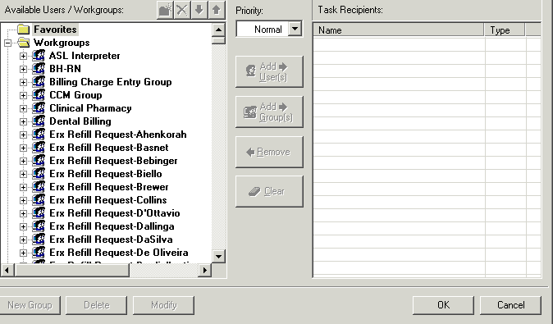

Missed Appointment template
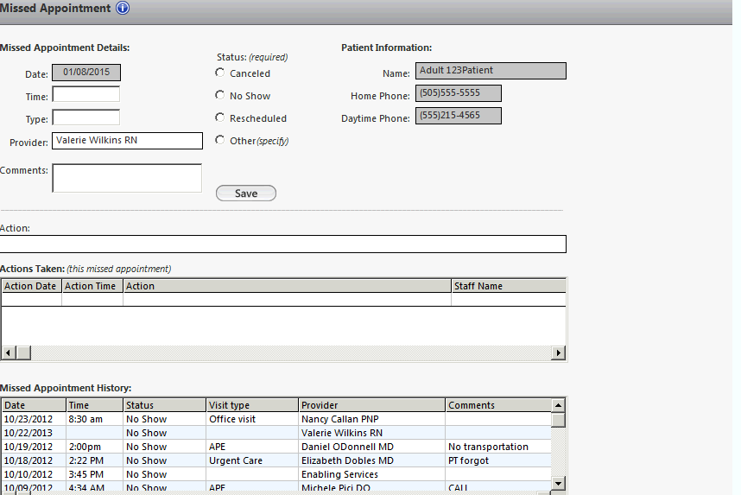

  - Patient checked in but left without being seen
- Do not open a template, send email to billing department and cc supervisor. Include the following information: medical record #, date of service and reason why encounter needs to be deleted.
- If patient did not reschedule, contact patient by phone

Attachments 5A, 5B, 5C

CHW Psychosocial Assessment Template and Procedures

Assessment Part 2- Patient Health Questionnaire (PHQ-2) Screenshot

Assessment Part 2 Screening Summary Screenshot

Record Alcohol and Drug Results but do not check box below questions
DO NOT CHECK THIS BOX
Record DV screen

INTRO  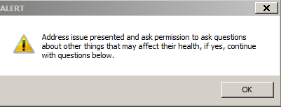 | QUESTION 1  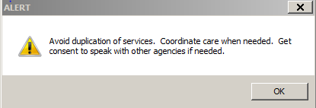
QUESTION 2  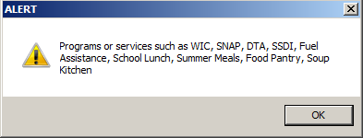 | QUESTION 3  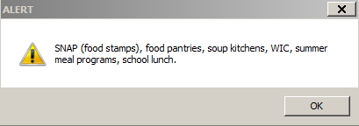

QUESTION 4  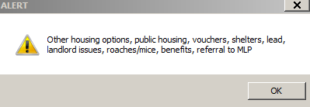 | QUESTION 5  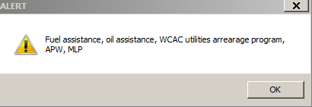
QUESTION 6  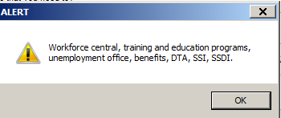 | QUESTION 7  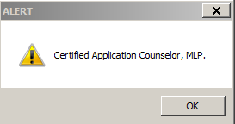
QUESTION 8  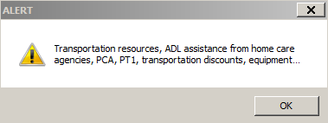 | QUESTION 9  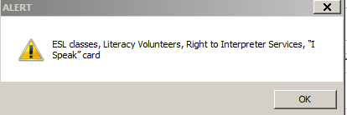
QUESTION 10  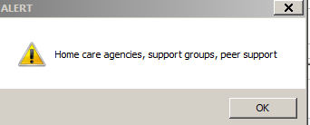 | QUESTION 11  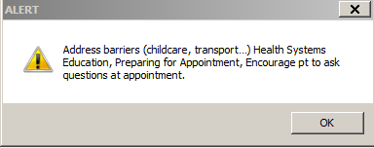
QUESTION 12  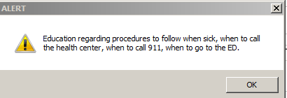 | QUESTION 13  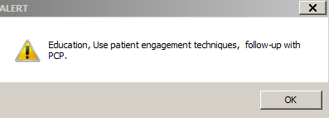

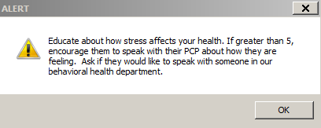

ASSESSMENT PART 2-PHQ2-PHQ9 Link-Depression Screening Question  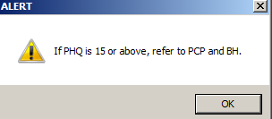 | ASSESSMENT PART 2- Screening Summary Questions- Drugs/Alcohol and DV  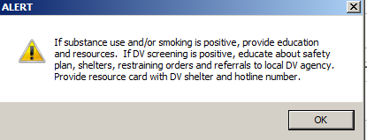
ASSESSMENT PART 2-Stress Question | PN/PP 1st TM QUESTION # 1.  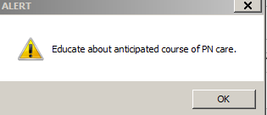
PN/PP 1st TM QUESTION #2  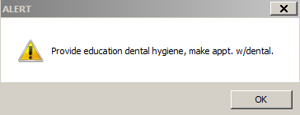 | PN/PP 1st TM QUESTION #3
PN/PP 3rd TM QUESTION #1  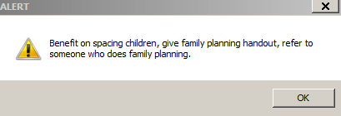 | PN/PP 3rd TM QUESTION #2  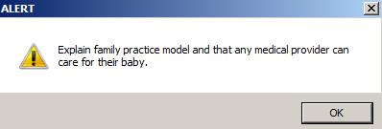
PN/PP 3rd TM QUESTION #3  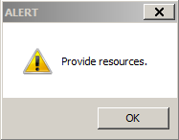 | PN/PP 3rd TM QUESTION #4  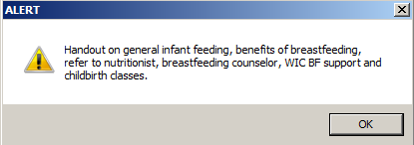

Psychosocial Assessment Procedures rev 1/25/2017

These guidelines were created by Edward M. Kennedy Community Health Center (Kennedy CHC). These guidelines may have compliance and organizational insurance implications for your organization which should investigated before adapting this policy to meet your organizational needs.

Purpose of the Psychosocial Assessment
The purpose of a psychosocial assessment is to gather data to better understand the psychosocial factors in the patient’s life that may impact his/her ability to achieve good health and well-being. The psychosocial assessment gives a fuller picture of the patient’s needs and strengths. The data gathered from the psychosocial assessment facilitates the development of a treatment plan that is holistic, addressing not only the physical aspects of care, but the social determinants of health as well.

Community Health Workers (CHW), by the nature of their role on the health care team, are particularly well-suited to engage patients in the psychosocial assessment process and to assist patients in connecting with resources to address areas of identified need.

The Psychosocial Assessment Process
The CHW psychosocial assessment is part of the CHW electronic record template. This assessment covers a number of important areas and includes the following: income and food security, housing issues, health insurance, screening for domestic violence, screening for alcohol/drug use.

Many times a referral to a CHW is made for a specific patient need, e.g. assistance with a housing issue, assistance in applying for SNAP (food stamps) or accessing a food pantry, or transportation. In these circumstances, a full psychosocial assessment may not be warranted, but parts of the psychosocial assessment that are relevant to the issue for which the patient was referred may help to identify other areas where the patient may be offered assistance. For example, a patient who is referred for SNAP (food stamps) because he/she does not have adequate resources to buy food may also be having difficulty paying rent or utility bills, and could be provided with appropriate assistance in these areas.

There may be times when a full psychosocial assessment may be recommended such as:

- For a prenatal patient
- For a new patient of the health center as part of the new patient process
- For a patient who is released from the correctional system and is connecting to primary care
- For a patient who is being followed for chronic disease management or other ongoing issues
- By provider referral
We help people live healthier lives.

Page 2 of 2

Addressing Psychosocial Issues—Referral to Community Resources
The psychosocial assessment may identify areas where there are opportunities to provide direct assistance (in the form of arranging transportation, completing applications, etc.) as well as referrals to other resources in the community.

In the Kennedy CHC I: drive under Operations, there is a CHW Resource Folder for all sites. There are also CHW Resource subfolders that are site specific for Milford, Framingham and Worcester. Information that is relevant for all sites is located under the main CHW Resource folder and items that are site specific are in the site specific folders. CHW supervisors will collect resources from CHW staff on an ongoing basis so this folder stays up to date. We will collect all information needed that could be helpful for CHWs to address items identified on the psychosocial assessment. Referrals to community agencies follow the specific procedures of the referral organization. Consent must be obtained from the patient in order to provide information to the community agency.

It is the responsibility of the CHW to assess whether the patient was able to connect with the community resources and to assist the patient if there are any barriers in making these connections.

Documentation
CHWs will document the assessment results in the psychosocial assessment. All identified areas of need, along with plans to address needs and specific referrals made to community resources, will also be documented in the CHW Template in the electronic health record.

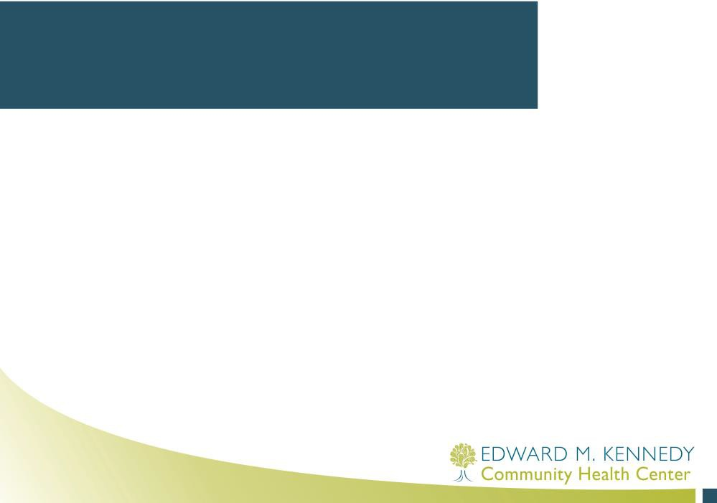
Training on Psychosocial Assessment Tools and Procedures for CHWs at Kennedy CHC
rev 5_11_2015

Why do we use a psychosocial assessment tool?
- To gather data to better understand factors in a patient’s life that may impact his/her ability to achieve good health and well- being.
- Give a fuller picture of patient’s needs and strengths.
- Develop a plan that is holistic, addressing not only physical aspects of care but also social determinants of health.

Social Determinants of Health (from Healthy People 2020)

- Economic Stability
  - Poverty
  - Employment Status
  - Access to Employment
  - Housing Stability (e.g., homelessness, foreclosure)
- Education
  - High School Graduation Rates
  - School Policies that Support Health Promotion
  - School Environments that are Safe and Conducive to Learning
  - Enrollment in Higher Education
- Social and Community Context
  - Family Structure
  - Social Cohesion
  - Perceptions of Discrimination and Equity
  - Civic Participation
  - Incarceration/Institutionalization
- Health and Health Care
  - Access to Health services—including clinical and preventive care
  - Access to Primary Care—including community-based health promotion and wellness programs
  - Health Technology
- Neighborhood and Build Environment
  - Quality of Housing
  - Crime and Violence
  - Environmental Conditions
  - Access to Healthy Foods

Psychosocial Assessment Tool
- Use as a guide for the assessment process.
- Full psychosocial assessment may of may not be used every time you see a patient
- Recommend doing full psychosocial assessment for:
  - Prenatal Patient
  - New Patient
  - Patient released from correctional system who we are connecting to primary care
  - Patient followed for chronic disease management or other ongoing issues
  - Patient referred by provider
  - Other patients

Psychosocial Assessment Tool
- Linking to community resources or providing direct assistance- I: drive- Operations- CHW All Sites- NEXTGEN-Documentation-Assessment- Communication with Staff folder
- Documentation:
  - Document in the CHW-EMK template psychosocial assessment tool section
  - List risks and plan in Risk Factors/Comments and Plan/Follow up section of the CHW-EMK template

ACTIVITY
- Practice using tool with a partner. One person will be the client and the other will be the CHW. CHW will ask all questions as stated on the tool and record answers. Switch roles when you are done so each CHW has a chance to ask all the questions.
- Importance of asking permission.
- Look at resources for each question. Do not provide resources during the activity, just go through the list of questions and look at the resources in the last column.
– If you do not feel you have access to these resources or other needed resources to address the issue, circle the number next to the question.

NEXT STEPS
Sharing Resources

Attachment 6

CHW-Clinical Staff Communication Procedures

Community Health Worker and Clinical Staff Communication Procedures
rev 1/13/2015
Page 1 of 1

These guidelines were created by Edward M. Kennedy Community Health Center (Kennedy CHC). These guidelines may have compliance and organizational insurance implications for your organization which should investigated before adapting this policy to meet your organizational needs.

Purpose of the CHW-Clinical Staff Communication Procedures
The purpose of the Communication Procedures is to clarify communication options between CHWs and Clinical Staff.
There are 5 major ways that CHWs and Clinical Staff communicate:

Connect to the CHW or clinical staff on the floor or in their office
- Phone calls to clinical staff or CHWs
- Telephone Template (with or without an attached document)
- Sending a Task (with or without an attached document)
- Email

Different communication methods may be used for different needs.
If communication needs to go into the patients chart, it is important to document the message in the telephone template.

Here is a description of the 5 ways to communicate between CHWs and Clinical Staff:

Connect to the CHW or clinical staff on the floor or in their office. Clinical staff can do a “warm hand-off” to connect the patient to the CHW.
  - If the CHW is free to see the patient, the CHW will see the patient at that time.
  - If the CHW is busy with other patients, the CHW may only have time for a quick introduction and the clinical staff may request a CHW appointment and “task” the request to the CHW or the CHW may meet briefly with the patient to schedule a future appointment.
- Call clinical staff or CHWs extension. CHW extensions are in the employee PORTAL. At TACOMA and in FRAMINGHAM, there is a call cue so if the clinical staff need CHW services, they can call the cue number. If staff needs to reach an individual CHW, they can call an individual extension. Clinical staff are encouraged to see if there is a CHW on the floor before calling the cue.
- Send a message through the Telephone Template. This documentation will become part of the patients chart. Once the template is completed, it may be sent as a task to the CHW or clinical staff. Use the telephone template if you would like a response back from the CHW or clinical staff.
- Send a task. Tasks can be used to provide information to other staff. A document can be attached if you want the other staff member to read your note. The task feature should be used as FYI only. If you would like a response back, use the telephone template.
- Email may be used for internal communication but is generally not recommended as staff may have many emails in their mailbox and may miss an important communication about the patient. This type of communication should not be used if you need a quick response.

Attachment 7

Interpreter Services Guidelines for CHWs

Interpreter Services Guidelines for CHWs
rev 4_7_2016
Page 1 of 2

These guidelines were created by Edward M. Kennedy Community Health Center (Kennedy CHC). These guidelines may have compliance and organizational insurance implications for your organization which should investigated before adapting this policy to meet your organizational needs.

At Kennedy CHC we have an on-site team of Professional Medical Interpreters supported by our OPI (Over-the-phone) interpreters. Together, they provide language services for patients who speak 90 different languages.

Professional Medical Interpreters are critical for Patient Safety. Our team of on-site interpreters is our first choice; however, if they are not available you can call one of the OPI services providers.

Our Deaf and Hard of Hearing Patients are assisted by American Sign Language (ASL) and/or Certified Deaf Interpreters (CDI). These interpreters are provided through our Language Services vendors. Bookings are processed through our Interpreter Services Department and a 2 week notice is requested, if possible.

Please review the language services procedures including “How to access OPI” and “ASL and Rare Languages Procedures” located in L:\Cultural & Language Services\Language Services

Our interpreters do not interpret word-for-word, they interpret for meaning. Depending on the language, interpretation may be longer or shorter than you expect. Interpreters also act as cultural brokers. S/he may ask you for permission to explain something to you about the patient’s culture, and may provide advice about how to rephrase the question or make you aware of culturally sensitive information and how to better convey a message to a patient.

Tips for working with Interpreters
- Always look at the patient (not the interpreter) when you or the interpreter are speaking.
- Use simple language and short sentences.
- Pause after a full thought for interpretation to be accurate and complete.
- Avoid asking multiple questions without breaks.
- Speak in the first person rather than asking the interpreter to tell something to the patient.
- Remember that everything you said will be interpreted.
- Use “teach back” to confirm patient understanding.
- Repeat yourself in different words if your message is not understood.

Important things you need to know
- Patients have the right to use or refuse a professional medical interpreter.
- Patients can refuse a medical interpreter by signing an Interpreter waiver/refusal form.
We help people live healthier lives.

Page 2 of 2

- At EMKCHC we have translated waiver forms into our main languages.
- Interpreters have copies of these forms and they are also available in the library.
- If you work with an interpreter during a visit, enter all interpreters’ information in the patient’s electronic medical record (EHR). Go to “Counseling Details”, check the box- "interpreter used", select "language", "interpreter name" (select the name of the onsite interpreter or enter the phone interpreter ID code) and select "relationship" from the dropdown list. CHWs only document interpreter information in this template, do not document in the other fields in this template.

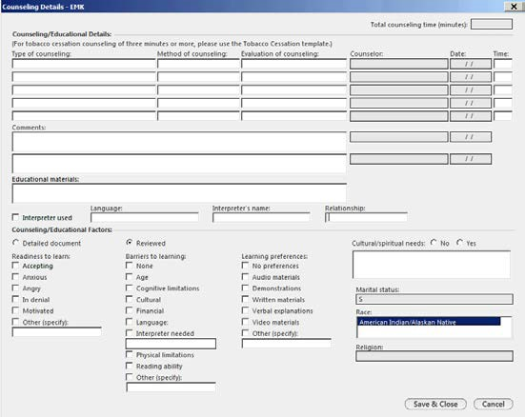

Attachment 8

Encouraging Patients to Ask Questions

Encouraging Patients to Ask Questions
Help patients engage in their care by encouraging patients to ask questions. Adapted from Right Question Institute http://rightquestion.org/healthcare/ and http://www.ahrq.gov/professionals/quality-patient-safety/patient-family- engagement/index.html

View the following video on the importance of patients asking questions http://www.ahrq.gov/patients-consumers/patient-involvement/ask-your- doctor/videos/waitroom/index.html

Why encourage patients to ask questions?
- Studies show that patients who ask questions become more engaged in their health, are more likely to follow up on treatment plans, focus on decisions to be made and are better able to navigate the health care system.
- Motivational Interviewing also engages patients but the “asking questions” is in the hands of the provider, not the patient. It is important that patients also learn to ask questions.

What to do?
- Work with patients to develop their ability to ask questions on a specific topic (such as selecting a PCP, finding housing, managing their illness)
  - Ask patients what is bothering them and what they want to know. Ask the patient to create a list of questions. If the patient is not sure what they would want to ask, give them some examples of the types of questions they could ask such as:
    - Why do I need this treatment?
    - When will I get the results?
    - Are there any side effects?
    - What are the possible complications?
    - Are there any alternatives to this treatment?
  - Ask patient’s to write their questions (or CHW can assist with writing) .
  - Ask patient to prioritize their most important questions with a
  - Discuss the difference between closed-ended questions (that can be answered yes or no) and open ended questions (that need an explanation). Ask patients to change questions depending on what information they would like to get.
  - Encourage the patient to think of questions they have before each medical appointment and bring the questions to their appointment.
  - Ask the patient what questions they have for you.

Attachment 9 (A, B, C, D)

Motivational Interviewing

CHW Training Session
Motivational Interviewing

Objectives
- Review Motivational Interviewing (MI) Techniques
- Practice MI!

Introduction
- Think about a behavior you have either changed or wanted to change
- Think about barriers to change
- Who has supported you in making changes?
- What works? What doesn’t work?
- When we talk to patients about change, they experience these same feelings!

Why MI?
- So why do we use motivational interviewing?
- Studies show that it works!

Asking Permission
- By asking permission to talk about these topics with patients, we are showing respect
- Patients are more likely to discuss changing when asked, rather than being lectured or told to change
  - I noticed on your medical history that you have hypertension, do mind if we talk about how different lifestyles affect hypertension?
  - Is it okay with you if we discuss [behavior] today?

Core Skills of MI
- Open-ended questions
- Affirmations (Acknowledge the positives!)
- Reflections (Let the patient know we are listening)
- Summary

Open-ended Questions
- Imagine you want to make a dessert for your friend on her birthday and you ask “do you like cake?” (CLOSED)
- What if your friend likes cake, but really
LOVES brownies? How would you know?
- “Can you tell me about the kinds of desserts you like?” (OPEN)

Open-ended Questions
- We want to use the same technique with patients.
  - Can you tell me about [behavior]?
  - What do you like/dislike about [behavior]?

Affirmations
- Often with behavior change, people will struggle.
- The goal is to motivate the patient to change!

Affirmations
- Therefore, we want to acknowledge the positive in the patient’s life.
  - I am very proud of you for coming here today; it isn’t easy to talk about this.
  - It is very courageous of you to talk about this with me today.

Reflections
- Reflecting back what the patient has told us lets him/her know we are listening and trying to understand what he/she is saying.
  - It sounds like you are thinking about changing
[behavior] but are worried about .
  - You are feeling because .
  - So you like [behavior], but know that causes
and are thinking about change.

Affirmations &Reflections
- MODERN FAMILY VIDEO
https://www.youtube.com/watch?v=7hFAv8z 8xmw

Summarize and Teach Back
- Summarizing what the patient has said can create closure and make sure you and the patient are on the same page.
  - I just want to be sure that the plan we’ve created is clear. Can you tell me what you are concerned about and what you are willing to try?
  - Great, so just to summarize, you are willing to
.

Other Tools
- Assess importance and confidence.
  - Find a balance between the importance in making a change and the patient’s confidence to make that change.
  - Resist the urge to order or command the patient to change! If they are not comfortable making that change, ask about why they are not sure and work in smaller steps.

Other Tools
- Looking Back
  - Ask patient to reflect on past successes and what has worked
- Looking Forward
  - Ask patient to think about hopes for the future if they make this change
  - Talk about realistic options for change now
- Explore Goals
  - Make sure goals are realistic!

Motivational Interview Steps
- Set an Agenda
  - Ask the patient if he/she is ready or willing to talk about the target behavior
- Ask about the behavior
  - The positives, the negatives, what they know about the behavior, etc.
- Explore goals
- Ask for a decision
  - What is the patient ready or not ready to try?

(TBD)Motivational Interview
- We will now watch this in action
- Pay attention to the interview and look specifically for the use of OARS
- What do you anticipate will be especially
challenging?
- www.youtube.com/embed/DmNBOVykeoM
?rel=0

Practice!
- As with many things, motivational interviewing takes practice. It is hard to resist the urge to lecture a patient that he or she ought to change!
- We will now go through various scenarios to practice these skills!

WHAT QUESTIONS DO YOU HAVE?

Motivational Interviewing (MI) CHW Role Playing Scenarios
Below are three scenarios. In pairs, you will decide who will be the CHW and who will be the patient. (This can be done in groups of 3 where the third person observes and at the end of the mock visit, offers feedback to the CHW). Each person will read the description next to your role. Once you have completed your scenario, switch roles and practice with another scenario.
- CHWs will utilize the skills discussed during MI training. Keep in mind that what you consider the “right” choice may not be the “right” choice for your patient at this time.
- CHWs that play the role of patient will play in character! Imagine how a real patient may react. Consider the anxiety around making changes and some of the other barriers that may stand in the way (for example, the social determinants of health!)

Scenario 1:
- CHW: Jane, a 32 year old woman and her 8 year old son, John, are referred to a CHW by John’s physician. John has asthma that appears to be poorly controlled and it is discovered that his mother smokes. Despite the providers ongoing discussions about the effects of smoking on her sons asthma, no changes have been made.
- PATIENT: Jane has smoked since she was in high school. She was able to quit while she was pregnant with John, but the stress of work and parenting have made it even harder to quit again. When she quit while pregnant, she stopped “cold turkey” but started shortly after John was born. She currently smokes inside the home and knows second hand smoke can affect John’s asthma, but is certain right now is not the time to quit. She would like to see John’s asthma get better.

Scenario 2:
- CHW: Robert is a 45 year old man who hasn’t come to the health center for a physical exam in years. He has made and kept a few sick visits, where it is discovered that he has hypertension. He misses a lot of his visits. Robert’s physician refers him to a CHW to discuss the importance of regular check ups, especially given his hypertension.
- Patient: Robert tries to avoid doctor’s appointments as best as he can. In the past he has had issues with insurance and doesn’t want to deal with the headache of receiving bills. Currently, he has insurance, but still doesn’t think hypertension is a “big deal.” He believes going to the doctor is a waste of time and money.

Scenario 3:
- CHW: Mary is a 40 year old woman who is morbidly obese. Her physician describes her as “non-compliant” as she refuses to exercise and eat healthy. She is referred by her physician to a CHW to address her non-compliance after missing multiple appointments with a nutritionist.
- Patient: Mary has always struggled with her weight and has tried in the past to get more exercise and eat right. More recently, she has been out of work and has little confidence that she can make changes to her exercise and eating habits due to her tighter budget. She states she feels unsafe exercising around her home but cannot afford a gym membership. Likewise she insists healthy food is too expensive. Regardless, she thinks she knows how to eat healthy and is unsure if she needs to meet with a nutritionist.

Motivational Interviewing Session-EXAMPLE:

- Set the Agenda – Find the Target Behavior (e.g, using, smoking, exercising, no showing for appts., not coming for preventative care, etc.)
Clarify the agenda around a target behavior about which there is ambivalence. Try a series of special questions to help sort things out.

- Ask about the positive (good things) aspects of the target behavior. This is often an engaging surprise. However, it will only work if you are genuinely interested.
  - What are some of the good things about ?
  - People usually because there is something that has benefited them in some way. How has
benefited you?
  - What do you like about the effects of ?
⩥Summarize the positives

- Ask about the negative (less good things) aspects of the target behavior:
  - Can you tell me about the down side?
  - What are some aspects you are not so happy about?
  - What are some of the things you would not miss?
⩥ Summarize the negatives

- Explore life goals and values.
These goals will be the pivotal point against which cost and benefits are weighed.
  - What sorts of things are important to you?
  - What sort of person would you like to be?
  - If things worked out in the best possible way for you, what would you be doing a year from now?
⩥ Use affirmations to support “positive” goals and values.

- Ask for a decision.
Restate their dilemma or ambivalence then ask for a decision.
  - You were saying that you were trying to decide whether to continue or cut down…
  - After this discussion, are you more clear about what you would like to do?
  - So have you made a decision?

- Goal setting – Use SMART goals
(Specific, Measurable, Achievable, Relevant, Time Based)
  - What will be your next step?
  - What will you do in the next one or two days?
  - Have you ever done any of these things before to achieve this?
  - Who will be helping and supporting you?
  - On a scale of 1 to 10 what are the chances that you will do your next step? (anything under 7 and their goal may need to be more achievable). For health literacy you may want to describe 0-10 scale with a glass or beaker.

⩥ If no decision or decision is to continue the behavior.
  - If no decision, empathize with difficulty of ambivalence.
  - Ask if there is something else which would help them make a decision?
  - Ask if they have a plan to manage not making a decision?
  - Ask if they are interested in reducing some of the problems while they are making decision?
  - If decision is to continue the behavior, go back to explore the ambivalence.

Adapted from the work of WR Miller & S Rollnick. Adapted by Edward M. Kennedy Community Health Center from Initiation and Engagement of Alcohol and Other Drug Treatment: Module 2: Strategies for Approaching, Engaging and Motivating Clients, a MassHealth/UMass Medical School Curriculum for Community Health Workers developed by the Center for Health Impact, Inc.

Motivational Interviewing: Preparing People to Change Health Behaviors- TIP SHEET Five General Principles of Motivation Interviewing:
- Express Empathy (show that you care and are trying to understand the patient’s point of view)
- Develop Discrepancy (show the patient that the behavior and its outcomes don’t match the patient’s personal goals or ideals)
- Avoid Argumentation
- Roll With Resistance
- Support Self-Efficacy (one’s belief in their own abilities)

Responses that are NOT Reflective Listening:
- Ordering, directing, or commanding
- Warning or threatening
- Giving advice, making suggestions or providing solutions
- Persuading with logic, arguing, or lecturing
- Disagreeing, judging, criticizing, or blaming
- Agreeing, approving, or praising
- Shaming, ridiculing, or labeling
- Interpreting or analyzing
- Reassuring, sympathizing, or consoling
- Questioning or probing
- Withdrawing, distracting, humoring, or changing the subject

Assumptions to AVOID:
- This person OUGHT to change
- This person WANTS to change
- This person’s health is the prime motivating factor for him/her (it might not be!)
- If he or she does not decide to change, the consultation has failed
- Individuals are wither motivated to change or not
- Now is the right time to consider change
- A tough approach is always best
- I’m the expert – he/she must follow my advice
- A negotiation approach is always best

Signs of Resistance
    - Arguing

      - Challenging
      - Discounting
      - Hostility
    - Interrupting
      - Taking over
      - Cutting off
    - Ignoring
      - Inattention
      - Non-Answer
      - No Response
      - Sidetracking
    - Denying
      - Blaming
      - Disagreeing
      - Excusing
      - Claiming impunity (exemption from punishment or freedom from the consequences of an action)
      - Minimalizing
      - Pessimism
      - Reluctance
      - Unwilling to change

Strategies for Handling Resistance:
- Simple Reflection: Acknowledgement of the client’s disagreement, emotion, or perception
- Double – Sided Reflection: Acknowledge what the client has said and add to it the other side of the client’s uncertainty.
- Clarification: Verify your understanding matches the patient’s perspective
- Shifting Focus: Shift the client’s attention away from what seems to cause resistance
- Emphasizing Personal choice and control: assure the patient that in the end, it is the client who determines what happens

Specific MI Strategies:
- Open-Ended Questions
- Reflective Listening
- Affirmations
- Summarize
- Help draw out self-motivational statements

Negotiating a Plan:
- Set Specific (short-term) Goals
- Consider Options
  - Discuss with the individual the different choices or approaches to making changes
  - Try to match the individual to the ideal behavior change strategy
  - Recognize that the person may not choose “right” strategy
- Establish a plan
  - Goals/Strategies/Tactics
  - Summarize the plan with the patient
  - Make sure to assess if the patient is now ready to commit to the plan

Specific MI Tools:
- List of Pros/Cons (Benefits/Costs) for and against behavior change
- Assess importance and confidence
- Looking Back – Client reflects on effective strategies used with past successes; have them think back to a time in life when things were going well – describe this and what has changed now
- Looking Forward – Have client think about their hopes for the future if they make this change; how would the like things to be different; what are realistic options now – what could you do now; what are the best results you could imagine if you make this change
- Exploring Goals – Assess the client’s current behavior and future goals; explore how realistic goals are (trying to explore and develop differences between current behavior and client’s goals for the future).

Adapted from the work of WR Miller & S Rollnick. Adapted by Edward M. Kennedy Community Health Center from Initiation and Engagement of Alcohol and Other Drug Treatment: Module 2: Strategies for Approaching, Engaging and Motivating Clients, a MassHealth/UMass Medical School Curriculum for Community Health Workers developed by the Center for Health Impact, Inc.

Attachment 10

Teach Back Procedures

Page 1 of 3

As stated in the Kennedy CHC Patient Education Policy, patient education is an important component of care. Kennedy CHC trains staff on the importance of addressing health literacy. Encouraging patients to ask questions and using “teach back” as a tool to confirm understanding are two tools that staff use when communicating with patients.

What is Health Literacy?
Health literacy is the degree to which individuals have the capacity to obtain, process, and understand basic health information and services needed to make appropriate health decisions.

There are 2 components of health literacy:
- Individuals ability to obtain, process and understand health information and services
- Communication skills of health care staff and the demands of health systems (including the environment, spoken and written communication)

Low health literacy has been linked to:
- Higher rates of hospitalization
- Higher use of expensive emergency services
- Increase in medication errors
- Poor health outcomes

Who is at risk for low health literacy?
- Studies show that 9 out of 10 adults, or most of us, are unable to fully and effectively understand medical terminology and communications with our providers.
- This includes many of us when we are sick or getting new information

Patients with low health literacy may have difficulty:
- Locating providers and services
- Seeking preventive care
- Making appointments
- Reading and following directions (for example- preparation for procedures)
- Completing forms
- Following directions on the medicine bottle
- Sharing their medical history
- Recognizing connections between risky behavior and health
- Understanding what to do (for example-treatment recommendations)

Why should we address health literacy with all patients?
Providers don’t always know which patients have limited health literacy. Some patients with limited health literacy:
We help people live healthier lives.

- Have completed high school or college
- Are well spoken
- Look over written materials and say they understand
- May hold health care jobs
- Function well when not under stress
- May be embarrassed about showing they don’t understand or may not want to offend the provider

Ways to communicate to improve health literacy:
- Use Plain Language
- Slow down when speaking
- Break information down into short statements
- Focus on the 2 or 3 most important concepts
- Encourage questions
- Check for understanding using “Teach Back”

Ways to encourage questions:
- Ask “What questions do you have?” This will let the patient know you would like him or her to ask questions.
- Do not ask “Do you have any questions?” This often results in a quick “no” even if patients do have questions.
- Encouraging Questions:
  - Lets patients know that their role in health care is important
  - Decreases the number of call backs or questions after the patient leaves
  - Increases patient satisfaction and patient safety

What is “Teach Back”?
- Technique that confirms the patient understands what the provider has ‘explained’.
- Asking patients to repeat in their own words what they need to know or do, in a non- shaming way.
- A chance to check for understanding and, if necessary, re-teach the information.
- Demonstrates that the burden for effective communication is on the provider not the patient

Why use “Teach Back”?
- Asking that patients recall and restate what they have been told is one of 11 top patient safety practices based on scientific evidence.
- Everyone benefits from clear information.
- Research shows that patients remember and understand less than half of what providers explain to them.
- Many patients are at risk of misunderstanding, but it is hard to identify them.

- National Healthy People 2020 goals include: “Increase the proportion of persons who report their health care provider always asked them to describe how they will follow the instructions” (“Teach Back” relates to this goal).

Examples of “Teach Back” – Ways you can ask patients to demonstrate understanding, using their own words:
- “I want to be sure I explained everything clearly. Can you please explain it back to me so I can be sure I did?”
- “What will you tell your (partner, family…) about the changes we made to your blood pressure medicines today?”
- “Instructions can be confusing. I want to be sure I was clear in how I explained this medicine. Can you tell me what it is for and how you will take it?”

Attachment 11

Patient Confidentiality Policy

Patient Confidentiality Policy

This policy was created by Edward M. Kennedy Community Health Center (EMKCHC) . This policy may have compliance and organizational insurance implications for your organization which should investigated before adapting this policy to meet your organizational needs.

PURPOSE
To outline the responsibility of the Health Center in protecting the privacy and confidentiality of its patients and patient information and to comply with the Health Information Portability and Accountability Act of 1996 (HIPAA), and Massachusetts General Laws Chapter III, Section 70E, known as the “Patient Bill of Rights, through which patients are guaranteed:
  - Confidentiality of all records and communications to the extent provided by the law
  - Privacy during medical treatment or other rendering of care within the capacity of the facility

SCOPE
This policy applies to all employees, contractors, vendors, students, and volunteers of the Health Center. This policy applies to any information collected in the course of providing care and treatment or other services to patients and clients.

RESPONSIBILITY
It is the responsibility of the leadership team and supervisors of the Health Center to ensure that all staff, vendors, contractors, and volunteers act consistently in a manner that protects the confidentiality and privacy of the patients of the Health Center. This policy shall be reviewed and updated by the Compliance Committee as needed.

DESCRIPTION
Confidentiality is at the core of high quality patient care. EMKCHC takes this right to privacy and confidentiality very seriously, and has set up a number of mechanisms to assure that the confidentiality of patient information is protected. It is the intent of the
We help people live healthier lives.

Health Center to communicate that the organization values confidentiality and to create and maintain a culture where patients feel safe in communicating their personal and health information. It is the expectation that all staff will respect privacy and confidentiality at all times. Any breach of confidentiality may result in disciplinary action up to and including immediate termination of employment.
Patient information should be shared within the organization only insofar as the information is necessary for the care and treatment of the patient, billing, or health center operations. Information may be shared outside the organization only with the permission of the patient or for one of these specified purposes: care and treatment of the patient, billing, legal requirements, or health center operations.

PROCEDURES
- Upon hire or commencement of internship at the health center, all employees, contractors, students, and volunteers will sign a confidentiality statement outlining expectations and rules of confidentiality, as well as the limits of confidentiality (as in child abuse/neglect issues). These rules are reviewed during the orientation process and on an annual basis. Infractions of the rules of confidentiality are considered very serious and are grounds for termination of employment.

- All information regarding a client is considered confidential. This includes identifying information such as name, address, social security number, telephone number, etc.; billing information such as balance owed; and any medical, dental, or psychosocial information. It is a breach of confidentiality to even acknowledge that a client uses the health center for care or that the client is currently at the health center. Therefore, any photographs, videos, or other types of media that may identify a client as a user of the health center cannot be done without the consent of the client who may be photographed.

- Contractors or regulators who review medical records, take pictures of clients, or who have access to patient information are asked to complete confidentiality statements where appropriate.

- The privacy of the Personal Health Information (PHI), including the patient’s medical record, is carefully protected through a multitude of policies and procedures related to appropriate release of PHI. (See Medical Records and HIPAA procedures) These policies and procedures outline the documentation that is required for authorization by the patient, the time limits on authorization, the patient’s right to retract his/her authorization, and the circumstances in which confidentiality may not be protected.

- Patients are informed about their rights to the privacy of their PHI through a variety of mechanisms, including the posted Notice of Patient Rights in the waiting areas, the Patient Rights and Responsibilities brochure and the HIPAA information sheet

distributed at the time of initial registration at the Health Center, and departmental consent forms and materials.

- Through the Patient Rights and Responsibilities brochure and the Notice of Patient Rights, patients are informed of their right to file a complaint or grievance if they feel that their confidentiality has not been maintained. They are given a process for filing a grievance in the Patient Rights and Responsibilities brochure.

- Confidentiality of any patient information must be protected by ensuring:
  - that information about clients be handled so that it is not visible to other clients and staff;
  - that the medical record and confidential information be kept in a secure locked place when not in use; and if in electronic form, that it be adequately secured through password protection and other security measures;

- Discussion of client information is not permitted even if the person receiving the information does not know the client (such as an employee’s family member).

- Information about a patient may never be discussed in a public place, such as the lunchroom, halls, etc.

- Confidential information contained in electronic or paper form must not be accessed except by staff when necessary in the performance of their jobs.

- Information contained in the medical record cannot be released without appropriate authorization by the client. The rules for release of medical information are quite complex and therefore should always be handled by the Medical Records Department, except for purposes of referral or by the care provider in the course of care directly to the patient and only to provide medication lists, immunizations or most recent physical exams.

- Subpoenas and court orders are sometimes received directly by Medical, Mental Health, Dental and Social Services staff. In all cases, these should be discussed with the Department Head and sent to the Medical Records Department for processing.

- Any documents to be discarded containing patient information should be shredded.

- Inquiries regarding clients from the police, FBI, or any other governmental investigative service should be handled as any other release but should also be discussed immediately with the President/CEO or her designee.

- The confidentiality of medical records requires that faxing portions of a client’s medical record be done only by the Medical Records Department or the Referral Department. The Behavioral Health Department also faxes medical/mental health information when hospitalizing a patient via section 12. Faxing may only be done

when all applicable requirements for release of medical information have been met. Care should be taken to assure that information is faxed to appropriate and secure locations. Further the following information may not be faxed except as necessary during an emergency situation.
- HIV information, with the exception of information related to the care of our patients at Worcester County House of Corrections
- Substance abuse information
- Behavioral health records
- Sexually transmitted disease information
- Clients may request that they do not wish to be contacted at home. The Health Center will honor the patient’s request and determine an alternative means for contact when needed.

- Care should be taken in communicating with patients via answering machines. Test results may never be left on an answering machine. However, it is possible to leave a message to remind patients of an appointment, to cancel an appointment, or to have a client call back a particular person as long as the client has not requested that we not contact them at home leaving a reminder or cancellation message. It is advised to leave the name of the caller, the first name of the person to whom the call is for, and if relevant, the name of the provider with whom the patient has an appointment. The name of the Department or the position of the person with whom the patient has an appointment should not be left on the answering machine as it may indicate the type of service the patient is receiving.

- The rules of confidentiality do not apply in some limited circumstances as follows:
- when a client is suicidal or homicidal and communication is necessary to protect the patient or others
- when there is suspected abuse of a minor (under 18) or an elderly or disabled individual
- when a court orders a health care provider/institution to release information about a client
- when it is necessary to report to the Department of Public Health certain contagious diseases of public health importance
- when the it is necessary to release information to a school under certain conditions, as required to maintain health and safety of the student

Attachment 12

Reporting Suspected Abuse or Neglect Policy

Reporting Suspected Abuse or Neglect of a Minor, Elderly or Disabled Person

This policy was created by Edward M. Kennedy Community Health Center (EMKCHC) . This policy may have compliance and organizational insurance implications for your organization which should investigated before adapting this policy to meet your organizational needs.

PURPOSE
The purpose of this policy is to outline the Health Center’s response to suspected abuse of a child, elderly person, or disabled person.

SCOPE
This policy applies to ALL staff working in all sites of Edward M. Kennedy Community Health Center.

RESPONSIBILITY
Responsibility for oversight of compliance with this policy lies with Leadership Team members. This policy shall be reviewed by the Quality Care Committee every three years or as needed.

DESCRIPTION
The policy of the health center is to report to the appropriate state agency when a staff member is aware of or suspects neglect or abuse of a child, elderly person, or disabled person. As a health facility, all employees who are mandated reporters under the law are expected to report suspected abuse or neglect of a minor, elder, or disabled individual as required by law.

PROCEDURES
- If any staff member who is not a mandated reporter suspects the abuse or neglect of an elder, disabled person, or child, the staff member should discuss this suspicion with his/her supervisor. Other members of the health care team may also be consulted, as appropriate.

We help people live healthier lives.

Page 2 of 2

- One member of the health care team (usually the staff person most familiar with the situation) reports via telephone to the appropriate state agency and follows up with a written report as required by each state agency’s guidelines. Contact with the agency will be documented as appropriate in the patient’s electronic medical record.
- The designated state Department responsible for investigating reports of neglect or abuse determines if the report will be investigated.
- If the case will be investigated, case workers will follow up with the reporter and others on the health care team to obtain information related to the report. During the investigation, the staff member who reported and other members of the care team have a duty to provide all information as requested by the investigator, and may do so without the consent of the patient or his/her guardians or caregivers. Staff must verify the identity of the investigator prior to providing any patient information. Once a suspected case is established as an open case of the designated investigating department, a valid release is required in order for staff to discuss the case with the designated agency’s case workers.

Attachment 13 (A,B)

CHW Safety Training

CHW Safety Training
These guidelines were created by Edward M. Kennedy Community Health Center
(Kennedy CHC). These guidelines may have compliance and organizational insurance implications for your organization which should investigated before adapting this policy to meet your organizational needs.

Objectives
- Discuss the policy for home visits and
contacts outside the home
- Review some of the reasons for conducting a home visit
- Review safety guidelines
- Discuss techniques for Verbal De-escalation

Introduction
- Community Health Workers play an important in role in addressing the social determinants of health and achieving health outcomes for patients

Introduction
- It is sometimes necessary that CHW perform home
visits for:
  - Patient(s) who cannot be reached by telephone or mail (such as patients not keeping appointments or not reaching their health care goals)
  - Assessment purposes
  - Patient(s) who is (are) home bound
  - Connection to a current patient or potentially new patient requires meeting them in an outside setting
  - Other situations defined by a supervisor
- It is important to help patients feel safe, heard, and
understood BUT…

Introduction
- It is also important that YOU are safe!
- Understanding safety guidelines help
achieve this goal!

Preparing for a Home Visit or Contact Outside of the Health Center
- Prior to going to a home visit, the CHW should
consult with supervisor
- Supervisor may want to consider cultural background and gender of CHW when assigning CHW for a home visit
- Typically one CHW will attend a home visit, however there may be occasions in which the supervisor feels two ought to go
- If possible, review specific sections of the EHR and discuss with supervisor as needed.

Preparing for a Home Visit or Contact Outside of the Health Center
- Call patient in advance to confirm visit (if phone # not working, consult with supervisor)
- Make sure you have reliable transportation
- Gather needed supplies
- Dress appropriately
- Bring your cell phone
- Let supervisor or designee know where and when you are going and check in with supervisor after the home visit.
- Once you arrive, maintain safety awareness
- Obey parking rules and park strategically so your car will not be blocked

Preparing for a Home Visit or Contact Outside of the Health Center
- Knock on the door loudly, but not
aggressively
- State your name, wear your Kennedy CHC ID and explain your purpose
- Ask permission to enter the home
- Ask if other people are at the home

Safety Awareness
- If the environment is dark or isolated, there are visible weapons or active drug or alcohol use do not continue with the home visit
- If there is an animal in the house and if you do not feel safe, do not continue with the home visit (if you have concerns, you may want to check about animals in the house when you call patient prior to home visit and request that they put the animals in a separate room prior to your arrival)
Weinger, S. (2001). Security Risk: Preventing client violence against. Social Workers, NASW Press.

Safety Awareness
- Patient signals to consider when assessing risk:
  - Body Movements
  - Speech
  - Facial cues
  - Bodily changes
  - Agitation (Annoyed)
  - Angry Verbalizations
  - Emotional Distress
  - Irrational or Confusion
  - Signs of Intoxication (appearing high or drunk)

Weinger, S. (2001). Security Risk: Preventing client violence against. Social Workers, NASW Press.

Safety Awareness
- Ask yourself:
  - What are your inner reactions to the situation?
  - Are you feeling uneasy?
- Trust your intuition and leave if you do not feel safe!

Safety Awareness
- If at any time a situation seems unsafe, the staff member should remove him/herself from the situation as quickly and safely as possible and seek consultation with their supervisor and/or Vice President, Behavioral Health or designee.
- Brainstorm Expressions CHWs can use when they need to get out of a situation.

So Far…
- So far we have discussed preparing for a visit and maximizing safety
- Now we want to focus on techniques for verbal de-escalation
- The following techniques and guidelines are from the NASW Massachusetts Chapter

Verbal De-Escalation
- When a patient becomes upset (and no weapon is present), talking to return to a state of “calm” is appropriate. This is called de-escalation.
- There are two important concepts to keep in mind:
  - Reasoning with an enraged person is not possible.
    - The first and only objective in de-escalation is to reduce the level of arousal so that discussion becomes possible.
  - De-escalation techniques are not our normal response.
    - We are driven to fight, flight or freeze when scared. However, in de- escalation, we can do none of these. We must appear centered and calm even when we are frightened. Therefore these techniques must be practiced before they are needed so that they can become "second nature.”

SkolniK-Acker, Eva. "Verbal De-Escalation Techniques." NASW-Massachusetts Chapter. National Association of Social Workers,
n.d. Web.

Verbal De-Escalation
THERE ARE 3 PARTS TO BE MASTERED IN VERBAL DE-ESCALATION:
- The Worker in Control of him/her self
- The Physical Stance
- The De-escalation discussion
SkolniK-Acker, Eva. "Verbal De-Escalation Techniques." NASW-Massachusetts Chapter. National Association of Social Workers,
n.d. Web.

The Worker in Control
- Appear calm, centered and self-assured even though you don’t feel it. Relax facial muscles and look confident. Your anxiety can make the patient feel anxious and unsafe and that can escalate aggression.
- Use a calm, clear tone of voice (our normal tendency is to have a high pitched, tight voice when scared).
SkolniK-Acker, Eva. "Verbal De-Escalation Techniques." NASW-Massachusetts Chapter. National Association of Social Workers,
n.d. Web.

The Worker in Control
- Do not be defensive-even if the comments or insults are directed at you, they are not about you. Do not defend yourself or anyone else from insults, curses or misconceptions about their roles.
- Be aware of any resources available for back up. Know that you have the choice to leave or call the police should de- escalation not be effective.
- Be very respectful even when firmly setting limits. The upset individual is very sensitive to feeling shamed and disrespected. We want him/her to know that it is not necessary to show us that they must be respected. We automatically treat them with dignity and respect.

SkolniK-Acker, Eva. "Verbal De-Escalation Techniques." NASW-Massachusetts Chapter. National Association of Social Workers,
n.d. Web.

The Physical Stance
- Never turn your back for any reason.
- Always be at the same eye level. Encourage the patient to be seated, but if he/she needs to stand, you stand up also.
- Do not crowd the patient.
- Do not maintain constant eye contact. Allow the patient to break his/her gaze and look away.
- Do not point or shake your finger.
- DO NOT smile when a patient is upset. This could look like
mockery or anxiety.
SkolniK-Acker, Eva. "Verbal De-Escalation Techniques." NASW-Massachusetts Chapter. National Association of Social Workers,
n.d. Web.

The Physical Stance
- Do not touch – even if some touching is generally culturally appropriate and usual in your setting. When people are upset, they may misinterpret physical contact as hostile or threatening.
- Keep hands out of your pockets.
- Do not argue or try to convince, give choices i.e. empower.
- Don’t be defensive or judgmental.
SkolniK-Acker, Eva. "Verbal De-Escalation Techniques." NASW-Massachusetts Chapter. National Association of Social Workers,
n.d. Web.

The De-escalation Discussion
- Remember the main goal is to calm the person down and keep you and
the patient safe
- Do not get loud or try to yell over a screaming person. Wait until he/she takes a breath; then talk. Speak calmly at an average volume.
- Respond selectively; answer all informational questions no matter how rudely asked, (e.g. "Why do I have to fill out these g-d forms?” This is a real information-seeking question). DO NOT answer abusive questions (e.g. "Why are all CHWs ?) This question should get no response what so ever.
- Explain limits and rules in a firm, but always respectful tone. Give choices where possible in which both alternatives are safe ones (e.g. Would you like to continue our meeting calmly or would you prefer to stop now and come back tomorrow when things can be more relaxed?)

SkolniK-Acker, Eva. "Verbal De-Escalation Techniques." NASW-Massachusetts Chapter. National Association of Social Workers,
n.d. Web.

The De-escalation Discussion
- Empathize with feelings but not with the behavior (e.g. "I understand that you have every right to feel angry, but it is not okay for you to threaten me or my staff.)
- Do not argue or try to convince.
- Give the consequences of inappropriate behavior without threats or
anger.
- Explain that these consequences or controls are organizational policy rather than personal decisions.
- Trust your instincts. If you assess or feel that de-escalation is not
working, STOP! You will know within 2 or 3 minutes if it’s beginning to work. Remove yourself from the situation, call for help or call the police if needed.
SkolniK-Acker, Eva. "Verbal De-Escalation Techniques." NASW-Massachusetts Chapter. National Association of Social Workers,
n.d. Web.

The De-escalation ROLE PLAY
ROLE PLAY
SkolniK-Acker, Eva. "Verbal De-Escalation Techniques." NASW-Massachusetts Chapter. National Association of Social Workers,
n.d. Web.

Incident Report
- Incident Report is for documentation, safety is our first concern:
  - In situations that require an incident report, contact your supervisor to debrief and you can work on incident report together
  - Call 911 or police if you feel it is necessary, you don’t need anyone's permission to call the police

Summary
- There is nothing magic about talking someone down. You are transferring your sense of calm and genuine interest in what the patient wants to tell you, and of respectful, clear limit setting in the hope that the patient actually wishes to respond positively to your respectful attention.
- Do not be a hero and do not try de-escalation when a person has a weapon or you feel threatened. In that case, remove yourself from the situation and get help.
SkolniK-Acker, Eva. "Verbal De-Escalation Techniques." NASW-Massachusetts Chapter. National Association of Social Workers,
n.d. Web.

Summary
What questions do you have?

Verbal De-Escalation Techniques
This document was adapted from the National Association of Social Workers – Massachusetts Chapter. http://www.naswma.org/?page=520#

For Defusing or Talking Down an Explosive Situation

When a [patient is very upset] and no weapon is present, verbal de-escalation is appropriate.

There are two important concepts to keep in mind:
  - Reasoning with an enraged person is not possible. The first and only objective in de-escalation is to reduce the level of arousal so that discussion becomes possible.
  - De-escalation techniques are [not our normal response]. We are driven to fight, flight or freeze when scared. However, in de-escalation, we can do none of these. We must appear centered and calm even when we are frightened. Therefore these techniques must be practiced before they are needed so that they can become "second nature.”

THERE ARE 3 PARTS TO BE MASTERED IN VERBAL DE-ESCALATION

The Worker in Control of Him/Her Self

  - Appear calm, centered and self-assured even though you don’t feel it. Relax facial muscles and look confident. Your anxiety can make the client feel anxious and unsafe and that can escalate aggression.
  - Use a [calm, clear] tone of voice (our normal tendency is to have a high pitched, tight voice when scared).
  - Do not be defensive-even if the comments or insults are directed at you, they are not about you. Do not defend yourself or anyone else from insults, curses or misconceptions about their roles.
  - Be aware of any resources available for back up. Know that you have the choice to leave … or call the police should de-escalation not be effective.
  - Be very respectful even when firmly setting limits or calling for help. The upset individual is very sensitive to feeling shamed and disrespected. We want him/her to know that it is not necessary to show us that they must be respected. We automatically treat them with dignity and respect.

The Physical Stance

  - Never turn your back for any reason.
  - Always be at the same eye level. Encourage the client to be seated, but if he/she needs to stand, you stand up also.
  - Allow extra physical space between you and the patient.
  - Do not stand full front to client. Stand at an angle so you can sidestep away if needed.
  - Do not maintain constant eye contact. Allow the client to break his/her gaze and look away.
  - Do not point or shake your finger.

  - DO NOT smile when a patient is upset. This could look like mockery or anxiety.
  - Do not touch – even if some touching is generally culturally appropriate and usual in your setting. [When people are upset, they may misinterpret] physical contact as hostile or threatening.
  - Keep hands out of your pockets.
  - Do not argue or try to convince, give choices i.e. empower.
  - Don’t be defensive or judgmental.

The De-Escalation Discussion

  - Remember, [your main goal is to calm the person down and keep you and the patient safe].
  - Do not get loud or try to yell over a screaming person. Wait until he/she takes a breath; then talk. Speak calmly at an average volume.
  - Respond selectively; answer all informational questions no matter how rudely asked, (e.g. "Why do I have to fill out these g-d forms?” This is a real information-seeking question). DO NOT answer abusive questions (e.g. "Why are all [CHWs] ?) This question should get no response what so ever.
  - Explain limits and rules in a firm, but always respectful tone. Give choices where possible in which both alternatives are safe ones (e.g. would you like to continue our meeting calmly or would you prefer to stop now and come back tomorrow when things can be more relaxed?)
  - Empathize with feelings but not with the behavior (e.g. "I understand that you have every right to feel angry, but it is not okay for you to threaten me or my staff.)
  - Do not argue or try to convince.
  - Give the consequences of inappropriate behavior without threats or anger.
  - Explain that these consequences or controls are organizational policy rather than personal decisions.
  - Trust your instincts. If you assess or feel that de-escalation is not working, STOP! You will know within 2 or 3 minutes if it’s beginning to work. Remove yourself from the location, call for help, and if needed, call the police.

There is nothing magic about talking someone down. You are transferring your sense of calms and genuine interest in what the client wants to tell you, and of respectful, clear limit setting in the hope that the client actually wishes to respond positively to your respectful attention. Do not be a hero and do not try de-escalation when a person has a weapon. In that case, remove yourself from the situation and get help.

Attachment 14

Public Benefits Information

MEDICAL-LEGAL PARTNERSHIP

PUBLIC BENEFITS INFORMATION

Low-income families may be eligible for the following benefits programs. Non-English speakers have the right to ask the agencies listed below for an interpreter at no cost.

“SNAP” Supplemental Nutrition Assistance Program
- “Food stamps” assist low income individuals and families to buy food
- SNAP Assistance Line 1-877-382-2363, then press “6”
- Apply Online at www.mass.gov/snap
- You can apply at the Department of Transitional Assistance (“DTA”) office
  - 13 Sudbury Street, Worcester MA 01609
  - To find another DTA office, go to https://eohhs.ehs.state.ma.us/DTAOffices/default.aspx

“TAFDC” Transitional Assistance to Families with Dependent Children
- “Welfare” provides cash assistance to low income families that have children
- You can apply at the Department of Transitional Assistance (“DTA”) office
  - 13 Sudbury Street, Worcester MA 01609
  - To find another DTA office, go to https://eohhs.ehs.state.ma.us/DTAOffices/default.aspx

“EAEDC” Emergency Aid to the Elderly, Disabled, and Children
- Cash assistance to low income individuals who are elderly, disabled, caring for someone who is disabled, or participating in a Massachusetts Rehabilitation Commission program
- You can apply at the Department of Transitional Assistance (“DTA”) office
  - 13 Sudbury Street, Worcester MA 01609
  - To find another DTA office, go to https://eohhs.ehs.state.ma.us/DTAOffices/default.aspx

“EA” Emergency Assistance Shelter
- A state-run program for emergency shelter for homeless families living with children
- You can apply at the Department of Transitional Assistance (“DTA”) office
  - 13 Sudbury Street, Worcester MA 01609
  - To find another DTA office, go to https://eohhs.ehs.state.ma.us/DTAOffices/default.aspx

Social Security
- Cash assistance program for individuals who are disabled, blind, elderly, and/or retired
- Apply at your local Social Security office, including:
  - 51 Myrtle Street, Worcester, MA 01608
  - To find your local SSA office, go to https://secure.ssa.gov/ICON/main.jsp.

State and Federal Subsidized and Public Housing
- Provides housing at reduced rent and provides rental subsidies
- You can apply at any local housing authority, including the Worcester Housing Authority
  - 40 Belmont Street, Worcester MA 01605
Community Legal Aid serves residents of Berkshire, Hampden, Hampshire, Franklin, and Worcester counties. To find your local legal aid program, go to http://www.masslegalservices.org/FindLegalAid.
December 2016

Attachment 15

Home Visits and Other Contacts Outside the Health Center Policy

Policy for Home Visits and
Other Contacts Outside of EMKCHC Sites

This policy was created by Edward M. Kennedy Community Health Center (EMKCHC). This policy may have compliance and organizational insurance implications for your organization which should investigated before adapting this policy to meet your organizational needs.

PURPOSE
To ensure that decisions to make home visits and other contacts outside of the Edward M. Kennedy Community Health Center are made in a way that is:
  - Consistent with the health center’s mission and resources;
  - With attention to patient needs; and
  - In consideration of the safety of staff as well as patients and their families.

To ensure staff conduct home visits and contacts outside the health center in a manner that meets the patient’s needs and considers the safety of staff as well as patients and their families.

SCOPE
This policy applies to all staff who have contact with patients or potential patients outside the EMKCHC as part of their professional roles at the health center.

RESPONSIBILITY
Responsibility for oversight of compliance with this policy lies with the Leadership teams at all sites, or their designees. This policy shall be reviewed by the Practice Standardization Committee annually or as needed.

DESCRIPTION
It is the policy of the EMKCHC that designated staff may conduct home visits and/or off-site patient contacts with patients or potential patients at the direction of their EMKCHC supervisor in order to further the mission of the health center. However, these home visits or outside contacts shall only be conducted when it is determined to be the most appropriate method of contact and when it is considered safe for staff and patients alike.
We help people live healthier lives.

Page 2 of 2

PROCEDURES
The site supervisor receives all requests for home visits, assesses the need and determines when home visits or contacts outside the health center are required. In making their determination of the appropriateness of these outside contacts, supervisors can consider the following reasons related to promoting health, such as, but not limited to:
  - Patient(s) who cannot be reached by telephone or mail (such as patients not keeping appointments or not reaching health care goals);
  - Assessment purposes;
  - Patient(s) who is (are) home bound;
  - Connections to a current patient or potentially new patient requires meeting them in an outside setting;
  - Other situations defined by a supervisor

Home visits or other outside contacts are conducted by designated staff during their work hours. In general, home visits are conducted by only one staff member. Staff who are designated to conduct home visits or have other off-site contacts with patients or potential patients must attend a safety training prior to conducting any visits outside of EMKCHC. An EMKCHC approved safety training will include a review of this policy as well as specific information and strategies to prevent, recognize, and address unsafe situations.
Periodically home visits will be conducted with the staff member and his/ her supervisor (this may be quarterly or another determined timeframe by the supervisor).

The following safety precautions are taken when making home visits or working with patients at locations outside of the health center during work hours:
  - Staff member communicates (by phone , text, or other agreed upon means) with supervisor or designee to let them know when they are leaving for a home visit or other outside contact, when they arrive at designated location, and when they return to their place of work or home.
  - While it is standard procedure for one staff member to conduct a home visit (or other visit outside the health center), there may be circumstances where the supervisor determines the need to send more than one person.
  - If at any time a situation seems unsafe, the staff member should remove him/herself from the situation as quickly and safely as possible and seek consultation with their supervisor and/or Vice President, Behavioral Health or designee.

Attachment 16

Assisting with Letters on Patient’s Behalf Procedure

Page 1 of 2

Procedures for Assisting with Letters on Patient’s Behalf (revised 8/4/2015)
These guidelines were created by Edward M. Kennedy Community Health Center (Kennedy CHC). These guidelines may have compliance and organizational insurance implications for your organization which should investigated before adapting this policy to meet your organizational needs.

Community Health Workers (CHWs) may be asked to assist providers and patients with supportive letters.
When a provider receives a request for a letter on behalf of a patient, the patient may be referred to a CHW. A patient may also request assistance directly from the CHW. The CHW will meet with the patient to review the criteria for the letter, the validity of the request, collect necessary consents, enter information into the template and have the letter signed by the referring provider. The patient should be advised that in most cases it can take 5 – 7 business days to generate the letter. A release must be signed by the patient when a letter is created. The letter will be mailed/faxed when appropriate, or the patient can return to pick up the letter.

Situations that warrant a support letter generated by a CHW:
  - Assistance with Special Accommodations for Housing. In this case the CHW will print forms if available, and provide to patient or advise the patient to go the housing authority for the appropriate forms. The CHW can assist the patient in completing the forms if needed.
  - Assistance to prevent the disconnection of utilities. Templates exist to be used to prevent utility shut off. The CHW will meet with the patient and explain that the letter is time limited and does not eliminate the bill for the utility. The CHW will encourage the patient to work with the utility company to determine a payment plan.
  - Template for letter excusing patient from work, school or jury duty
  - Letter stating the patient is currently under the care of the provider (currently use generic template but specific template may be developed in the future).
  - Letter documenting EDD for pregnant patients (currently use generic template but specific template may be developed in the future).

It is recommended that CHWs only be asked to assist with letters that are generated from an existing template. Templates can be found in the EHR (Document Library).

We help people live healthier lives.

Page 2 of 2

There may be a request for a letter from the provider that does not fall within previous categories where the assistance of the CHW might be helpful. There is a Generic Letter Template that can be used for these unique situations, at the provider’s discretion. In most cases it is recommended that the provider enter the appropriate content into the template, and utilize the CHW to assist in printing and delivering the letter to the patient.

If a request has legal implications, the provider may consult with the medical legal partnership staff.

CHW procedures to access letter templates:

The letter templates can be accessed through the CHW template or the Telephone template. In both templates you will see a Navigation Bar and you can select Document Library to get to all the templates.

- If the request for the letter was tasked to you via a telephone template:
  - Select telephone call template
  - Select specialty- Internal Medicine
  - Select Document Library from navigation bar on the left
  - Select template and follow instructions for individual templates
  - Letter will be generated and populated
  - Print letter
  - Reply to providers request via telephone template
  - Get provider signature on the letter
  - Contact patient to pick up or mail/fax letter as appropriate
  - Document in CHW template that signed letter was given to patient or mailed or faxed and task provider if needed

- If the request for the letter was not tasked to you via a telephone template:
  - Open CHW template
  - Select Document Library from navigation bar on the left
  - Select template and follow instructions for individual templates
  - Letter will be generated and populated
  - Print letter
  - Get provider signature on the letter
  - Contact patient to pick up or mail/fax letter as appropriate
  - Document in CHW template that signed letter was given to patient or mailed or faxed and task provider if needed

Attachment 17 (A,B)

Special and Urgent Need Outreach Flowcharts

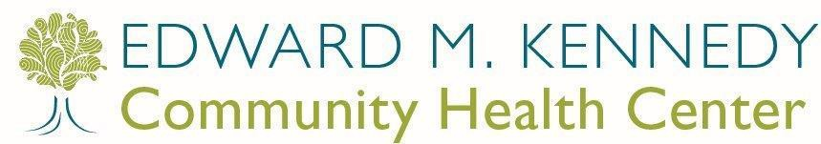Special Outreach Projects* to Patient/Parent rev 9_8_15

A

Patient Answers Patient’s Voicemail
Phone Disconnected
Busy / No Answer

Explain reason for call. Provide information, follow script and schedule appointment if appropriate.

If appointment is
Has transferred care to another provider, does not want to continue care with us or moved out of the area.
Patient calls back

Follow “A”
Patient does not respond w/in 1 week

Send a letter to patient per project protocol or consult with provider if needed
Try again later that day or next

Busy no answer x 2 If patient responds follow “A”
*Special Outreach Projects Such As:
- Well Child Visits
- Chronic No Shows
- Asthma
- Diabetes
- Tobacco
- Hypertension
- Kindergarten
- Preventive Health Projects (cancer screenings-pap, colorectal cancer screening, mammography)
- Emergency Room-high utilizer
- Other

scheduled, remind patient of the importance of keeping appointments and calling to cancel if needed.
Determine and address barriers.
Move Patient to “Inactivation” in Patient
Status Tab in EPM

If patient responds to letter, follow “A”

Document Per Protocol

(CHW template, telephone template, log)
Move Patient to “Inactivation” in Patient Status Tab in EPM if:
- Patient moved out of the area OR
- Patient does not want to continue care with us OR
- Patient transferred to new PCP at another site

SAMPLE PROTOCOL

Urgent Need* Outreach to Patient/Parent 9_3_2015
*Urgent Need may include:
- Abnormal test results
- Urgent situation as determined by PCP
A

Patient Answers Patient’s voicemail
Phone disconnected
Busy / No Answer

Explain reason for call. Provide
Has transferred care to another
Patient calls back
Patient does not respond w/in 1 week
Try again later that day or next

information, follow script and schedule
appointment if
provider, does not want to continue care
with us or
Follow “A” Call emergency contact

Busy no answer x 2 If patient responds, follow
“A”

appropriate.

If appointment is scheduled,
moved out of the area.

Move Patient to
Patient calls back

Follow “A”

If no response, consult with PCP re: next steps

remind patient of the importance of keeping appointments
“Inactivation” in Patient Status Tab in EPM
Do nothing
Certified letter
Outreach visit by CHW

and calling to cancel if needed. Determine and address barriers.

Document Per Protocol
If patient
responds, follow “A”
If no contact from
patient one week after letter was sent or letter is returned to sender, consult with PCP
If patient responds and wishes to receive further care, follow “A”
If patient refuses further care, moved,
transferred PCP, move patient to” inactivation” in Patient Status tab in EPM and inform EMK PCP
If no contact with the patient, consult with PCP

Document Per Protocol

Attachment 18

Patient Rights and Responsibilities Policy

Patient Rights & Responsibilities

This policy was created by Edward M. Kennedy Community Health Center (EMKCHC). This policy may have compliance and organizational insurance implications for your organization which should investigated before adapting this policy to meet your organizational needs.

PURPOSE
To ensure that the rights of patients and patients’ families are protected through the provision of care that respects their dignity.

SCOPE
This policy applies to all employees, students/interns, contracted staff, and volunteers of the Edward M. Kennedy Community Health Center.

RESPONSIBILITY
Responsibility for oversight of compliance with this policy lies with the Leadership Team. This policy shall be reviewed and updated by the Quality Care Committee annually or as needed.

DESCRIPTION
It is expected that the dignity of each patient will be respected by staff at all times. To this end, the following aspects of patient rights must be paramount in the provision of services by EMKCHC.

PROCEDURES
- Patients are informed of their rights upon entry into care at Edward M. Kennedy Community Health Center. In addition to a verbal explanation of rights and responsibilities, a brochure outlining patient rights and responsibilities is given to each family upon registration. The Patient Rights and Responsibilities brochure is available in the most prevalent languages. The Notice of Patient Rights is posted conspicuously in all waiting areas in the most prevalent languages. A letter-size copy of this poster is available upon request.

We help people live healthier lives.

- Patients receive a full orientation to health center services upon registration, including hours of operation, after hours coverage, and urgent care. Patients give their consent for EMKCHC to bill their insurance when appropriate as well as general consent to care.
- Patients have a right to access and receive health center services without fear of discrimination due to age, race, color, religious creed, ethnicity, national origin, culture, language, socioeconomic status, sex, handicap (disability), veterans’ status, sexual orientation, gender identity or expression in the provision of or access to services and activities.
- Confidentiality and security of patient information is protected by staff at all times. (See Confidentiality Statement).
- Patients are considered important partners in their care and the health center makes efforts to engage them in treatment and decision-making, wherever possible. With the patient (or surrogate decision-maker’s) permission, the health center will involve the patient’s family in care and treatment as well. Patients, and their families, as appropriate, are further encouraged to be fully involved in all aspects of their care through an active program of patient education throughout the health center and in the community. Further, to assist with patient engagement and decision-making, the health center will make an effort to inform the patient (or surrogate) about the outcomes of care or treatment or services needed.
- Patients have a right to the appropriate and timely assessment and management of pain. Patient reports of pain will be evaluated and patients will be given information about pain and pain relief measures. Patients will be partners in the development and implementation of effective pain management strategies.
- Patients provide written informed consent before high-risk or invasive procedures are performed. Staff is familiar with state and federal laws about the involvement of family members in the patient’s care as in the case of minors or patients with impaired capacities. (See Informed Consent Policy)
- Care is provided in a culturally and linguistically competent manner. Individual cultural, linguistic, spiritual, and psychosocial issues are considered in the provision of care. When the specific provider does not speak the patient’s language, interpretation is provided by an interpreter employed by the health center. In those cases where the patient speaks a language that is not provided by health center interpreters, interpretation is arranged through a telephonic interpretation service.
- Research projects involving health center patients cannot be undertaken without review and approval by the health center’s Quality Care Committee (QCC). Clear criteria have been developed which must be met before a research project can take place at the Health Center. These criteria are designed to protect the privacy of patients, decrease the likelihood of disruption in patient care, and to ensure that patients will be given the opportunity to make a fully informed choice as to whether they wish to participate based on the explained benefits of the study.

- EMKCHC is committed to the rapid resolution of patient complaints. When patient complaints cannot be adequately resolved by the employee involved, the patient is immediately referred to the supervisor or Department leadership. A grievance procedure is available when these mechanisms do not result in resolution. Patient complaints are tracked and are examined in order to identify trends and resolve ongoing issues (See Patient Complaints & Grievance Policy).
- Patients are encouraged to provide health care providers with advance directives in the event that they become unable to make health care decisions for themselves. (See Advance Directives Policy)
- Patients have full access to care regardless of ability to pay. Patients receive information about fee schedules and payment options at the time of registration as a patient of the health center. Patients without insurance are informed of their ability to apply for healthcare coverage both at the time of registration and at the time of service.
- Patients have a right to refuse care. The consequences of refusing care are discussed with the patient and the conversation is documented in the EMR, so that the patient can understand what the refusal of care may mean to his/her health. When a patient is not legally responsible for decisions about his/her care, a surrogate decision maker (i.e. parent or healthcare proxy) has the right to refuse care, services, and treatment on a patient’s behalf to the extent provided by the law.
- There is a process for the resolution of conflicts between the provider and the patient and/or patient’s family in the provision of care or treatment plan. This process is outlined in the policy entitled “Conflicts in the Provision of Care”.
- If unanticipated outcomes of treatment occur, a patient has the right to full information about the causes and corrective actions possible in the situation so that the patient may participate in current or future decisions about his/her care.
- Each patient has responsibilities in assuring that the care that he/she receives is appropriate. These responsibilities are outlined in the Patient Rights and Responsibilities brochure, which is given to the patient upon registration at the health center. These responsibilities are reviewed as part of the new patient orientation at the time of registration.

Attachment 19

Domestic Violence Screening Flow Chart

SAMPLE PROTOCOL
rev 4_1_2015

Worcester
only
END
- Assist with shelter options
- Discuss restraining orders
YES
NO
YES
NO
“Would you like to talk to someone today?”
- “You are not alone!”
- “You are not to blame for your abuse”
- “Unfortunately, what happened to you is very common”
- “There are people who can help you”
NO

Framingham & Milford
Provide hotline numbers if safe to do so

- Day break (Worcester): (508) 755-9030
- New Hope (Milford): (800) 323-4673
- Voices of Violence (Framingham): (800) 593-1125
- National DV Hotline: (800) 799—SAFE
- Safelink: (877) 785-
2020
Whenever you want, you ask to talk to a CHW about DV
Create a safety plan and provide options:
- Educate patient about shelters, restraining orders, or police involvement
- Never tell a patient what they “should do”. This can be dangerous!
- Develop an “exit plan in advance for you and your children.”
- Pack an overnight bag
- Pack toilet articles, medications, an extra set of keys to the house and car, clothing for you and your children, and keep them in a safe place
- Have extra cash, have access to “911”, a cell phone, checkbook, or savings account book hidden or with a friend
- Pack important papers and financial records: such as social security cards, birth certificates, green cards, passports, etc.
YES

Ask patient at every visit
“Would you like to talk to someone later?”
Contact Community Health Worker (CHW) (sites specific, call or page)

“I’m glad. If you or anyone you know ever needs help with this kind of issue, please know there is help available here”.
Avoid Victim Blaming
Show compassion
Domestic Violence Screening at Edward M. Kennedy Community Health Center
- Make sure patient is alone
- Ask simple direct questions

- Are you in a relationship with someone who hurts you, threatens you or makes you feel afraid in any way? or
- Are you currently or have you ever been in a relationship where you were physically hurt, threatened, or made to feel afraid?

Attachment 20

Social Security Disability Benefits

Medical-Legal Partnership

Social Security Disability Benefits: What CHWs Should Know

Social Security Disability Insurance (SSDI) (Title II): Social Security benefits for disabled workers.

- Must have recent work history in order to qualify.
- Special rules apply to younger persons who need less work to qualify.
- Benefit amount is calculated based on the individual’s work history.

Supplemental Security Income (SSI) (Title XVI): Social Security cash benefits for people with:
- Limited income and resources, and
- Who are blind, disabled, or age 65 or older.

SSI Details:
- Needs-based benefit for disabled adults and children.
- Monthly cash benefit. The amount depends on the recipient’s living arrangement and any countable income.
- The maximum monthly payment is set each January by SSA ($733 for 2016, and $735 for 2017)
- The “resource limit” for an individual is $2,000, i.e. the recipient cannot have countable assets that are worth more than this amount.
- The resource limit for a married couple is $3,000.

Who is Considered Disabled?
- The standard is the same under both programs.
- This is a FEDERAL definition of disability for the SSA, and it may differ from definitions used by state and other agencies.
- “Inability to engage in any substantial gainful activity by reason of medically determinable physical or mental impairments that can be expected to last for a continuous period of not less than 12 months or result in death.”
- The same analysis is used to determine if someone is disabled. It has 5 steps and is quite complex.

The SSI/SSDI Application and Appeals Process: What CHWs Should Know

Application
  - Apply in person at 51 Myrtle St. (in Worcester) or online at www.ssa.gov. Outside of Worcester, find your local office at https://secure.ssa.gov/ICON/main.jsp.
  - Applicants should provide SSA with all information that could be helpful, including all of their medical providers, and their education and work history.
  - Once everything is submitted to the SSA local office, the case is sent to Disability Evaluation Services (DES) at UMass Medical School for an assessment of disability.

If an Initial Application is Denied
  - File a Request for Reconsideration.
  - 60 days to appeal (plus 5 days for mailing)
  - Paper appeal

If Request for Reconsideration is Denied
  - Request a Hearing before an Administrative Law Judge (ALJ)
  - 60 days to appeal (plus 5 days for mailing)
  - Average of 8 to 12 months from time of request to the actual hearing date
  - New paperless system—most disability claims files are available electronically in a CD- ROM format and can be requested by the hearing office (ODAR).
  - Office of Disability Adjudication and Review (ODAR) – Worcester County is primarily served by Springfield ODAR

Refer AFTER applicant has been denied a Request for Reconsideration (Step 2).

If applicant has been denied at the Request for Reconsideration stage, it is best to seek legal assistance as soon as possible, so that a lawyer can evaluate the case.

It is best to always APPEAL before the deadline in order to avoid having to start over (i.e. re-apply). Even if an applicant wins after re-application, they may have lost out on some retroactive benefits.
Community Legal Aid serves residents of Berkshire, Hampden, Hampshire, Franklin, and Worcester counties. To find your local legal aid program, go to http://www.masslegalservices.org/FindLegalAid.

December 2016

2

Attachment 21 (A,B,C,D) Transportation Policy and Agreements

Transportation Policy

This policy was created by Edward M. Kennedy Community Health Center (EMKCHC). This policy may have compliance and organizational insurance implications for your organization which should investigated before adapting this policy to meet your organizational needs.

PURPOSE
To ensure that patients needing transportation resources to carry out their treatment plan receive appropriate assistance. To provide guidelines for what types of transportation are appropriate in certain situations, as well as guidelines for when it is appropriate for staff to transport patients in their own vehicles.

SCOPE
This policy applies to all situations where patients need assistance with transportation.

RESPONSIBILITY
Responsibility for oversight of compliance with this policy lies with leadership teams at all sites or their designees. This policy shall be reviewed by the Practice Standardization Committee annually or as needed.

IV. DESCRIPTION
It is the policy of the Health Center that Community Health Workers (CHWs) assess those patients who need transportation to medical appointments and then arrange for the appropriate method of transport. In certain circumstances, at the discretion of a provider, EMKCHC supported transportation may be provided.

V PROCEDURES
CHWs assess patients who need transportation to medical appointments according to the following protocol:

- Determine if the patient has family/friends or other personal resources
- Determine if it is possible for another public or private organization to provide the transportation, e.g., Medicaid (PT-1) or RTA van. These are especially appropriate if the need for transportation is ongoing.
- Determine if a patient is eligible through grant funds for bus passes or any other method of transportation.

We help people live healthier lives.

Page 2 of 2

Patients may be eligible for EMKCHC supported transportation if:

- There are no other resources to provide the transportation and there is an urgent need to transport the patient to meet their medical needs.
- The patient has physical or psychiatric disabilities that preclude their using other modes of transportation to attend medical appointments.
- In the judgment of the supervisor or provider, such transportation is necessary to assure the patient’s treatment at EMKCHC.

If the CHW determines that EMKCHC-provided transportation is needed, taxi transport is used unless there is a grant which supports the provision of bus passes. Taxi transport is not to be used for the routine transportation of patients to EMKCHC or any other medical provider for regularly scheduled appointments.

Transportation service is limited as follows:

- EMKCHC transportation is provided only when there is exceptional medical necessity.
- Transportation is provided only for the patient, the patient’s children (if childcare is otherwise not available), and a spouse or friend if the patient requires assistance in coming to EMKCHC. In the case of bus passes, transportation may not be provided to friends or family members who simply want to accompany the patient.

Personal Transport by Staff

Staff may transport patients in their personal vehicles in cases where: 1) a grant requires or suggests personal transport of patients by staff, e.g. transportation at the time of release from a correctional facility; or 2) in urgent cases with approval of one’s supervisor. Staff who transport patients must provide our HR Department, on an annual basis, proof of their current driver’s license and active auto insurance on the vehicle they will be driving. In the event of an accident, the employee’s auto liability insurance is the primary coverage and EMKCHC liability insurance is the secondary coverage. Further, before staff transport patients, they must: 1) complete a training on general safety and a specific orientation on safety for staff transporting clients (see GL-OP-107.2-F1 Safety Orientation for EMKCHC Staff Transporting Clients/Patients);
- sign a staff agreement regarding transporting clients (see attached GL-OP-107.2-F2 Staff Agreement for Transporting Clients/Patients); and 3) review and request that the client/ patient signs the Client Agreement regarding EMKCHC provided transportation (see attached Client/Patient Agreement for EMKCHC Provided Transportation).

ORIENTATION ON SAFETY FOR STAFF TRANSPORTING CLIENTS/ PATIENTS

These guidelines were created by Edward M. Kennedy Community Health Center (EMKCHC). These guidelines may have compliance and organizational insurance implications for your organization which should investigated before adapting these guidelines to meet your organizational needs.

Prior to transporting clients/patients, staff must review Edward M. Kennedy Community Health Centers (EMKCHC) Transportation Policy; receive general safety training; receive this orientation about transporting clients/patients; and sign the Staff Agreement - Regarding Transporting Clients/Patients. Clients/Patients must sign the Client/Patient Agreement - Regarding Health Center Provided Transportation prior to being transported by a health center staff member.
It is important that all staff pay attention to their safety and the safety of others when transporting clients/patients.
Below is information to keep you and your passengers safe:

  - Only the client/patient, children in the care of the client/patient and or a caretaker attending to the client/patient are permitted to travel in the vehicle provided that the maximum carrying capacity is not exceeded. Seatbelts are to be worn at all times and children are to be seated by the parent or guardian utilizing child restraints where applicable. All children are to be seated in the rear of the vehicle and under supervision. Transportation will not commence until all seatbelts are in use. Drivers are required to immediately cease transportation if seatbelts are not in use for all passengers. This includes the correct securing of children’s safety restraints.
  - If children requiring car seats are transported in the car, the parent/guardian must provide the car seat. The car seat must be secured and guidelines below must be followed:
    - MA Law states that children ages 7 and younger and less than 57 inches tall must ride in a child safety seat (car seat or booster seat depending on weight and age)
    - MA.gov recommends that children should ride rear facing until they are at least one year of age and weigh at least 20 pounds - both criteria are needed before they can ride facing forward. However, it is recommended that children remain rear facing as long as possible (up to the rear facing weight limit of the seat).
AAP advises parents to keep their infants and toddlers in rear-facing car seats until age 2, or until they reach the maximum height and weight for their seat
  - Do not transport clients/patients during severe weather or potentially severe weather.
  - Do not use your cell phone while driving. If there is an emergency, pull off the road to a safe location to use your cell phone.
  - Do not transport passengers if you or the other passengers do not feel safe.
  - Do not transport clients/patients if either the client/patient or any other passengers are under the influence of drugs or alcohol.
  - Do not carry animals in the car (except service animals)
  - Driver and passengers may not smoke in the vehicle.

  - Drivers and passengers may not transport drugs (except those prescribed for the client/patient), alcohol or any weapons in the car.
  - Keep gas tank at least ½ full.
  - Follow the speed limit and other rules of the road.
  - Keep emergency supplies in your vehicle such as: blankets, windshield scraper, shovel, flashlight, emergency flares, jumper cables, water, and maps.
  - Carry a cell phone so you can make an emergency call if needed.
  - Try to only transport clients/patients during daylight hours
  - Transportation is only from the pick-up point to the location designated and back. Do not stop at other locations while transporting clients/patients to or from their destination.
  - Park in a well-lit area when possible.
  - If you ever feel unsafe when transporting clients/patients, pull over to the nearest public location, get out of the car, and call for help.
  - If there is a weapon involved or someone threatens to hurt you, call 911.
  - Immediately report any unsafe situation to your supervisor or designee. If there is an accident, first assess the situation for injury and take any necessary steps to address safety of everyone in the vehicle.

In case of an accident:
  - Move vehicle to a safe place if possible.
  - Use hazard warning lights and switch off your engine.
  - Do not move injured passengers unless they are in immediate danger of further injury.
  - Call the emergency services immediately; provide them with information about the situation, any special circumstances and if any passengers have special needs.
  - If the emergency services are called, stay at the scene until they allow you to leave.
  - Obtain the names and addresses of all independent witnesses (if possible).
  - Ensure the vehicle is roadworthy before continuing the journey.
  - If there is any injury or the names of people involved are not exchanged, you must report the accident to the Police as soon as possible or in any case within 24 hours.
  - Report incident to your supervisor and complete an EMKCHC Incident Report.

In case of a breakdown:
  - Move the vehicle off the road and switch on the hazard warning lights.
  - If this is not possible, move it as far away from moving traffic as you can.
  - On busy roads, passengers should be taken as far from the traffic as is practical.
  - Keep passengers together.
  - Call for assistance, giving emergency responders accurate details of the vehicle's location.

These guidelines were created by Edward M. Kennedy Community Health Center (EMKCHC). These guidelines may have compliance and organizational insurance implications for your organization which should investigated before adapting these guidelines to meet your organizational needs.

CLIENT/ PATIENT AGREEMENT – REGARDING HEALTH CENTER PROVIDED TRANSPORTATION

A staff member of the Edward M. Kennedy Community Health Center has agreed to transport me: From:
To:

I agree that:

- I will wear a seatbelt while being transported.

- If a child is being transported with me, I will provide a car seat that is certified by Massachusetts Car Seat Laws and I will safely secure my child in the car seat.

- If an older child is being transported with me, I will safely secure my child in the rear of the car and supervise my child while we are being transported.

- I will not smoke while being transported.

- I will not be under the influence of alcohol or drugs while being transported.

- I will not bring animals in the car (unless it is a service animal).

- I will not have illegal drugs, alcohol, or weapons in my possession while being transported.

- Kennedy Health Center staff will only transport me to and from the above designated locations.

Client’s/Patient’s Name Date

These guidelines were created by Edward M. Kennedy Community Health Center (EMKCHC). These guidelines may have compliance and organizational insurance implications for your organization which should investigated before adapting these guidelines to meet your organizational needs.

STAFF AGREEMENT – REGARDING TRANSPORTING CLIENTS/PATIENTS

I understand that in my role as an employee of the Edward M. Kennedy Community Health Center I may be called upon to transport clients/patients of the Health Center in my personal vehicle.

I acknowledge that the Health Center has provided me with an Orientation on Safety for Staff Transporting Clients/Patients, and I have read and understand all requirements and guidelines. I have also reviewed the Transportation Policy (GL-OP-107.2) and received a general safety training provided by the Health Center.

I understand that every client/patient requiring staff transportation has reviewed and signed a
Client/Patient Agreement – Regarding Health Center Provided Transportation.

I have submitted a copy of my Massachusetts State Driver’s license to Human Resources and I understand that I must resubmit a copy of my license every year.

I have submitted a copy of my Massachusetts Vehicle Registration to Human Resources and I understand that I must resubmit a copy of my Registration every year.

I have submitted a copy of the Massachusetts Automobile Insurance Policy that covers my vehicle verifying that I have all the coverage required by the Health Center to Human Resources and understand that I must resubmit a copy of my insurance coverage every year.

I declare that my vehicle is compliant with the Massachusetts Registry of Motor Vehicles Safety Requirements and has a current Massachusetts Inspection Sticker legally affixed to the windshield.

I understand that the decision to transport a client/patient of the Health Center in a personal vehicle is made judiciously, and can only be done following review and authorization provided by the CHW Supervisor or designee.

EMKCHC Staff Date

Attachment 22

Utility Termination Protection

Medical-Legal Partnership

Eligibility for Key Protections Against Termination of Utilities

Protection | Requirements
Elderly | - All adult household members must be 65 or older.  - Household must notify company.  - No proof of financial hardship required; company must get Department of Public Utilities permission to terminate.  - IF there is a financial hardship, termination absolutely prohibited.
Serious Illness | - Must show that someone (customer or family member) is seriously ill, by submitting letter from doctor/nurse practitioner or physician’s assistant.  - Must demonstrate financial hardship.  - Letter must be renewed every 90 days (or every 180 days for a “chronic” illness).
Winter Moratorium | - Applies to gas (if used to heat) or electricity (if used to operate furnace, boiler, thermostats, or heating controls).  - Runs from November 15 – March 15 (often extended).  - Must demonstrate financial hardship.
Infant | - An infant under the age of 12 months must be living in the household.  - Must submit birth certificate, baptismal certificate, or other reasonable proof of age.  - Must demonstrate financial hardship.

Community Legal Aid serves residents of Berkshire, Hampden, Hampshire, Franklin, and Worcester counties. To find your local legal aid program, go to http://www.masslegalservices.org/FindLegalAid.

December 2016

Attachment 23

Asthma Procedures and Basic Education Guidelines

Asthma Procedures and Basic Education Guidelines for CHWs

Rev 12_23_2015
Page 1 of 2

These guidelines were created by Edward M. Kennedy Community Health Center (Kennedy CHC). These guidelines may have compliance and organizational insurance implications for your organization which should investigated before adapting these guidelines to meet your organizational needs.

Basic Education Guidelines for working with patients with Asthma
CHWs work with many patients diagnosed with asthma. Some Kennedy CHC sites have CHWs who participate in the Prevention and Wellness Trust Fund Grant (PWTF). The CHWs who work with this grant may have additional roles when working with children with asthma (see below).

Asthma is an illness of the airways in the lungs. The airways in the lungs are blocked and it is hard to breathe. People with asthma may cough, or wheeze (make a whistling sound when they breath), or feel they need to catch their breath. It may feel like trying to breathe through a pinched straw.

Asthma can happen at any age. It runs in families, there is no cure and children do not “outgrow” asthma. Asthma is a chronic illness. It can come and go all your life and never go away but it can be controlled with the right treatment.

Asthma triggers are chemicals, pollutants or allergens around you that make asthma worse. They can be strong chemical smells, dust, smoke, pollen, perfumes, mold, pets or viral infections. Asthma triggers are different for different people.

Patient’s with asthma are usually treated with medications given through inhalers. There are two major categories of inhalers: relievers and controllers. It is important that families understand the differences between these two medications. If the parent and/or child do not understand the medications they are using or how to use an inhaler, refer the patient to a nurse/clinical pharmacist/provider or CHW will review provider’s instructions if trained.

Asthma is measured in a few ways. At diagnosis the provider looks at the severity of the asthma and then an asthma control test (ACT) is usually given at follow up visits. An ACT is a short self-administered survey which asks the child and parent/caretaker about asthma symptoms. It is age specific and allows providers to understand child’s current level of asthma control and to track asthma control. If score is 19 or less, asthma is not controlled, if score is greater than 19, asthma is controlled. This provides a starting point for provider conversations about asthma triggers, medication use, inhaler technique, need for treatment changes.

When working with patients with asthma, CHWs will:
- Find out what barriers patients have to achieve their asthma control goals
- Confirm that patient understands the asthma action plan developed with provider
- Confirm patient understands how to reach the health center
- Provide patients with resources and support to achieve their asthma goals such as:
  - Address barriers to asthma control (as described in plan of care with PCP)

Page 2 of 2

  - Basic asthma handouts and/or referral to PCP or consult with PCP to refer to nurse and/or clinical pharmacist
  - Refer to chronic disease self-management group
  - Basic tobacco cessation handouts and/or referral to tobacco cessation counselor and/or help line 1-800-QUIT-NOW
  - Consult with PCP to refer to nurse and/or clinical pharmacist to provide medication management
  - Address barriers to keeping appointments
  - Address barriers to obtaining needed medications
  - Encourage patients to participate in their care, partner with their medical team, ask questions.

Note: When educating patients, use brochures or CHW basic guidelines rather than general counseling.

Skills to use for Basic Education
- Highlight the key topics found in the following handouts and brochures.
- Use teach back and motivational interviewing techniques

Handouts to use when providing asthma basic education (at: I:\Operations\Community Health Workers - ALL SITES\Procedures-Guidelines-Edu-Resources\Asthma)
- Asthma Control Test (if trained)
- Asthma Action Plan (if trained and provider initiated)
- Asthma Triggers
- Inhalers- clean and prime, spacers, masks, diskus (if trained and provider initiated)
- Medications- control and quick relief (if trained and provider initiated)
- Asthma Children’s Activity Book

Special Role of CHWs working with pediatric patients with moderate or persistent asthma as part of the PWTF Grant:

- CHWs trained by PWTF Worcester may offer specific interventions to children with asthma such as:
  - Review ACT score done with provider or administer ACT during a home visit
  - Review how to use an inhaler and medications (using handouts above)
  - Review Action Plan that provider gave to patient
  - Conduct Home Visits
  - Coordinate services with outside partners
  - Coordinate services with chronic care manager

- CHWs trained by PWTF Framingham may offer specific interventions to children with asthma such as:
  - Refer to local board of health for a home assessment

Attachment 24

Behavioral Health Procedures and Basic Education Guidelines

Behavioral Health Procedures and
Basic Education Guidelines for CHWs 4_7_2016
Page 1 of 2

These guidelines were created by Edward M. Kennedy Community Health Center (EMKCHC). These guidelines may have compliance and organizational insurance implications for your organization which should investigated before adapting these guidelines to meet your organizational needs.

Basic Education Guidelines for working with people with emotional/behavioral health concerns:
CHWs work with many patients who are experiencing anxiety, depression, stress or other emotional or behavioral health concerns. It is helpful to see the person, not the illness and actively listen to the patient so they do not feel judged. Cultural stigma associated with mental illness often prevents people from getting treatment. When talking about “mental health”, use the terms “emotional health” or “behavioral health”.
Emotional/behavioral health conditions, like physical health problems, are highly treatable and manageable when they are properly diagnosed.
Reassure patient that the information he/she shares will be confidential among his/her medical team and we will not share this information without her consent (unless she is a danger to his/her self or others).
It is important to provide basic education around this topic and reinforce the connection between emotional and physical health. Note: When educating patients, use behavioral health brochures or CHW basic guidelines rather than general counseling.

Skills to use for Basic Education
- Highlight the key topics found in the following handouts and brochures.
- Use teach back and motivational interviewing
- Handouts to use when providing basic education (at: I:\Operations\Community Health Workers - ALL SITES\Procedures-Guidelines-Edu-Resources\Behavioral Health\HANDOUTS- Stress and Feeling Sad)
- Feeling Sad (English, Portuguese, Spanish, Arabic, Somali)
- Stress (English, Portuguese, Spanish, Arabic, Somali)

When to ask PHQ2 and PHQ9 questions and what to do if positive (link in psychosocial assessment):
- If the patient has not had a medical visit within 6 months or is in obvious emotional distress, request permission to ask questions about how they are feeling. If patient consents:
  - Ask PHQ2
    - If PHQ2 is positive, ask PHQ9 questions.
    - If PHQ9 is 15 or above: discuss with PCP or behavioral health staff and if appropriate, request PCP make a referral to behavioral health or obtain emergency services.
  - Share and discuss handout on Feeling Sad if appropriate

When to ask distress question and what to do if positive (link in psychosocial assessment)
- Ask this question when completing the psychosocial assessment
- If result is greater than 5, ask if patient would like to speak with someone about managing their stress. Discuss with PCP or behavioral health staff and if appropriate, request PCP make a referral to behavioral health.
- Share and discuss handout on Stress if appropriate

Page 2 of 2

When to discuss a referral to behavioral health services with PCP?
- Patient identifies need to speak with someone in behavioral health
- PHQ9 or distress question results indicate a referral to behavioral health
- If you have other concerns, speak with PCP to determine if this concern can be addressed by PCP or if behavioral health intervention is recommended.
- If patient mentions one or more of the concerns below and would like to speak with someone about the concern or you see/hear about these concerns during your visit:

- Changes in sleep patterns  - Unexpected crying or excessive moodiness  - Eating habits that result in noticeable weight loss or gain  - Expressions of hopelessness or worthlessness  - Paranoia or excessive secrecy | - Obsessive body-image  - Excessive isolation  - Abandonment of friends or social groups  - Substance use  - Self-mutilation or mention of hurting oneself or others (connect to BH staff immediately)

How can a CHW connect a patient to behavioral health services?
- Discuss concern with PCP and PCP can make referral to Behavioral Health (for locations where BH is not on site, assist provider if needed) OR
- CHW may schedule appointment for Behavioral Health Integration (BHI) in the EPM:
  - ALWAYS document the reason for referral to BHI in CHW template prior to scheduling a BHI appointment.
  - Go to the EPM and search for BHI slots at your location. Schedule a BHI visit for the patient (color is BLUE). CHW can also check to see if BHI provider is available for a “warm handoff”.
  - In “reason for visit”, document “SEE CHW NOTE of (date).
  - Task your note to PCP so they are aware of need for BHI and appointment booked.
- When working in the community with clients who do not get primary care at Kennedy Community Health Center, use BH resource lists (I:\Behavioral Health\Behavioral Health Resources)

When to report suspected abuse/neglect?
If a staff member suspects the neglect of an elder, disabled person, or child, the CHW should discuss this suspicion with his/ her supervisor or behavioral health staff. Other members of the health care team may also be consulted, as appropriate. See details in policy below:
\\Emk-index1\production\Operations\Community Health Workers - ALL SITES\Procedures-Guidelines-Edu- Resources\GENERAL POLICIES PROCEDURES\GL-PR-106.8 ReportingSuspectedAbuseNeglect - Shortcut.lnk
CHWs identified to specifically focus on BH, will work closely with the VP, BH and her team to:
- Proactively intervene to engage patients and their families into behavioral health care and to re-engage patients into (medical primary) care
- Manage BH referrals both in house, and into the community
- Assist psychiatry, in directed follow-up w/pts
- Assist w/other psychosocial needs and perform other duties as detailed on CHW job description

Attachment 25

Diabetes Procedures and Basic Education Guidelines

Diabetes Procedures and Basic Education Guidelines for CHWs
rev 2_25_2016
Page 1 of 2

These guidelines were created by Edward M. Kennedy Community Health Center (Kennedy CHC). These guidelines may have compliance and organizational insurance implications for your organization which should investigated before adapting these guidelines to meet your organizational needs.
Basic Education Guidelines for CHWs working with patients with Diabetes*
Diabetes means that there is too much sugar (glucose) in the blood. The blood takes glucose to the cells in your body where it is turned into energy. A hormone called insulin, which is made in the pancreas, helps glucose move out of the blood to enter the cells. A person with diabetes does not make enough insulin or does not use it well. This causes the glucose to build up in the blood which can result in diabetes.
Keeping blood glucose levels close to the target goals set with the primary care provider (PCP) may prevent and slow complications of diabetes. Some complications of diabetes that may be prevented include blindness, sexual dysfunction, nerve damage, kidney disease, heart disease, and leg or foot amputations. Lifestyle changes that may control diabetes include: maintaining a healthy weight, being physically active, preventing and treating high blood pressure and high cholesterol levels.
Certain factors which we cannot change increase the risk for diabetes. This includes: family history of diabetes, race/ethnicity (Latino, African-American, Native American or Asian), age (over age 45), giving birth to a baby weighing more than 9 pounds, gestational diabetes (diabetes during pregnancy that went away after the baby was born).

There are different types of diabetes:
Type 1 Diabetes usually occurs in children and young adults and these patients usually need insulin every day.
Type 2 Diabetes is the most common type of diabetes. It usually occurs in adults who are overweight, and/or have family members with diabetes. It is also common in children who are overweight. This type of diabetes may be controlled with healthy eating, weight loss and physical activity. Some people will also need diabetes pills and/or insulin.
Pre-Diabetes occurs in people with higher than normal blood sugar. They are at higher risk of developing type 2 diabetes. Healthy weight and physical activity may help prevent or delay type 2 diabetes.
Gestational Diabetes occurs during pregnancy and often goes away after the baby is born. Women who have gestational diabetes are at a higher risk of developing type 2 diabetes later in life.

There are two tests to tell if blood sugar is at a healthy level:
- HbA1C or A1C- this measures the blood sugar control over the last 2-3 months. The PCP usually orders this test every 3-6 months. The best result is usually less than 7%. If it is higher, the PCP may change the treatment plan.
- Finger-Stick Test- patient may test their own blood sugar. This checks the blood sugar at the time it is tested. The PCP will tell the patient how often and when to check their blood sugar (it may be 1-3 times a day or more). This test lets the patient know if their treatment plan is controlling their blood sugar right now.

If someone has diabetes, it is important they know their blood sugar number! If blood sugar is kept in control, patient will:
- Have more energy
- Feel better
We help people live healthier lives.

Page 2 of 2

- Lower their chances of problems with their eyes, feet, kidneys and nerve function
- Reduce their risks of heart attack and stroke

It is important that patients understand their ABC goals. Goals may vary by age and health conditions. ABC goals include:
- A1C
- Blood Pressure
- Cholesterol
Suggestions for people with diabetes:
- Eat healthy foods in the right portions
- Be active (30-60 minutes of activity most days of the week)
- Quit smoking
- See the dentist twice a year, brush and floss every day
- Take medicines as suggested by their Primary Care Provider (PCP)
- Check feet daily for cuts, blisters, red spots, swelling. Call PCP if soars won’t heal.
- Check blood glucose the way PCP recommends
- Have a dilated eye exam once a year or as directed by PCP
- Get a yearly flu shot

When working with diabetic patients, CHWs will provide patients with resources and support to achieve their diabetes goals such as:
- Address barriers to control their diabetes (as described in their plan of care with PCP)
- Address barriers to keeping appointments
- Address barriers to obtaining needed medications
- Consult with provider to refer to nurse and/or clinical pharmacist to provide medication management
- Discuss importance of tracking glucose readings
- Basic diabetes handouts and/or refer to medical provider and/or consult with PCP to refer to chronic disease nurse
- Refer to chronic disease self-management group
- Consult with PCP about referral to nutritionist and/or chronic disease nurse to discuss meal plan
- Basic exercise handouts and/or referral to exercise resources
- Basic tobacco cessation handouts and/or referral to tobacco cessation counselor and/or help line 1-800-QUIT-NOW
- Encourage patients to participate in their care, partner with their medical team, ask questions. Note: When educating patients, use brochures or CHW basic guidelines rather than general counseling. Skills to use for Basic Education
- Highlight the key topics found in the following handouts and brochures.
- Use teach back and motivational interviewing techniques Handouts to use when providing diabetes basic education:
- Diabetes, Are You at Risk? (English, Spanish, Portuguese)
- Diabetes Know Your Blood Sugar Numbers (English, Spanish, Portuguese)
- Stroke (English, Spanish, Portuguese, Arabic)
- Heart Attack (English, Spanish, Portuguese, Arabic)
..\..\..\Operations\Community Health Workers - ALL SITES\Procedures-Guidelines-Edu-Resources\Diabetes\Diabetes Basic Ed Handouts
*Adapted from MA DPH Diabetes Prevention and Control Program “Diabetes Are you At Risk?” and “Diabetes Know Your Blood Sugar Numbers” brochure

Attachment 26

Fall Prevention Procedures and Basic Education Guidelines

Fall Prevention Basic Education Guidelines for CHWs
rev 8_16_16 Page 1 of 2

These guidelines were created by Edward M. Kennedy Community Health Center (Kennedy CHC). These guidelines may have compliance and organizational insurance implications for your organization which should investigated before adapting these guidelines to meet your organizational needs.

Basic Education Guidelines for discussing falls with patients
CHWs may work with patients over the age of 65. The risk of falls increases with age, 30-40% of patients over 65 will fall every year in the USA, and 50 % of those over 80 will fall. The Prevention Wellness Trust Fund (PWTF) in Framingham provides resources to work with Community Based Organizations (CBO) which provides programs such as: Matter of Balance (MOB), Movement for Better Balance (Tai Chi) and Enhanced Fitness programs at the Metrowest YMCA and Latino Health Insurance Program (LHIP). Fall prevention programs also exist in other communities Background:
- Falls are the most important health problem interfering with the independence of older adults.
- In 2011, 2.4 million patients were seen in an emergency room for falls.
- Causes/risk factors of falls include: health problems, medications, vision problems and environmental factors.
  - Health problems:
    - Abnormal heart rate, abnormal rhythm and/or low blood pressure.
    - Diseases that affects balance- vertigo (may be associated with hearing loss)
    - Stroke history
    - Seizures
    - Alcohol or Drug use
    - Behavioral health diagnosis such as: anxiety, depression, obsessive compulsive disorder, panic disorders
    - Migraines
    - Multiple Sclerosis
    - Incontinence (lack of control over urination)
    - Stress
  - Medications (encourage the patient to discuss which medications which may increase risk of falls with their provider):
  - Vision- blurry vision may be described as dizziness by some patients.
    - Encourage patients to have an eye exam at least yearly. Diabetics and patients with other health problems may need more frequent eye exams.
  - Environmental factors:
    - Inside the home: throw rugs, no handrails on stairs or in bathroom, wet bathroom floor, clutter around walking spaces, poor lighting, foot pain or poor footwear
    - Outside the home: curbs, irregular surfaces on the street, snow, ice, leaves, poor lighting
Complications related to falls:
- Falls can cause minor lesions such as: bruises, scrapes and cuts
- Falls can cause major injuries such as: fractures and head injuries
- The number of older adults who die from fall related injuries nearly doubled since 2000
- People who fall, even if they are not injured, may become afraid of falling. This fear may cause a person to be less active. Being less active may cause a person to become weaker which may increase their chance of falling.
Prevention:

We help people live healthier lives.

Page 2 of 2

- Exercise, stay active
- Have regular eye exams
- Review medications with provider
- Schedule a home assessments to decrease environmental risks
- When getting up from bed, sit on the side of the bed for a few seconds before standing
- Keep your home bright, turn on lights at night, use night lights and keep a flashlight in all rooms
- Keep floors dry, do not use floor wax
- Do not use throw rugs and keep cords and other things away from walking areas
- Put up grab bars and hand rails
- Wear shoes that fit well with low heels and non-slip soles
- Try not to use a ladder, store things where you can reach them
- Be sure leaves, ice and show are cleared from sidewalks
- Be very careful walking if you drink alcohol or take sleeping pills or other medications that may affect your balance.

When working with patients older the 65, CHW will:
- Discuss the risks associated with falling in older adults using brochures and/or websites.
- If trained, use the STEADI fall risk checklist.
- Encourage patient to discuss vision problems, medications, and symptoms with provider.
- Refer to the provider or trained staff for standardized screening for fall risk.
- Refer to Community Based Organizations (CBO) for exercise and education program to prevent falls.
- Refer to CBO for a home assessment visit
- Encourage patient to identify problems at home or in his/her environment and make the home owner aware of the risk. Refer to MLP if needed.
- Involve the family if possible.
Note: when educating patients, use brochures or CHW basic guidelines found in:
I:\Operations\Community Health Workers - ALL SITES\Resources-Procedures-Guidelines-Edu\Fall Prevention
Skills to use for Basic Education
- Highlight the key risk factors for falls
- Use teach back and motivational interviewing techniques
- Use cultural communications skills when discussing risks
- Show empathy
- Avoid judgement
Special role of CHWs working with as part of the PWTF grant in Framingham:
- Refer to YMCA and LHIP for education, home visits, and exercise programs to prevent falls.
- Follow PWTF guidelines for home safety and follow up.

Resources used to create this document include:
- http://www.cdc.gov/steadi/pdf/algorithm_2015-04-a.pdf
- http://www.cdc.gov/steadi/pdf/fall_risk_checklist-a.pdf
- http://www.cdc.gov/homeandrecreationalsafety/falls/adultfalls.html
- http://www.mass.gov/eohhs/gov/departments/dph/programs/community-health/dvip/injury-prevention/falls.html
- http://www.cdc.gov/homeandrecreationalsafety/falls/
- http://www.cdc.gov/steadi/pdf/talking_about_fall_prevention_with_your_patients-a.pdf
- http://www.cdc.gov/steadi/pdf/stay_independent_brochure-a.pdf
- http://www.cdc.gov/steadi/patient.html

Attachment 27

Health Systems Education Guide

These guidelines were created by Edward M. Kennedy Community Health Center (Kennedy CHC). These guidelines may have compliance and organizational insurance implications for your organization which should investigated before adapting these guidelines to meet your organizational needs.
MEDICAL APPOINTMENTS
- Give information: Tell the provider *your symptoms *the medications you take (prescribed, over the counter, herbal, home remedies, supplements) *allergies *side effects to medications *if you are pregnant *if you think you are pregnant *if you are breast feeding.
- Get information: Ask questions about everything you want to know or don’t understand. While your provider may not be able to address all your problems or questions in any one visit, he/she will focus on your main concern and address other issues in separate visits.
- Follow-up: Call if your symptoms get worse or if you have problems with your medications. If your provider refers you to a specialist, please keep the appointment and call our referral coordinator if you have any questions. If your provider encourages you to see a specialist known to you, make an appointment as soon as possible.
- Effective use of EMKCHC services: *arrive 30 minutes before appointments *an adult must stay with children at all times *bring insurance card, address, phone *bring all the medications (or a list of medications) you are currently taking *cancel appointments by calling ahead of time – 2 days before your appointment is best *for refills on medications call 48 hours before needed *for forms such as disability forms, give 2 weeks time if possible (you may need to make an appointment with your provider for completion of forms) * for letters for housing, utility bills, or employment issues during pregnancy, please give provider/community health workers 5 days notice
PRESCRIPTIONS AND THE PHARMACY
- Bring your medications (or a list of all your medications) to all appointments.
- Ask about the use- how much, how often, and side effects of your medication.
- Do not share your medication with others.
- Do not take medication prescribed for someone else.
- Always take as prescribed, no more and no less.
- Always finish antibiotics, even if you feel better.
- Try to use the same pharmacy for all your prescriptions.
- Check the amount left. When you are low, call 48 hours in advance for refills.
- Check your bottle for # of refills left : PICTURE* →→→
URGENT CARE
- Urgent Care is for patients with a medical injury or illness that is not serious enough to warrant an ER visit.
- If possible, call Urgent Care before arrival and before 2:30 to make an appointment.
- If possible, call and check to see if your Primary Care Provider is available to see you.
- Bring your medications or a list of medications (prescribed, over the counter, herbal, home remedies, supplements).
- Urgent care is NOT for ongoing care, or follow-up treatment.
CALLING 911
- Examples of when to call: *severe chest pain or pressure *severe bleeding *difficulty breathing *suspected stroke (weakness on one side, change in vision or speech) *unfamiliar severe pain in belly or head *choking *severe burns
*severe allergic reaction *severely ill child *loss of consciousness
- What happens when you call 911? 911 calls are answered 6-12 seconds after you call. In some cases there is about 5-6 seconds of silence on your phone before you hear someone answer—DO NOT HANG UP.
- If you do not speak English it is important that you tell the 911 operator what language you speak. The 911 telephone operators may bring an interpreter on line or ask if you are with someone who speaks English.
- The 911 operator is required to ask a number of questions. Some of the questions may seem unnecessary, but they are important! The operator will ask: “What is the emergency?” “Where are you?” “Who needs help?”, “Who is with you?”
- Stay on the telephone for as long as you can to guide the operator in getting help to you.
POISONING
Call Poison Control at 800-222-1222 if you are concerned that you or a loved one may have come in contact with a toxic substance. Operators are available to answer your questions and help you determine if you need further emergency assistance.

Attachment 28
HIV/AIDS, STDs, Hepatitis C
|Procedures and Basic Education Guidelines

HIV/AIDS, STDs, Hepatitis C Procedures and Basic Education Guidelines for CHWs
rev 06_16_2016
Page 1 of 7

These guidelines were created by Edward M. Kennedy Community Health Center (Kennedy CHC). These guidelines may have compliance and organizational insurance implications for your organization which should investigated before adapting these guidelines to meet your organizational needs.

Basic Education Guidelines for working with patients with HIV/AIDS, STDs, Hepatitis C CHWs work with many patients who are diagnosed with HIV/AIDS, STDs and/or Hepatitis C. Some Kennedy CHC sites have CHWs have additional roles when working with HIV/AIDS, STDs, and/or Hepatitis C.

When working with patients with HIV/AIDS, STDs or Hepatitis C, CHWs will:
- Provide patients with resources and support to achieve health care goals such as:
  - Address barriers to keeping appointments.
  - Address barriers to obtaining needed medications.
  - Basic handouts on HIV/AIDS, STDs or Hepatitis C and/or referral to medical provider, nurse or health educator/counselor.
  - Refer to nurse or clinical pharmacist to provide medication management.
  - Encourage patients to participate in their care, partner with their medical team, and ask questions.

- When educating patients, use brochures or CHW basic guidelines rather than general counseling.

Skills to use for Basic Education
- Highlight the key topics found in the following handouts and brochures.
- Use teach back and motivational interviewing techniques

Handouts to use when providing HIV/AIDS, STD, Hepatitis C basic education: I:\Operations\Community Health Workers - ALL SITES\Resources-Procedures-Guidelines- Edu\HIV, STDs, Hepatitis C

We help people live healthier lives.

HIV/AIDS

Basic Education
HIV stands for human immunodeficiency virus. HIV weakens a person’s immune system by destroying important cells that fight disease and infection. It is the virus that can lead to acquired immunodeficiency syndrome, or AIDS.
No effective cure exists for HIV. But with proper medical care, HIV can be controlled. That means that once you have HIV, you have it for life.
HIV is spread mainly by body fluids such as blood, semen, vaginal fluids and breast milk. A person can become infected by:
- Having sex with someone who has HIV. In general:
  - Anal sex is the highest-risk sexual behavior.
  - Vaginal sex is the second highest-risk sexual behavior.
  - Having multiple sex partners or having other sexually transmitted infections can increase the risk of infection through sex.
- Sharing needles, syringes, rinse water, or other equipment (works) used to prepare injection drugs with someone who has HIV.

Getting an HIV test is the only way to know if you have HIV. The health center recommends that our patients who are between the ages of 13 and 64 get tested for HIV at least once as part of routine health care. OB patients are tested during each pregnancy.

Brief Assessment/Screening
All CHWs do not do brief HIV assessments and screenings. If HIV brief assessments and screenings are part of your CHW role, below are the questions that you would ask to make referrals for testing:
- Have you ever been tested for HIV?
  - If the patient has never been tested, make a referral for testing.
  - If the patient states that he/she is HIV+, make a referral to the HIV Ryan White Program.
- In the last 12 months, have you ever had sex without a condom?
- Have you ever injected drugs? Have you ever shared drug injecting equipment?
- In the last 12 months, have you had a sexually transmitted infection?
- Have you been diagnosed with hepatitis B or C?
  - If the patient answers any of these questions with a Yes, make a referral for testing.

Referrals
In WORCESTER, referrals for:
- HIV+ Patients
  - Referral to HIV Ryan White Program, 2nd Floor; Extension 1171 or 1721
- HIV Testing
  - By their medical provider:
    - Patients can ask their provider at any time to have the HIV test done.
    - Encourage patients to talk to their medical provider.
  - Health Counselor:
    - Patients can make an appointment with the Health Counselor.
    - You can check with Health Counselor to see if there is any time available today.

In FRAMINGHAM, referrals for:
- HIV+ Patients
  - Referral to patient’s Kennedy CHC primary care provider.
  - Project RISE, 29 Hollis Street, Framingham  508-935-2960
- HIV Testing
  - By their medical provider:
    - Patients can ask the provider at any time to have the HIV test done.
    - Encourage patients to talk to their medical provider.
  - Outside the Health Center at
    - Project RISE, 29 Hollis Street, Framingham  508-935-2960

In MILFORD, referrals:
- HIV+ Patients
  - Referral to patients Kennedy CHC primary care provider
  - Project RISE, 29 Hollis Street, Framingham  508-935-2960
- HIV Testing
  - By their medical provider:
    - Patients can ask the provider at any time to have the HIV test done.
    - Encourage patients to talk to their medical provider
  - Outside the Health Center at
    - Project RISE, 29 Hollis Street, Framingham  508-935-2960

Sexually Transmitted Diseases (STDs) Basic Education
Sexually transmitted diseases (STDs) are infections passed from one person to another
through vaginal, anal or oral sexual contact. An infection occurred when a bacteria, virus, or parasite enters and grows in or on your body. STDs are also called sexually transmitted infections, or STIs. These include chlamydia, gonorrhea, genital herpes, human papillomavirus (HPV), syphilis, and HIV. You can get an STD from having sex with someone who has no symptoms.

Many of these STDs do not show symptoms for a long time, but they can still be harmful and passed on during sex. Some STDs can be cured and some STDs cannot be cured. For those STDs that cannot be cured, there are medicines to manage the symptoms.

While most STDs do cause symptoms, many have only mild symptoms or no signs or symptoms at all; many are easily mistaken for other conditions. Sometimes when women have symptoms, they may be mistaken for something else, such as a urinary tract infection or yeast infection.

The only way to completely prevent an STD is abstinence from any type of sexual contact or contact with open sores and bodily fluids of an infected person. Condoms, when used correctly during intercourse are proven to be effective in preventing STDs. Reducing sexual partners is also a way of preventing infections.
Brief Assessment/Screening
All CHWs do not do brief STDs assessments and screenings. If STDs brief assessments and screenings are part of your CHW role, below are the questions that you would ask to make referrals for testing:
- Have you ever been tested for STDs?
  - If the patient has never been tested, make a referral for testing.
- In the last 12 months, have you ever had sex without a condom?
- In the last 12 months, have you or your sexual partner(s) been told to have a sexually transmitted disease?
  - If so, did you get treatment for it? Did your partner(s) get treatment?

Referrals
In WORCESTER, referrals for:
- Patients with symptoms and/or with sexual partner(s) with a STD
  - Referral to Urgent Care for treatment and testing after consulting with their Kennedy CHC primary care provider.
- STD Testing
  - By their medical provider:
    - Patients can ask their provider at any time to have the STD tests done.
    - Encourage patients to talk to their medical provider.
  - Health Counselor:
    - Patients can make an appointment with the Health Counselor.
    - You can check with Health Counselor to see if there is any time available today.
    - Health Counselor can only provide testing for syphilis, Chlamydia and gonorrhea.

In FRAMINGHAM, referrals for:
- Patients with symptoms and/or with sexual partner(s) with a STD:
  - Referral for treatment and testing after consulting with their Kennedy CHC primary care provider.
- STD Testing
  - By their medical provider:
    - Patients can ask the provider at any time to have the STD tests done.
    - Encourage patients to talk to their medical provider.
  - Outside the Health Center at
    - Project RISE, 29 Hollis Street, Framingham  508-935-2960

In MILFORD, referrals:
- Patients with symptoms and/or with sexual partner(s) with a STD
  - Referral for treatment and testing after consulting with their Kennedy CHC primary care provider.
- STD Testing
  - By their medical provider:
    - Patients can ask the provider at any time to have the STDs test done.
    - Encourage patients to talk to their medical provider.
  - Outside the Health Center at
    - Project RISE, 29 Hollis Street, Framingham  508-935-2960

Hepatitis C

Basic Education
Hepatitis C is a liver infection caused by the Hepatitis C virus (HCV). Hepatitis C is a blood- borne virus. Today, most people become infected with the Hepatitis C virus by sharing needles or other equipment to inject drugs. For some people, hepatitis C is a short-term illness but for 70%–85% of people who become infected with Hepatitis C, it becomes a long-term, chronic infection.

Persons with acute HCV infection usually are asymptomatic or have mild symptoms that are unlikely to prompt a visit to a health care professional. When symptoms occur, they can include: fatigue, dark urine, clay-colored stool, joint pain and jaundice.

Chronic Hepatitis C is a serious disease than can result in long-term health problems, even death. The majority of infected persons might not be aware of their infection because they are not clinically ill. Most persons with chronic HCV infection are asymptomatic. However, many have chronic liver disease, which is progressing slowly without any signs or symptoms for several decades.

There is no vaccine for Hepatitis C. The best way to prevent Hepatitis C is by avoiding behaviors that can spread the disease, especially injecting drugs.

HCV-positive persons should be evaluated for presence of chronic liver disease, including assessment of liver function tests, evaluation for severity of liver disease and possible treatment, and determination of the need for Hepatitis A and Hepatitis B vaccination.
Hepatitis C infection can be treated. The response rate to treatment is higher among persons with acute than with chronic HCV infection. Effectiveness of treatment is measured by the sustained virologic response, which is defined as undetectable HCV RNA in the patient's blood 24 weeks after the end of treatment.

Brief Assessment/Screening
All CHWs do not do brief HCV assessments and screenings. If HCV brief assessments and screenings are part of your CHW role, below are the questions that you would ask to make referrals for testing:
- Have you ever been tested for HCV?
  - If the patient has never been tested, make a referral for testing.
  - If the patient states that he/she is HCV+, make a referral to the HIV Ryan White Program.
- Have you ever injected drugs? Have you ever shared drug injecting equipment?
- Have you been diagnosed with hepatitis B or C?
  - If the patient answers any of these questions with a Yes, make a referral for testing.

- Have you been vaccinated against hepatitis A or B?
  - If the patient answers No, make a referral to the primary care provider.
Referrals
In WORCESTER, referrals for:
- HCV+ Patients
  - Referral to their Kennedy CHC primary care provider
- HCV Testing
  - By their medical provider:
    - Patients can ask their provider at any time to have the HCV test done.
    - Encourage patients to talk to their medical provider.
  - Health Counselor:
    - Patients can make an appointment with the Health Counselor.
    - You can check with Health Counselor to see if there is any time available today.

In FRAMINGHAM, referrals for:
- HCV+ Patients
  - Referral to their Kennedy CHC primary care provider

- HCV Testing
  - By their medical provider:
    - Patients can ask their provider at any time to have the HCV test done.
    - Encourage patients to talk to their medical provider.
  - Outside the Health Center at
    - Project RISE, 29 Hollis Street, Framingham  508-935-2960

In MILFORD, referrals:
- HCV+ Patients
  - Referral to patient’s Kennedy CHC primary care provider
  - Project RISE, 29 Hollis Street, Framingham  508-935-2960

Attachment 29

Hypertension Procedures and Basic Education Guidelines

Hypertension Procedures and Basic Education Guidelines for CHWs
Rev 12_6_2016
Page 1 of 2

These guidelines were created by Edward M. Kennedy Community Health Center (Kennedy CHC). These guidelines may have compliance and organizational insurance implications for your organization which should investigated before adapting these guidelines to meet your organizational needs.

Basic Education Guidelines for working with patients with Hypertension (High Blood Pressure)
CHWs work with many patients who are diagnosed with hypertension. People also refer to hypertension as “high blood pressure”. Some Kennedy CHC sites have CHWs who participate in the Prevention and Wellness Trust Fund Grant (PWTF). The CHWs who work with this grant may have additional roles when working with hypertension patients (see below).

Blood pressure is the force of blood pushing against the blood vessel walls. Blood pressure is recorded in two numbers. The systolic pressure (as the heart beats) over the diastolic pressure (as the heart relaxes between beats). The systolic is the first number and the diastolic is the second number:
- Normal blood pressure: first number below 120, second number below 80
- Pre-hypertension: first number between 120-139, second number between 80-89
- Hypertension: first number 140 or higher, second number 90 or higher

Hypertension means the heart has to pump harder than it should to get blood to all parts of the body. Hypertension increases the risk of:
- Having a heart attack
- Having a stroke (blood stops going to the brain and brain cells die)
- Kidney problems
- Becoming blind

Some risks for the complications above can be controlled such as: high blood pressure, being overweight, alcohol use, physical inactivity, abnormal cholesterol, tobacco use, and diabetes.

According to the American Heart Association, non-modifiable risk factors for Hypertension are: family history, age, gender and race. Modifiable risk factors include: lack of physical activity, unhealthy diets (especially high in sodium), being overweight or obese and high alcohol consumption. In addition to the known risk factors, there are others that may contribute to high blood pressure such as: tobacco use and stress.

When working with Hypertensive patients, CHWs will:
- Provide patients with resources and support to achieve their BP goals such as:
  - Address barriers to achieve blood pressure goals (as described in their plan of care with PCP)
  - Address barriers to keeping appointments
  - Address barriers to obtaining needed medications or blood pressure cuff
  - Consult with PCP about referral to nurse and/or clinical pharmacist if medication management is needed
  - Discuss importance of using blood pressure cuff, taking blood pressure, tracking and understanding BP reading

We help people live healthier lives.

Page 2 of 2

  - Basic hypertension handouts and/or refer to medical provider and/or consult with PCP to refer to chronic disease nurse.
  - Refer to chronic disease self-management group
  - Basic nutrition education handouts and/or consult with PCP about referral to nutritionist to discuss DASH diet, spices, reading food labels
  - Basic exercise handouts and/or referral to exercise resources
  - Basic tobacco cessation handouts and/or referral to tobacco cessation counselor and/or help line 1-800-QUIT-NOW
  - Basic alcohol handouts and/or referral to counseling or treatment program
  - Basic stress relief handouts and/or refer to stress reduction program.
  - Encourage patients to participate in their care, partner with their medical team, ask questions.

- Note: When educating patients, use brochures or CHW basic guidelines rather than general counseling.

Skills to use for Basic Education
- Highlight the key topics found in the following handouts and brochures.
- Use teach back and motivational interviewing techniques

Handouts to use when providing hypertension basic education:
- Hypertension (English, Spanish, Portuguese, Arabic)
- Stroke (English, Spanish, Portuguese, Arabic)
- Heart Attack (English, Spanish, Portuguese, Arabic)
- Blood Pressure Tracking Sheet
Click on link to access handouts Hypertension Basic Ed Handouts

Special Role of CHWs working with patients with Hypertension as part of the PWTF Grant:
- Worcester: Offer specific interventions to patients with uncontrolled blood pressure (>140/90) such as:
  - Offering Blood Pressure Cuff (if patient agrees to do monitoring and be referred to PWTF partner)
  - Refer to Chronic Disease Self-Management Group
  - Refer to Walking Group at Audubon in Worcester
  - Provide tracking log for blood pressure readings
  - CHW follow up according to protocols after providing BP cuff
- Framingham: Refer to CDSMP at LHIP or MW YMCA

Attachment 30 (A,B)

Prenatal-Postpartum-Newborn Procedures and Basic Education Guidelines

CHW Prenatal-Postpartum-Newborn Procedures rev 7_16_2015
Page 1 of 5

These guidelines were created by Edward M. Kennedy Community Health Center (Kennedy CHC). These guidelines may have compliance and organizational insurance implications for your organization which should investigated before adapting these guidelines to meet your organizational needs.

Community Health Workers (CHW) have an important role in helping achieve healthy outcomes for mom and baby. The CHW works with women and their families during the prenatal (PN) and postpartum (PP) period to reduce barriers to care and improve outcomes by addressing psychosocial needs and providing education, resources, support and navigation. CHW engages pregnant women and their families to be active members in their health care.
Although staff that provide OB medical care are not available at all EMKCHC sites, CHWs do provide services to pregnant and postpartum women at all sites.
- After a positive pregnancy test and patient meets with EMKCHC medical staff to confirm that patient would like to continue with the pregnancy, a medical staff will refer the patient to a CHW for an initial CHW PN visit. CHWS do not provide options counseling so it is important that the CHW sees the patient after the woman meets with a medical staff and confirms she would like to continue with the pregnancy. If available, the CHW will meet with the pregnant woman that same day or there will be a “warm handoff” and the CHW will meet briefly with the woman and schedule a future visit. If CHW cannot see the woman at time of medical visit, the medical staff will arrange for an appointment to be scheduled with the CHW asap (ideally within 1 week).
- In general, CHWs in Worcester do not provide services to OB patients if patient does not choose to receive OB care at our site. The exception is for women who are transferred to the high risk clinic at UMass and are EMKCHC patients, CHW will provide services to these patients.
- When CHW Prenatal or Postpartum visits are scheduled, the reason for the visits will be documented as PRENATAL or POSTPARTUM. If the patients do not show up for these visits, the CHW will contact the patient to address barriers and reschedule the appointment.
- At 1st CHW PN Visit (asap after confirmed positive pregnancy test or for new pregnant woman beginning care at our practice):

We help people live healthier lives.

For sites where OB care is not provided on site (such as Milford, Framingham):
    - Connect the woman to an OB provider and assist patient with setting up their first OB visit.
    - If the patient is new to the EMKCHC practice, help the woman schedule her first appointment with their new PCP (schedule this to occur at a date after first OB provider appointment).
    - Explain the difference between their PCP and their OB provider and why it is important for both staff to be involved in their health care.
    - Follow b-i below
  - Find out when patient had last dental cleaning and connect patient with dental cleaning appointment, if needed. Pregnant women should have a dental cleaning every 6 months.
  - Assist patient in connecting with a Certified Application Counselor (CAC) if patient does not have active health insurance or if CHW is a CAC, they may assist with the health insurance application.
  - Complete psychosocial assessment (including 1st TM PN questions) and provide basic education, screening, brief intervention and/or facilitate referrals to needed resources to address issue such as: health insurance, WIC, food resources, DTA, utilities assistance, SNAP, housing, employment, education, transportation, social support (including support during delivery and care for other children during delivery), barriers to care, health systems education, domestic violence, depression, tobacco use, substance use, stress, anticipated course of PN care and dental cleanings.
  - Follow psychosocial assessment procedures and summarize risks in the CHW template and task to OB provider if on site.
  - If CHW cannot complete the full assessment during one visit, schedule a visit for the client to come back for a second visit in 1st TM or asap.
  - Ask patient about interest in tubal ligation and set up family planning appointment in the 2nd trimester if the patient is at all interested as this is time sensitive (consent is valid for 6 months and must be done at least 30 days prior to delivery). Tubal is generally only available for women over 25 with at least 2 children, a special consent is needed for women 18-20 years of age. There are exceptions for medical reasons.
  - Provide basic 1st TM education using PN education brochures or CHW PN basic guidelines rather than providing general counseling on the topics below. Topics will include:

- Text 4 baby
- Oral Health
- Childbirth/Breastfeeding Class Information
- Importance of Vitamins
- Safety (seatbelts)
- Domestic Violence
- Environmental Concerns (fish, lead)
- Substance Use (alcohol, drugs, including tobacco and second hand smoke)
- Concerns and Discomforts of Pregnancy
- Nutrition (refer to nutritionist if available onsite)
- Healthy Pregnancy
  - Make a follow up CHW appointment if there are ongoing risk factors that need to be addressed. If there are no ongoing risk factors, make CHW PN appointment for 3rd TM.
- At 3rd TM CHW visit:
  - Complete psychosocial assessment (3rd TM PN questions on psychosocial assessment) and provide basic education, screening, brief intervention and/or facilitate referrals to needed resources.
  - Follow psychosocial assessment procedures and summarize risk factors in CHW template and task to OB provider if on site.
  - Discuss selecting a PCP for the baby and our family practice model.
  - Discuss and assist with supplies needed for baby such as car seat, diapers, clothes, crib.
  - Arrange for patient to speak with someone to discuss family planning options prior to delivery (person may vary by site- family planning counselor, provider, nurse).
  - For WORC only- complete 1st page of pre-admission OB packet, attach printout of insurance information and leave in folder on side C (Clara’s office).
  - Provide basic 3rd TM education using PN education brochures or PN CHW basic guidelines rather than providing general counseling on the topics below. Topics will include:
- Family Planning (give handout and refer to staff who do family planning counseling)
- Baby Care and Safety (car seat/safety locks)
- Infant Feeding (Nutrition/WIC referral, breast/bottle, resource for pump if needed)

- SIDS
- Tobacco and Second Hand Smoke (including hookah)
- PP Depression
- Childcare Resources (if needed)
- Pre-Admission Hospital Form for UMass Deliveries (assist with completion if needed, give to Clara/Dr. Kostecki at Worcester site)
- Postpartum CHW Visit
  - Just as in the prenatal period it was important for CHW to help address barriers to care to achieve healthy outcomes for mom and baby, it is important to continue this attention in the postpartum period.
- Postpartum patients identified as high risk or referred by a provider will schedule a CHW postpartum visit to address the psychosocial needs of the patient. Prior to calling the PP patient at Worcester site, look in OB chart review (history) to see birth outcome.
- To ensure continued care for all postpartum patients, CHW will also check in during the medical appointments for newborn and/ or postpartum checks with mom and baby.
  - CHW on the floor will look at the schedule for their shift and identify patients in for their newborn and/or postpartum visit.
  - CHW will connect with these patients and address concerns listed on the newborn/ postpartum checklist.
  - If the patient needs assistance, the CHW in the room will either:
    - Address the needs of the patient during that visit and schedule a follow- up if needed
OR
    - If the patient prefers to see the CHW who they met with during the PN period, the CHW on the floor can connect the patient with the CHW with whom she worked during the prenatal period to address her needs.
  - In FRAM, provide basic education on topics suggested by and trained on by provider such as infant development and starting solids
- Documentation
  - Complete full psychosocial assessment and document visit in CHW template.
  - If patient misses a CHW appointment, follow up by phone and document.
  - If OB care is ONSITE:
    - Summarize pertinent positive results under “risk factors” in the CHW template. If there are pertinent positive results, task the document to the OB provider if on site (this may not be the PCP, it is the provider

that is seeing the patient for OB care). CHW does not need to task all notes, only those with pertinent positive results.
    - Change encounters description to include CHW OB New or CHW OB Follow-Up before your name.
    - In future CHW may be asked to document on OB problem list if OB initial has been open but we will wait for NEXTGEN provider champion can train CHWs on how to do this.

Prenatal-Postpartum-Newborn Basic
Education
Page 1 of 4

These guidelines were created by Edward M. Kennedy Community Health Center (Kennedy CHC). These guidelines may have compliance and organizational insurance implications for your organization which should investigated before adapting these guidelines to meet your organizational needs.

Basic Education Guidelines for Prenatal, Postpartum Newborn Patients
Patients will typically be seen for 2 prenatal (PN) CHW visits and 1 postpartum/newborn (PP) CHW visit. For some patients, these visits will not be enough and they will need to be seen for additional CHW visits to address risks and barriers to care. At these visits, it is important to provide basic education surrounding pregnancy and prenatal care that apply to the patient.
- Note: When educating patients, use PN education brochures or CHW PN basic guidelines rather than general counseling!

Skills to use for Basic Education
- Highlight the key topics found in the following handouts and brochures.
- Make use of teach back

Calculating EDD (this is important for insurance purposes).
If no EDD in OB note, find LMP on family planning note in NEXTGEN (check under vitals or GYN history in note) and then EDD can be calculated at website below: http://www.marchofdimes.org/pregnancy/calculating-your-due-date.aspx

Topics at 1st CHW Prenatal Visit
- Text 4 Baby
  - Describe Text4Baby to patient
    - A free educational program of the National Healthy Mothers, Healthy Babies Coalition (HMHB), text4baby provides pregnant women and new moms with information they need to take care of their health and give their babies the best possible start in life. Women who sign up for the service by texting BABY (or BEBE for Spanish) to 511411 will receive free SMS text messages each week, timed to their due date or baby’s date of birth.
  - Help set her up Text4Baby if she is interested.
- Oral Health
  - Women with periodontal disease may be seven times more likely to deliver babies that are too early or too small.
  - It is important that patients take good care of their teeth and gums during pregnancy as they are at higher risk for developing various gum diseases.
    - Refer to Oral Health handout
  - Help patient schedule a Dental Appointment
- Childbirth/Breastfeeding (Class)
  - Ask patient about interest in birthing or breastfeeding classes
  - For breastfeeding, refer to handouts to briefly educate patients on the topic if they are unsure. Refer to WIC and/or nutritionist.
    - Breastfeeding handout/ WIC Handout

We help people live healthier lives.

- Environmental Concerns
  - During pregnancy, certain substances and chemicals may have developmental effects on baby.
    - Lead can hurt the brain, kidneys and nervous system of children and high levels during pregnancy can cause miscarriage
    - High levels of mercury and BPA can damage the brain and lead to changes in behavioral development.
  - Refer to handouts regarding fish, lead, and BPA during pregnancy
    - Fish Safety and Pregnancy Handout
    - Lead Pregnancy Handout
    - BPA Pregnancy Handout

- Substance Abuse
  - Alcohol and drugs
    - The use of alcohol during pregnancy can damage the brain, face and developing organs of the baby and lead to Fetal Alcohol Spectrum Disorders and Fetal Alcohol Syndrome.
      - Both syndromes are characterized by physical, mental, behavioral, and learning disabilities.
    - Alcohol Use in Pregnancy Handout and Fetal Alcohol Syndrome Handout for alcohol abuse

  - Tobacco
    - The use of tobacco during pregnancy can have many negative consequences such as
      - Miscarriage
      - Premature Birth
      - Low Birth Weight
      - Increased risk for asthma and respiratory infections
    - Use the Smoking During Pregnancy Handout to educate patients about the risks

- Domestic Violence
  - Pregnant women can be victims of domestic violence, too.
    - Refer to power and control wheel when discussing this issue with patients.

- Concerns and Discomforts of Pregnancy
  - Refer to resources to discuss the potential concerns and discomforts
    - What To Do When You Are Having A Baby by Gloria Mayer, R.N. and Ann Kuklierus, R.N. pg. 87
  - Encourage patient to ask questions at OB appointments
- Nutrition
  - Explain importance of eating healthy and taking vitamins

    - Refer to WIC Handout
  - Refer patient to a nutritionist and/or WIC for counseling

- Family Planning (Part 1 Tubal Ligation Consent)
  - Tubal Ligation (BTL) consent in time sensitive for insurance purposes and consent is discussed by trained family planning staff.
    - Mass Health BTL consent must be completed at least 30 d prior to delivery and is valid for 6 months after signing
    - Mass Health insurance includes payment for BTL up to 60 d pp
    - MH limited and HSN do not cover BTL
  - Use the family planning handout to discuss this and refer the patient to family planning if she is interested in learning more.

3rd Trimester CHW Prenatal Visit
- Family Planning
  - Family planning is an important topic for many patients. CHW do not provide counseling around family planning, however it is helpful for patients to be briefly educated regarding the topic before meeting with a medical provider.
  - Utilize Family Planning Handout to discuss the topic
  - Refer patient to family planning specialist or medical provider to discuss family planning options

- Baby Care and Safety
  - Refer to safety handouts
    - USAA Child Passenger Safety: This booklet reviews installing and buckling car seats.
    - USAA Child Safety In & Around Vehicles: This booklet addresses more general safety regarding children and vehicles
    - Note: These handouts will not be handed out to patients – rather they are simply to be used as a teaching tool (more copies can be found online
at https://usaaef.org/publications-media/publications/order)

- SIDS
  - SIDS stands for Sudden Infant Death Syndrome. Babies are at most risk for SIDS:
    - Between 2-4 months of age
    - In the first few weeks of a new child care arrangement
  - Refer to SIDS handout to discuss with patients
    - SIDS Handout

- Tobacco and Second Hand Smoke
  - Second hand smoke can have negative effects on a child’s health. For example
    - It causes ear infections and kids who breathe it have more ear operations
    - Kids who breathe it have coughs, bronchitis, and pneumonia more often.
    - It gives kids with asthma worse and more frequent attacks
    - It can hurt pregnant women and their babies.
  - Refer to Second Hand Smoke Handout

- Postpartum Depression
  - Use Postpartum Depression Handout to discuss postpartum depression.
    - Explain to patients the importance of seeking help.
    - Point out available resources for patient to seek help and support.
- Postpartum/Newborn Visit Checklist
  - The following are objectives to be met when connecting with patient during postpartum/newborn visit:

 | Objective | Suggested Actions If Needed
⎕ | Health Insurance | Add baby to insurance and connect to CAC if needed
⎕ | WIC for Mom and Baby | Educate about WIC, Address Barriers, Warm Handoff or Refer to WIC
⎕ | Infant Feeding-Breast Feeding Support | Warm Handoff or Refer to Nutritionist or WIC
⎕ | Support Systems and Parenting Programs | Refer to Mom-Baby Classes, Other Support Groups
⎕ | Domestic Violence | Follow DV Procedures
⎕ | Postpartum Depression | Assist in Connecting with BH, Support Groups
⎕ | Address Other Psychosocial Needs | Use CHW Resources to Address Psychosocial Needs
⎕ | Birth Certificate and Social Security Card | Answer any concerns about hospital process for birth certificate and social security number

Attachment 31

Alcohol and other Drug Treatment Websites and Organizations

Related Websites and Organizations

TREATMENT RESOURCES | CONTACT INFO
24/7 Alcohol and Drug Treatment Referral Line | 1-800-662-HELP (4357)
Boston Public Health Commission's Providing Access to Addictions Treatment and Hope (PAATHS). One-stop shop for people looking for information about or access to substance abuse treatment services. Services are for individuals and families from the Boston area with any type of insurance.  Hours are Monday-Friday 7am-3pm | (617) 534-5108 (program coordinator) or  (855) 494-4057 (to make a referral)
Find Addiction Self-Help Groups (e.g., Alcoholics Anonymous, Marijuana Anonymous, others) | http://findtreatment.samhsa.gov/locator  /link-focSelfGP
Massachusetts Substance Abuse Information and Education Helpline. Free and confidential information and referrals for alcohol and other drug abuse problems and related concerns. Services are available: Monday-Friday 8am-11pm;  Saturday-Sunday 9am-5pm. Language interpreters are always available. | http://www.helpline-online.com/ 1-800-327-5050 (Toll free)  TTY 1-888-448-8321 (Toll free)
Massachusetts Treatment Resources | http://www.massresources.org/substanc e-use-disorders.html
Opioid Treatment Program Directory | http://dpt2.samhsa.gov/treatment/direct ory.aspx
SAMHSA (Substance Abuse and Mental Health Services Administration) on-line Treatment Locator | http://findtreatment.samhsa.gov/

ORGANIZATIONS | WEBSITES
Centers for Disease Control | http://www.cdc.gov/idu/substance.htm http://www.cdc.gov/ncbddd/fasd/freematerials.html
Institute for Health & Recovery (IHR) | www.healthrecovery.org
Massachusetts Bureau of Substance Abuse Services (BSAS) | http://www.mass.gov/eohhs/gov/departments/dph/progra ms/substance-abuse/
Massachusetts Partnership on Substance Use in Older Adults | http://www.mass.gov/eohhs/gov/departments/dph/progra ms/community-health/health-disability/healthy- aging/programs-workshops/mass-partnership-on-substance-  use-in-older-adults.html

Massachusetts Screening, Brief Intervention and  Referral to Treatment | http://www.masbirt.org/
National Institutes of Health – Medline articles | http://search.nih.gov/search?utf8=%E2%9C%93&affiliate=ni h&query=substance+abuse
Substance Abuse and Mental Health Service Administration of the US (SAMHSA) | www.samhsa.gov

OTHER RESOURCES BY TOPIC
Children and Adolescents and their Families | - http://www.mass.gov/eohhs/docs/dph/substance- abuse/care-principles-guidance-youth-families.pdf  - http://www.aacap.org/aacap/Families_and_Youth/Resou  rce_Centers/Substance_Use_Resource_Center/Home.asp x
Community Health Workers | - http://www.mass.gov/eohhs/gov/departments/dph/programs  /community-health/primarycare-healthaccess/healthcare- workforce-center/comm-health-wkrs/  - MA Association of CHWs - Information, training, advocacy and networking opportunities for CHWs at: www.machw.org  - CHW Core Competencies  at: http://www.mass.gov/eohhs/gov/departments/dph/p rograms/hcq/dhpl/community-health-workers/ma- board-of-certification-of-community-health-workers.html
Culturally Competent Care | - http://www.mass.gov/eohhs/docs/dph/substance- abuse/care-principles-guidance-culturally-competent.pdf
Fetal Alcohol Spectrum Disorders (FASD) | - http://fasdcenter.samhsa.gov/statesystemsofcare/states  /massachusetts.aspx  - http://www.fasdcenter.samhsa.gov/  - http://www.nofas.org/  - http://www.cdc.gov/ncbddd/fasd/alcohol-use.html and http://www.cdc.gov/ncbddd/fasd/facts.html and http://www.cdc.gov/ncbddd/fasd/index.html  - Toolkit: http://www.aap.org/en-us/advocacy-and- policy/aap-health-initiatives/fetal-alcohol-spectrum- disorders-toolkit/Pages/default.aspx
Lesbian, Gay, Bisexual, Transgender, Queer and Questioning Youth & Young Adults and Their Families | - http://www.mass.gov/eohhs/docs/dph/substance- abuse/serving-lgbtq-youth-young-adults-families-july- 2014.pdf

OTHER RESOURCES BY TOPIC
Massachusetts Medical Use of Marijuana | - http://www.mass.gov/eohhs/gov/departments/dph/programs  /hcq/medical-marijuana/
Massachusetts Opioid Overdose Prevention Information | - http://www.mass.gov/eohhs/gov/departments/dph/prog rams/substance-abuse/prevention/opioid-overdose- prevention.html#materials  - http://www.mass.gov/eohhs/feature-story/end-opioid-abuse- in-mass.html
Substance Use and Pregnancy | - http://www.mass.gov/eohhs/docs/dph/substance- abuse/care-principles-guidance-pregnant-women.pdf  - http://www.marchofdimes.com/pregnancy/alcohol- during-pregnancy.aspx  - http://www.mass.gov/eohhs/docs/dph/substance- abuse/dcf-mat-guidance-for-pregant-women.pdf  - Motherisk – information about safety/risk of maternal exposure to drugs  at: http://www.motherisk.org/women/index.jsp
Treatment Access for Persons with Disabilities | - http://www.mass.gov/eohhs/docs/dph/substance-  abuse/care-principles-guidance-access-for-persons-with- disabilities.pdf
Veterans and Treatment | - http://www.mass.gov/eohhs/docs/dph/substance- abuse/care-principles-guidance-veterans.pdf

This handout is from the Initiation and Engagement of Alcohol and Other Drug Treatment, a MassHealth/UMass Medical School Curriculum for Community Health Workers developed by the Center for Health Impact, Inc.

Attachment 32

Tobacco Procedures and Basic Education Guidelines

Tobacco Basic Education Guidelines for CHWs
rev 9_5_2016 Page 1 of 3

These guidelines were created by Edward M. Kennedy Community Health Center (Kennedy CHC). These guidelines may have compliance and organizational insurance implications for your organization which should investigated before adapting these guidelines to meet your organizational needs.

Basic Education Guidelines for discussing tobacco use with patients
CHWs work with many patients use tobacco products. Some CHWs are trained as tobacco cessation counselors and can counsel patients to quit or reduce the use of tobacco products.

Background:
- In the USA, an estimated 40 million adults currently smoke cigarettes
- Tobacco use is the leading cause of preventable disease and deaths in the USA
- Cigarette smoking accounts for 480,000 deaths every year in the USA
- More than 16 million Americans live with a tobacco-related disease
- Studies show that the best results for quitting are obtained when medication and behavioral therapy are combined

Effects of tobacco:
Tobacco harms nearly every organ of the body, causes many diseases and health problems. Some health problems associated with tobacco use include:
- Heart attack
- Stroke
- Lung cancer or chronic lung diseases (such as COPD)
- Cancer almost anywhere in the body (ex: bladder cancer, blood cancers, colon cancer, liver cancer, and many others)
- During pregnancy, smoking increases the risks for preterm birth, still birth, low birth weight, sudden infant death syndrome, preeclampsia and many others
- Decreased overall bone health, hip fractures.
- Diabetes
- Other health problems: http://www.cdc.gov/tobacco/data_statistics/fact_sheets/health_effects/effects_cig_smoking/

Second hand smoking (SHS):
- SHS is the smoke inhaled involuntarily by nonsmokers
- SHS has been related to eye and upper respiratory irritation
- SHS is also a cause of cancer in family members who have been exposed to a lifetime of SHS
- SHS affects pregnant women and their babies (prematurity, perinatal mortality, small babies, sudden infant death syndrome, respiratory illnesses including asthma)
- The only approach that protects non-smokers is to make the environment smoke free.
Third hand Smoke:
- Third hand smoke consists of tobacco residues that are left behind after smoking and builds up on surfaces (such as furniture, clothes)
- Tobacco smoke toxins remain harmful even when breathed or ingested after the active smoking ends

We help people live healthier lives.

The use of electronic cigarettes (e-cigarette), does not involve combustion of tobacco but nevertheless contains nicotine and other chemicals including tobacco related carcinogens. There is not enough information at present regarding the risks and the exposure to second hand smoke from e-cigarettes.

Quitting tobacco use:
- Reduces the risks of heart attack, stroke, and many cancers associated with tobacco use
- Lowers your risk for tobacco-related diseases and can add years to your life
- Is the single most effective measure to reduce cardiovascular risk
- Has benefits regardless of the age and the number of year a patients has been using tobacco.

When working with patients who use tobacco, CHW will:
- Discuss the risks associated with tobacco use using the basic education guidelines and associated handouts
- Discuss the benefits associated with quitting
- Encourage patient to discuss with his/her provider the use of medications to help in the process of quitting (to reduce cravings and withdrawal)
- Refer to clinical pharmacist for treatment such as nicotine replacement therapy (NRT)
- Discuss the benefits of support when trying to quit tobacco use and how NRT or counseling can help with withdrawal symptoms such as depression, weight gain, anxiety, and insomnia
- Refer patients to tobacco cessation counselor and/or help line such as 1-800-QUIT- NOW
- Discuss the importance of counseling to identify triggers and overcome cravings
- Refer to Board of Health to initiate smoke-free housing initiative with property owner
- Discuss other ways to increase chances of quitting: exercising, staying away from smokers, gum, candy or something to put in the mouth for cravings

When working with patients who use tobacco and are not willing to quit, CHW will:
- Provide motivational interviewing
- If trained, use the 5 R’s Relevance, Risks, Rewards, Roadblocks and Repetition
- Let the patient know they can contact you to connect with services or speak with their primary care provider if they decide they want to quit in the future.

Skills to use for Basic Education
- Use teach back and motivational interviewing techniques
- Use cross cultural communications skills when discussing tobacco use and treatment.
- Show empathy
- Avoid judgements
- Highlight the key health problems associated the use of tobacco products and resources to assist with quitting

Note: when educating patients, use brochures or CHW basic guidelines rather than general counseling
Handouts to use when providing tobacco basic education
..\..\..\..\Operations\Community Health Workers - ALL SITES\Resources-Procedures- Guidelines-Edu\Tobacco
Special role of CHWs working with tobacco users as part of the PWTF grant:
- Refer to QUITWORKS 1-800-784-8669
- Refer to tobacco cessation counselor

- Refer to PWTF partners to assist with smoke free housing
- Follow guidelines on PTWF flowsheets Resources used to create this document include:
- http://www.cdc.gov/tobacco/data_statistics/fact_sheets/adult_data/cig_smoking/
- http://www.cdc.gov/tobacco/basic_information/secondhand_smoke/index.htm
- http://www.cdc.gov/nchs/data/databriefs/db217.htm

